Municipality of Žabljak | Sustainable Energy
Covenant of Mayors EU Program | Action Plan

EXECUTIVE SUMMARY

The general objective of this Action Plan is to conjugate the reduction of the GHG emissions at municipal level and the development of the community of Žabljak in a sustainable way, which means preservation of the natural heritage for the next generations, economic development and social fairness.
Joining the EC Program “Covenant of Mayors”, the Municipality of Žabljak has committed itself to adopt a strategy for the management and the development of the local energy sector based on sustainability principles such as energy saving, efficient use of energy and generation of renewable energy with the aim of reducing the CO₂ emissions by 2020.
The Sustainable Energy Action Plan (SEAP) is therefore a key document that demonstrates how the administration intends to achieve the objectives of reducing CO₂ emissions by 2020 identifying the best fields of action and opportunities, defining concrete reduction measures, together with time frames and assigned responsibilities, which translate the long-term strategy into actions which will cover both the public and private sectors, with initiatives on the urban environment and infrastructures including new buildings, public lighting, electricity grids, the urban and regional planning, the generation of energy through renewable resources, the development of policies for sustainable urban mobility, etc.
In realities like Žabljak, where the situation is evolving rapidly as for the number of tourists and the related energy uses, the comparison of the generated emissions with a past baseline year would not provide a reliable picture of the situation due to the huge changes occurred between the baseline and the future scenario. Therefore, the real objective of emissions reduction consists in the reduction in comparison with the situation which would show up in case of a not sustainable development. For this reason a scenario-based approach has been chosen: a “do-nothing” forecast is compared with a “baseline scenario” taking into account the impacts of some sustainable actions. Specifically, the year 2020 has been selected as reference year for the comparison between sustainable and “do-nothing” scenarios.
The long-term vision of the Municipality of Žabljak foresees the development of tourism and of the community in a sustainable way. Energy is fundamental within the sustainable development. The analysis of the current situation of Žabljak showed many opportunities in the energy field. The key elements to implement a sustainable energy action plan for the Municipality allow a gradual reduction of the GHG emissions in each relevant sector (residential, commercial, public, tourism transport).
In its vision for a sustainable energy future, the Municipality of Žabljak will pursue electricity generation from wind and will work to create intelligent energy consumption, through both the use of solar and biomass energy for heat production and the increase of efficiency in heating, in street lighting and in electric equipment. Also, Žabljak vision is to develop a climate-friendly transport system based on pedestrian priority zones, biking and horse riding paths.
CURRENT SITUATION
The territory of Žabljak is characterized by a significant potential in terms of production of renewable energy: in particular forest biomass, wind and solar energy have good perspectives for the next future. Currently, only firewood is used, meeting an important share of the current energy demand, especially for heating. Energy use at local level is characterized by low efficiency and by the overuse of electricity for thermal purposes, implying high costs for inhabitants and significant indirect carbon emissions. Lignite is also used for heating.
The most promising sources in the territory seem to be wind for electricity production, wood residues, suitable both for space heating at local level and for pellets production for export, and solar energy for hot water production, that is the most important electric use in the residential and tourist sectors. On the contrary, lignite use should be quickly banned and the electric network should be rehabilitated.
Issues on the Electricity Line
Žabljak is served by an electricity transmission line coming from Pljevlja, which has a capacity consistent with local needs even in case of strong increase of consumption. The local distribution grid is characterized by old equipment and poor stability, with frequent voltage drops and blackouts.
Inefficient Use of Local Renewable Resources
Montenegro has a significant renewable energy potential and the key renewable resources in the country are hydropower, wind, biomass and solar energy. Apart for some hydro power plants, most of the potential is currently unused. Apart from locally collected firewood, currently there is no energy production in Žabljak. The energy consumed within the Municipality, i.e. electricity, liquefied petroleum gas (LPG), mazut, lignite, diesel, gasoline and others, are imported. Wood is the only energy source obtained within the territory. Most of the energy used for heating comes from firewood, mainly used in traditional stoves.
Solar energy is currently not exploited although the yearly irradiation is good. As for solar thermal, currently, domestic hot water in the residential sector is mainly generated through electric boilers. As for Photovoltaic, at the moment the installation of such power plants on a large scale is only at an early phase of implementation due to the recent introduction of a feed-in tariff (new Energy Law, 2010) that can make the investments appealing in a close future.
Low Energy Efficiency in the Residential and Public Sector
Large amounts of energy are presently wasted due to low efficiency of energy using appliances. The main areas of intervention are buildings, in particular space heating and domestic hot water production, and electricity end uses. Residential, tourist and public sectors are the most energy consuming segments in the Municipality and account for the most relevant GHG emissions.
ACTION PLAN OBJECTIVES AND GHG EMISSIONS REDUCTION TARGET
General objective is to combine the development of tourism industry and the sustainability principles in the Municipality of Žabljak. The crucial challenge related to sustainable energy is how to increase access to affordable and modern energy services.
The key pillars of a sustainable energy strategy are the development of renewable energy plants and the improvement of the energy efficiency in end uses. Enhancing energy efficiency levels can also slow down the growth of energy demand and alleviate, as a consequence, the reliance on fossil fuels.
The key actions to be pursued in order to reach a good level of sustainability can be therefore grouped under four main measures:
- improvement in electric infrastructures;
- energy production from renewable energy sources;
- increase of energy efficiency in end uses;
- promotion and management of sustainable energy.
The goal is to improve the electricity production using the local available resources, to promote the use of solar and biomass for heat production and to increase the street lighting and the electric equipment efficiency.
Improved Electric Infrastructures
The first action that can be undertaken is the local electric grid rehabilitation, and specifically the rehabilitation of the substation feeding the town, the central hub of the local electric grid.
Production of Renewable Energy
The Municipality of Žabljak shall pursue the exploitation of its local resources to produce both electricity and thermal energy.
The most interesting renewable source in the municipality is wind. Wind plants, as big size energy production plants, are not directly competence of the Municipality but are included in a wider prospective of national energy planning.
However, the spread of renewable energy plants is an important point of the sustainability planning, so that an evaluation has been carried out even if the results will not be accounted in the SEAP. In the optimal configuration, the proposed wind farms could reach 76 MW of power, with a related energy production of 167 GWh/year, a value largely exceeding the local electric consumption.
As for biomass, the Municipality has a substantial unused potential, estimated at 14,000 m³. About 10,000 m³ of the total are wood waste produced at sawmills, whereas the remaining 4,000 m³ are branches and other wood residues abandoned in forests after cutting operations. Therefore, the use of wood residues for energy purposes and for producing wood pellets for exportation, and wood chips and briquettes for local use will be pursued. The use of wood based systems will allow shifting the energy demand from imported fuels (broadleaved tree wood, lignite, LPG, fuel oil) to local wood derived fuels.
The introduction of solar thermal technologies would help decrease the electricity consumptions for the electrical boilers producing domestic hot water. Another recommendation is the use of solar energy for heat production.
Increase of Energy Efficiency in End Uses
The increase of efficiency in heating represents the most effective action for the reduction of energy consumption and improvement of internal comfort. The main focus is the reduction of energy demand, thanks to a better insulation of roofs, facades, basement and higher performances of glazed structures. The main goal is to gradually transform the buildings of Žabljak into “green buildings”.
In the public sector, lamps replacement in street lighting is a priority action for achieving good results in the short term period. The use of energy efficient street lighting technologies provides energy and cost savings, GHG emission reductions, as well as economic benefits by an increase in municipal commercial activity. The proposal is to install high-pressure sodium lamps in all new public lighting systems by 2020. In order to reduce the high energy consumption in the residential sector it is suggested to gradually replace the current low efficient electrical devices with new and more efficient appliances. Following a necessary awareness raising campaign, the use of high efficiency electric equipment will significantly reduce the consumption in the residential sector.
A significant increase of energy efficiency in end uses could be realized also in the transportation sector, which is responsible of significant energy consumption and GHG emissions. The recommendation is to increase energy efficiency in transportation by realizing modern infrastructures and encouraging the use of collective transport systems against the single-occupancy vehicle. Moreover, the creation of pedestrian zones and new parking areas should encourage cycling and walking. A further important possibility for decreasing GHG emissions in the transportation sector is a gradual switch to cleaner fuels, such as LPG, biofuels and methane.
BASELINE EMISSIONS INVENTORY
The Baseline Emissions Inventory (BEI) quantifies the energy flows and the amount of CO₂ emitted due to energy consumption in the territory of the Municipality of Žabljak in the baseline year, which serves as the reference for monitoring and comparison of the reduction targets and the actual achievements of individual actions and related emissions reduction in 2020. The BEI is prepared according to the Intergovernmental Panel on Climate Change (IPCC) protocol. The BEI contains data on energy production and consumption within the Municipality, and corresponding CO₂ emissions, related to the following sectors:
- municipal buildings, equipment/facilities;
- tertiary (non municipal) buildings, equipment/facilities;
- residential buildings;
- municipal public lighting;
- industries & Small and Medium Enterprises (SMEs);
- transport.
An overall analysis was carried out for each sector, though the accuracy of the collected data was different section by section, not allowing to assess all sectors with the same level of detail. Most of the GHG emissions are originated by the combustion of fossil fuels. The GHG emissions in the Municipality of Žabljak are calculated combining the amounts of the energy used (fuels and electricity) and the GHG emission factors of the energy sources. International standards were used as a reference for fossil fuel emissions evaluation.
The Municipality of Žabljak used around 50 GWh in 2009 with an equivalent GHG emissions volume of 18 ktCO₂; a majority consistent share of the energy (42%) was supplied by biomass mainly used for domestic heating and by the electric power which is largely used (23%) in all the sectors.
The residential sector is the main energy consumer accounting for approximately the 65% of the total energy consumption; another relevant sector is transportation, accounting for almost the 20% of the share, while smaller contributions are given by tourism (10%), public (4%) and commercial sector (2%). A negligible amount of energy, if compared with the other final uses, is requested by the industrial field.

PLANNED ACTIONS AND MEASURES
RESIDENTIAL SECTOR
The proposed actions will significantly reduce the consumption in the residential buildings, allowing the citizens to reach energy and financial savings.
Use of Solar Energy for Heat Production in Residential Buildings
The production of hot water with solar systems will reduce electric consumption and the total electricity saving from this action during the whole period will be around 1.2 GWh against the baseline projection by the end of 2020. Solar energy is a renewable energy and does not cause GHG emissions. It is hence expected that the GHG emissions for hot water production in the residential sector would decrease proportionally to electricity savings. The annual GHG emissions for hot water production in the residential sector are expected to be around 2.5 ktCO₂e by the end of 2020 with the presented measured, against the 2.76 ktons of the baseline projections. The total installed area of solar thermal collectors should reach about 660 m² by the end of 2020.
The introduction of solar thermal technologies would help decrease the electricity consumptions. Another recommendation is the use of solar energy for heat production, through a three-phase strategy: pilot, voluntary and mandatory. The pilot phase, lasting one-two years, foresees the installation of the first solar systems in a set of new and/or renovated buildings, preferably public buildings or tourist facilities. Then, the existing subsidies introduced for citizens and enterprises interested in installing solar collectors by the Montesol Program will help boost confidence in the new technology and to broaden the market. Finally, the use of these technologies could become mandatory, requiring solar collectors in all civil structures facing construction or a heavy renovation.
Increase of Energy Efficiency in Heating
Space heating final energy consumptions, and the related GHG emissions, can be reduced acting both on the demand and on the supply side.
For this reason, three actions have been considered:
- improvement of buildings insulation;
- ban of lignite;
- increase of heating systems efficiency.
One of the most effective measures for reducing energy consumption (and improving at the same time internal comfort), is to decrease the energy demand, through a better insulation of roofs, facades, basement and higher performances of glazed structures. The gradual decrease of thermal energy demand for heating purposes (global heating demand should pass from 17.5 GWh/y to 15.2 GWh/y) brings to a corresponding reduction of the related energy consumptions and GHG emissions: this action will lead to an energy saving of almost 2.3 GWh/y and an avoided GHG emissions of 300 tCO₂/y in 2020.
On the supply side, the first action considered is the ban of lignite. Assuming that lignite is used in the residential sector only, its substitution with carbon neutral firewood should allow the reduction of GHG emissions by about 800 tCO₂e by 2020, against the reference scenario.
The use of building-scale technologies, run with wood pieces, briquettes, chips or pellets will be promoted, such as:
- kitchen stoves (also suitable for cooking), also producing hot water for space heating, running with wood pieces or briquettes;
- boilers producing hot water for space heating, running with wood pieces, with tunable power and autonomy of several hours;
- wood chips boilers, suitable for medium to large sizes, from about 30 kW thermal power up, so that their best application is in large buildings;
- pellet stoves, suitable also for small sized plants. Depending on the stove type they can work only by radiation and convection (like traditional stoves) or produce hot water or hot air for a heat distribution network, and have a typical efficiency around 90%.
The final implementation of this action will lead to GHG emissions reduction of 154 tCO₂e/y.
Use of High Efficiency Electric Equipment
It is foreseen to gradually replace the current low efficient electrical devices with new, more efficient appliances (e.g.: grade A+). This action will significantly reduce the consumption in the residential sector. The implementation of this action will be actually feasible only if an initial information and awareness raising campaign at municipal level is implemented. Based on the results of energy labeling and related awareness raising campaign in Europe, it is expected that about 50% of the population will switch to domestic appliances with energy label of Grade A+ in accordance with the EU standards by the end of 2020.
The annual energy consumption for domestic appliances will reach 0.7 GWh/y in the residential sector by the end of 2020, compared to 0.9 GWh/y in the baseline scenario. The total annual GHG emissions for domestic appliances in 2020 are envisaged to be 1,020 tCO₂e/y, with a net reduction of 65 tCO₂e/y, while compared to the baseline scenario.
Also, indoor lighting, even though representing a small share of total energy consumption, could be easily reduced with low financial impact. The diffusion of energy efficient lamps, such as CFLs, into lighting market increased due to lower prices and increase of consumers’ awareness. Advancement of technology allows CFLs to replace conventional incandescence lamps with no changes in existing lighting fixtures. It is expected that many residents in the Municipality will decide to switch from the traditional incandescence lamps to CFLs after they become aware of their economic and environmental benefits. The annual electricity consumption for residential lighting is expected to decrease to 190 MWh/y by the end of 2020 (baseline scenario). Implementing this Action, it will drop down to 100 MWh/y by the end of 2020. The GHG emissions in 2020 will be 114 tCO₂/y versus 220 tCO₂/y in the baseline scenario and 396 tCO₂/y in 2009.
TOURISM SECTOR
Use of Solar Energy for Heat Production in Tourism Sector
Since domestic hot water heating covers an important fraction of the energy demand in the tourist structures, a measure regarding solar thermal systems for hot water production in the tourism sector in the Municipality is proposed. It is likely that the existing structures will follow the path of resident’s homes, with high share of the structures (and of bed capacity) having solar systems installed. If such policy will be carried out, around 1,000 beds could be served by solar thermal systems by 2020.

PUBLIC SECTOR
Increasing energy efficiency is the most cost-effective way to minimize the gaps between energy supply and demand, to lower energy-related expenses and to lower the contributions to GHG emissions and other air pollutants in the Municipality. The public sector has a crucial role in this, since it has to play an exemplary and awareness raising role for the population.
Actions on Municipal Buildings
Municipal buildings shall apply actions analogous to the ones of the residential sector: improvement of building insulation, installation of solar collectors, substitution of obsolete heating systems with biomass efficient stoves. The reduction of electricity consumption and bills would be further pursued through a gradual replacement of the currently used electric appliances and lighting systems with more efficient devices, that account for relevant shares in this sector.
The energy consumption for municipal facilities is expected to reach 3.14 GWh by the end of 2020, and the GHG emissions are envisaged to increase, up to around 2.60 ktCO₂e/y.
Reductions of 10% in electricity consumption related to hot water production, 20% for improvement of the electrical appliances, 30% for efficiency in lighting and 15% in electrical appliances have been estimated. Moreover, a decrease of 15% on the demand side of space heating should be achieved thanks to better buildings insulation. This will lead to a reduction in GHG terms of 637 ktCO₂e in 2020 compared with the reference scenario.
Lamps Replacement in Street Lighting
The use of energy efficient street lighting technologies provides energy and cost savings, GHG emission reductions, as well as economic benefits by an increase in the municipal commercial activity. It is hence proposed to install high-pressure sodium lamps in all new public lighting systems and for replacing all the existing public lighting street lamps by high-pressure by 2020. The annual electricity consumption for street lighting is expected to increase from 109 MWh/y in 2009 to 320 MWh/y by the end of 2020, due to the higher number of public lights (from 415 in 2009 to 2,000 in 2020). The electricity consumption in the action scenario will be 55% lower than in the baseline scenario. The GHG emissions in the action scenarios will reach 300 tCO₂e/y by the end of 2020, 45% lower than in the baseline scenario.
INDUSTRIAL AND COMMERCIAL SECTOR
In the reference scenario, an annual increase of the energy consumption equal to 3% in the commercial sector is foreseen, due to new openings and to the working time extension.
The annual energy consumption is expected to increase from 1.2 GWh in 2009 to 1.6 GWh by the end of 2020, and the GHG emissions will reach 1.3 ktCO₂e by the end of 2020.
No significant development of the industrial sector in the next decade is foreseen, therefore the consumption in this sector will remain approximately in line with the current figures.
Due to the development of the Municipality, an energy efficiency action is also proposed for the commercial and industrial sectors, aimed at maintaining the annual energy consumption at 2009 level.

TRANSPORTATION
Transportation is nowadays responsible of a significant amount of energy consumption and, consequently, of GHG emissions.
The action gives a quantitative evaluation of the emission savings related to the implementation of transport policies as car-pooling by tourists, promotion of LPG use, etc.
The identified policies for the implementation of an efficient transport framework are:
- enhancement of the bus service for the extra-urban accessibility;
- introduction of local shuttles and buses to get to the tourist attractions at urban level.
A further important possibility for decreasing GHG emissions in the transportation sector is a gradual switch to cleaner fuels, i.e. LPG, biofuels and methane. In Žabljak there is only one fuel station, not selling LPG. Therefore, two barriers should be overcome: the introduction of LPG in the local market (i.e.: the fuel station must be provided with LPG pump) and the retrofit interventions on cars.
The estimated benefit of such strategy in 2020 will be a reduction of GHG emissions equal to 350 tCO₂e/y, i.e. 1,680 tCO₂e/y in the sustainable scenario versus 2,030 tCO₂e/y in the baseline scenario.
EXPECTED RESULTS
The growth of the local economy and in particular of the tourism sector will lead to an increase of energy consumptions and GHG emissions if compared with 2009 despite the planned actions: annual energy consumption will grow from 50.0 GWh to 58.2 (+17%) and annual CO₂e emissions from 18.0 to 24.4 kton (+36%).
Without the sustainable development principles, such increase would have been much stronger: +41% in energy consumptions and +74% in GHG emissions.
Therefore, following the scenario-based approach, the real comparison has to be done between the two 2020 scenarios: in this case, a decrease from 70.3 to 58.2 GWh/y in annual consumptions (-17%) and from 31.1 to 24.4 tCO₂e/y in annual emissions (-21.5%) will be achieved.
TABLE OF CONTENTS
Page
executive summary
LIST OF TABLES iii
LIST OF FIGURES iv
Glossary vi
1 INTRODUCTION 1
2 OVERALL STRATEGY 6
2.1 SUSTAINABLE ENERGY VISION FOR 2020 7
2.2 CURRENT FRAMEWORK 7
2.2.1 Poor Quality of Electric Services 8
2.2.2 Inefficient Use of Local Renewable Resources 8
2.2.3 Low Energy Efficiency in the Residential and Public Sector 10
2.3 ACTION PLAN OBJECTIVES AND GHG EMISSIONS REDUCTION TARGET 10
2.3.1 Improved Electric Infrastructures 12
2.3.2 Production of Renewable Energy 12
2.3.3 Increase of Energy Efficiency in End Uses 15
2.3.4 Promotion and Management of Sustainable Energy 16
2.4 ORGANISATIONAL AND FINANCIAL ASPECTS 17
2.4.1 Coordination and Organisational Structures 17
2.4.2 Staff Capacity Allocated 17
2.4.3 Involvement of Stakeholders and Citizens 18
2.4.4 Budget and Financing Sources for the Investments 18
2.4.5 Planned Measures for Monitoring and Follow-Up 18
3 BASELINE EMISSIONS INVENTORY 20
3.1 SOURCES OF DATA 20
3.2 ENERGY DEMAND AND GHG EMISSIONS 21
3.2.1 Residential Sector 22
3.2.2 Tourism Sector 38
3.2.3 Public Sector 42
3.2.4 Commercial Sector 47
3.2.5 Industrial Sector 49
3.2.6 Transportation 50
3.3 BASELINE EMISSIONS INVENTORY RESULTS 56
4 PLANNED ACTIONS AND MEASURES 60
4.1 RESIDENTIAL SECTOR 60
4.1.1 Use of Solar Energy for Heat Production in Residential Buildings 60
4.1.2 Increase of Energy Efficiency in Heating 64
4.1.3 Use of High Efficiency Electric Equipment 68
4.1.4 Second Houses 72
4.2 TOURISM SECTOR 73
4.2.1 Use of Solar Energy for Heat Production in Tourism Sector 73
4.3 PUBLIC SECTOR 74
4.3.1 Actions on Municipal Buildings 75
4.3.2 Lamps Replacement in Street Lighting 75
4.4 INDUSTRIAL AND COMMERCIAL SECTOR 77
4.5 TRANSPORTATION 78
4.5.1 Reduction of Energy Consumption in Transport 78
4.6 ACTION PLAN 80
4.6.1 Summary of the Expected Results 80
4.6.2 Timeframe for Implementation 83
REFERENCES

APPENDIX A: OVERALL STRATEGY
APPENDIX B: BASELINE EMISSIONS INVENTORY
appendiX C: SUSTAINABLE ENERGY ACTION PLAN

LIST OF TABLES
Table No. Page
Table 2.1 Actions Planned 12
Table 2.2: Optimal Configuration of the Proposed Wind Farms 15
Table 2.3: Funds and Programmes of the EU 20
Table 3.1: BEI Data Sources 22
Table 3.2: GHG Emission Factors of Energy Sources 23
Table 3.3: Features of Residential Housing in Žabljak 26
Table 3.4: Evaluation of Household Energy Demand for Heating 28
Table 3.5: Space Heating Energy Use in the Residential Sector 29
Table 3.6: Assumed Parameters for Hot Water Production in the Residential Sector 30
Table 3.8: Calculation of First Houses Summer Consumption 33
Table 3.9: Calculation of First Houses Winter Consumption 33
Table 3.10: Diffusion and Consumption of Domestic Appliances 34
Table 3.11: Summary of Energy Use of First Houses (MWh/y) 35
Table 3.12: Summary of GHG Emissions for First Houses (tCO₂/y) 35
Table 3.13: Daily Electricity Consumption of First and Second Houses 37
Table 3.14: Total Overnights in Žabljak, 2007-2009 41
Table 3.15: Split of Energy Use between Structural and Overnights Contribution 42
Table 3.16: Electricity Consumption Split in Tourist Structures 43
Table 3.17: Electricity Consumption Split in the Industrial Sector 51
Table 3.18: Data Assumptions for Transport GHG Emissions 53
Table 3.20: Annual GHG Emissions for Trucks 54
Table 3.21: Data Assumption for Tourists’ Traffic Emission 55
Table 3.22: GHG Emissions for Vehicular Traffic – 2009 56
Table 3.23: Baseline Energy Consumption and GHG Emissions – 2009 57
Table 4.1: Phases of Solar Thermal Systems Installation in the Residential Sector 62
Table 4.2: Hot Water Consumption in the Residential Sector 62
Table 4.3: Phasing of “Increase of Energy Efficiency in Heating” – 2012-2020 65
Table 4.4: Data on Energy Demand in Renovated Residential Buildings 65
Table 4.5: Electricity Consumption of Energy Efficient Domestic Appliances 70
Table 4.7: Phases of CFLs Installation in the Residential Sector – 2012-2020 72
Table 4.8: Effects of Solar Systems in the Tourist Sector 75
Table 4.9: Action Plan Summary 81

LIST OF FIGURES
Figure No. Page
Figure 1.1: Žabljak’s Morphological Features 3
Figure 1.2: The Land Use Map of Žabljak 4
Figure 2.1: Example of Incoming Solar Irradiation in Žabljak 10
Figure 2.2: Potential Areas for Wind Energy 14
Figure 3.1: Monthly Electricity Consumption in the Residential Sector 25
Figure 3.2: Energy End Uses Breakdown in Residents’ Houses 26
Figure 3.3: Breakdown of Electricity Consumption in Households – 2009 27
Figure 3.4: Breakdown of Energy Consumption for Space Heating in the Residential Sector 29
Figure 3.5: Breakdown of Energy Consumption for Cooking 31
Figure 3.6: Electricity Consumption and Tourist Overnights – 2008-2009 32
Figure 3.7: Energy Breakdown by Source, First Houses 35
Figure 3.8: Breakdown of GHG Emissions by Source, First Houses 36
Figure 3.9: Breakdown of GHG Emissions by End Uses in First Houses – 2009 36
Figure 3.10: Breakdown of Energy Consumption in Second Houses – 2009 38
Figure 3.11: Breakdown of GHG Emissions in Second Houses 39
Figure 3.12: Electricity Consumption in the Tourist Sector 40
Figure 3.13: Average Measured and Fitted Data on Electricity Consumption 41
Figure 3.14: Breakdown of Electricity Demand in Institutional Facilities – 2009 44
Figure 3.15: Breakdown of Annual Energy Consumption in the Žabljak Health Care Center – 2009 45
Figure 3.16: Annual Energy Consumption in the Schools – 2009-2020 46
Figure 3.17: Annual Energy Consumption in the Municipal Buildings 2007-2009 47
Figure 3.18: Breakdown of GHG Emissions in the Public Sector – 2009 48
Figure 3.19: Monthly Electricity Consumption in the Commercial Sector – 2007-2009 49
Figure 3.20: Breakdown of Energy Consumption in the Commercial Sector – 2009 50
Figure 3.21: Breakdown of GHG Emissions of the Commercial Sector by Energy Sources – 2009 50
Figure 3.22: Influence of Transport Sectors on GHG Emissions, with Transit – 2009 56
Figure 3.23: Influence of Transport Sectors on GHG Emissions – 2009 57
Figure 3.24: Energy Sources Contribution to the Baseline Scenario Energy Consumption – 2009 58
Figure 3.26: Energy Sources Contribution to the Baseline Scenario GHG Emissions – 2009 60
Figure 3.27: Sectoral Contribution to the Baseline Scenario GHG Emissions – 2009 60
Figure 4.1: Breakdown of Consumption by Energy Sources for DHW Production 63
Figure 4.2: GHG Emissions for Hot Water Production in the Residential Sector - Baseline Scenario vs. Proposed Action 64
Figure 4.5: GHG Emissions for Space Heating in the Residential Sector 68
Figure 4.6: Electricity Consumption for Domestic Appliances in the Residential Sector – 2009-2020 71
Figure 4.7: GHG Emissions for Domestic Appliances in the Residential Sector – 2009-2020 71
Figure 4.8: Projected Consumption for Residential Lighting – 2009-2020 72
Figure 4.9: Projected GHG Emissions for Residential Lighting – 2009-2020 73
Figure 4.11: Electricity Breakdown in Municipal Buildings 76
Figure 4.12: Projected Energy Consumption for Street Lighting – 2009-2020 77
Figure 4.13: Projected GHG Emissions for Street Lighting – 2009-2020 77
Figure 4.14: Projected Electricity Consumption in the Commercial Sector – 2009-2020 78
Figure 4.15: Projected GHG Emissions in the Commercial Sector – 2009-2020 79
Figure 4.16: Total Transport GHG Emissions 80
Figure 4.17: Energy Consumptions Scenarios 82
Figure 4.18: GHG Emissions Scenarios 82
Figure 4.19: GHG Emissions Reduction – Sectoral Contribution 83
Figure 4.20: Breakdown of the Generated GHG Emissions in 2009 84

Glossary
Acronyms
BEI Baseline Emissions Inventory
CDM Clean Development Mechanism
CFL Compact Fluorescent Lamp
EC European Commission
EF Emission Factor
EPCG Power Utility of Montenegro (Elektro Privreda Crne Gore)
ESCO Energy Services Companies
EU European Union
GHG Greenhouse Gases
HIM Hydro-meteorological Institute of Montenegro
HPP Hydro Power Plant
IEA International Energy Agency
IMELS Italian Ministry for the Environment Land and Sea
LPG Liquefied Petroleum Gas
PPP Private-Public-Partnerships
PV Photovoltaic
RES Renewable Energy Sources
SEAP Sustainable Energy Action Plan
SHPP Small Hydro Power Plant
WRI World Resources Institute

Units of Measurement - Abbreviations
asl above sea level
CO₂ Carbon Dioxide
CO₂e equivalent Carbon Dioxide
GW Giga Watt
GWh Giga Watt-hour
h hour
ha hectare
km kilometers
km² square kilometers
kW kilo Watt
kWh kilo Watt-hour
l liter
m meter
m² square meter
m³ cubic meter

Units of Measurement – Abbreviations (Continuation)
MW Mega Watt
MWh Mega Watt-hour
t ton
tCO₂ ton of Carbon Dioxide
tCO₂e ton of equivalent Carbon Dioxide
W Watt
y year
% Percentage

Municipality of Žabljak
Sustainable Energy Action Plan
COVENANT OF MAYORS EU PROGRAM

INTRODUCTION
The Municipality of Žabljak is located in the Northern part of Montenegro and, thanks to its altitude of 1,456 meters a.s.l., the town center is the highest town of the Balkans.
The territory of Žabljak includes several natural resources, spectacular landscapes and cultural values. Ideal place for summer and winter sports (skiing, rafting, biking, hiking, fishing and hunting), rich in rivers, lakes and forests, hosted in the Durmitor National Park, it is one of the most attractive tourist destinations in the Balkans.
Tourism will play a key role in the future of the area; it represents the main economic sector and, therefore, one of the highest development priorities at national level.
Due to the natural characteristics of the Žabljak territory and to the potential of economic growth of the tourism industry in the area, the importance of developing any future activity in such a sector according to the sustainability principles is widely recognized.
Žabljak is the gateway to the Durmitor and the Tara River, two of the most important and famous areas of the entire Balkan region. Its legacy is protected within a National Park whose value is recognized on a worldwide scale, being a UNESCO World Heritage Site. Canyons, mountains, lakes and forests are the distinguishing marks of the Municipality of Žabljak. Thanks to its unique natural resources, Žabljak has a huge tourist potential that must be developed without damaging its natural heritage.
Topography is a key factor in understanding the characteristics of the territory of Žabljak. The municipality hosts in its western part a large portion of the Durmitor, one of the highest and broadest massifs of the Dinaric Alps, and is bounded at North by the Tara canyon, the longest and deepest one in Europe, and by its tributary Susica canyon.
The remaining part of the municipality (over 80% of the territory) is occupied by a vast hilly plateau at elevation between 1,300 and 1,700 meters that slowly rises from the center of the municipality towards South-East to the Sinjajevina Massif. The lowest part of the municipality (at elevation of 500-600 meters) coincides with the Tara canyon.
The highest peaks reach a maximum altitude of 2,300 meters and are part of the Durmitor Massif (i.e. Bobotov Kuk, Šljeme, Prutaš), but they represent only around 1% of the municipal territory.
The acclivity is thus less than 10-15 % over more than 75% of the area, while it is steeper along the northern border of the municipality, where the Rivers Tara and Sušica are creating the famous canyons, and in some parts of the Durmitor Massif.
The slope orientation is quite uniform and the predominant direction is North-North East.
The following Figure 1.1 shows the main morphological features of the area.

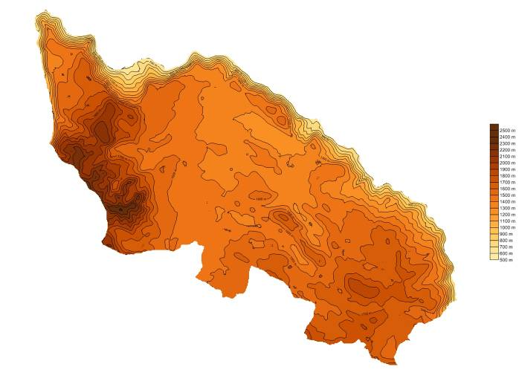
a) Elevation
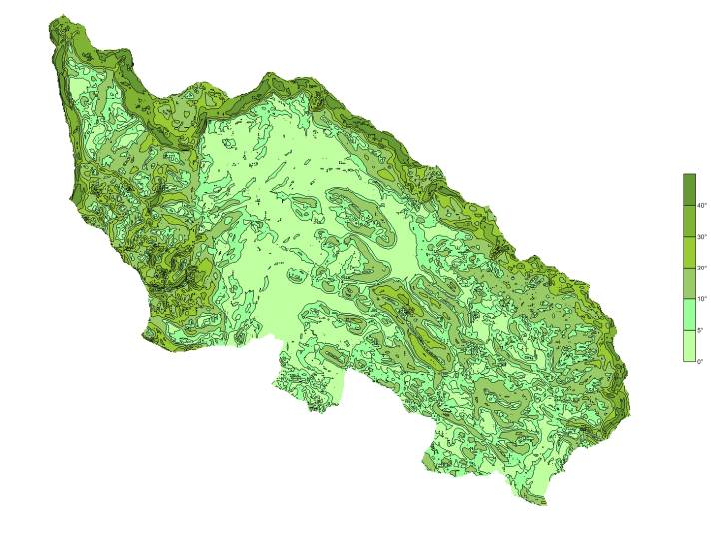
b) Acclivity
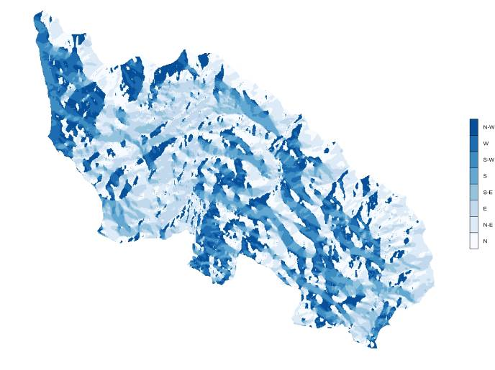
c) Slope Orientation

Figure 1.1: Žabljak’s Morphological Features

The Municipality of Žabljak has a total population of approximately 4,200 people (1,900 of which living in the town) spread on an area of about 450 square kilometers.
The population is concentrated mainly in the town of Žabljak, having all the other villages less than 100 inhabitants on the average. The settlements are spread all over the municipality and mainly on the hilly plateau. The only noteworthy industrial or commercial units are located in the town area, while the regional economy is mostly based on farming.
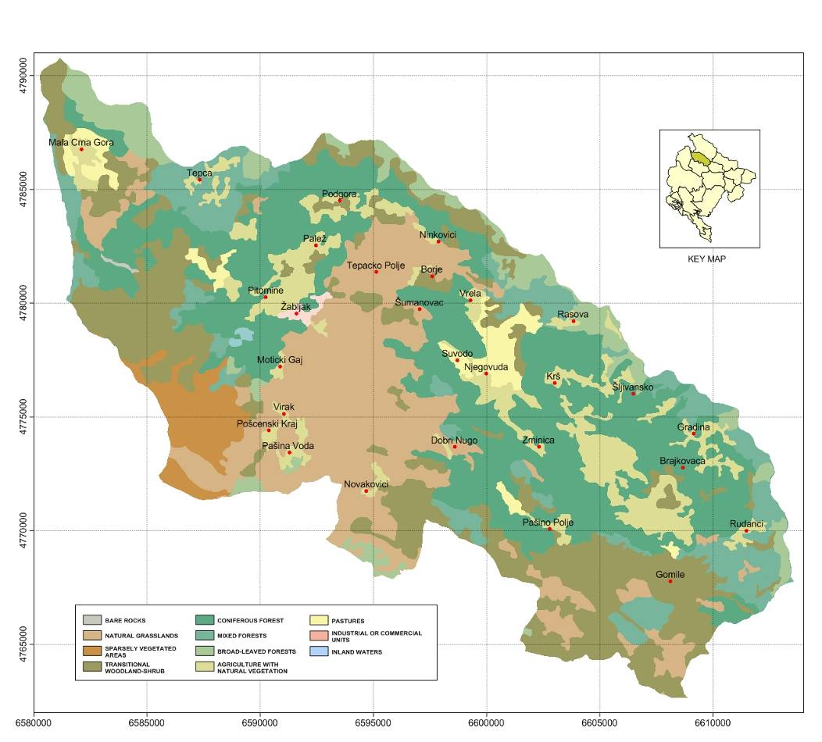
Figure 1.2: The Land Use Map of Žabljak
With the exception of the large natural grassland area in the center of the Municipality, the territory is mainly covered by forests, leaving space to only a few pastures and cultivated areas (Figure 1.2). In fact, less than 10% of the territory is used for agriculture, 0.2% is used by human activities while the remaining is very close to its natural status and is mostly covered by different types of forests. Broad leaves and mixed forests extend up to the elevation 1,300 meters, leaving then space to the coniferous forests. Starting from elevation 1,600 meters transitional woodlands/scrubs are widespread, while over 2,300 meters grasslands and sparsely vegetated areas are predominant. Wood is considered a valuable natural resource; therefore, the municipality should exploit this abundance in a sustainable way, in particular as tourist attraction.
Žabljak, besides a limited number of high mountain lakes and small seasonal streams in the Durmitor area, due to its morphology and to the karst nature of its basin, is not characterized by a definite drainage network. The Tara River is the only major water body in the area, flowing North-North West in the direction of the Bosnia and Herzegovina, where it converges with the Piva River to form the Drina River. It features the spectacular Tara Canyon, which is the deepest canyon in Europe and the second deepest in the world after the Great Canyon in the USA. The territory is characterized by the presence of many springs, very important for the local population and cattle water supply. Some of them are located on steep slopes, canyons or cirques thus creating beautiful waterfalls.
The small areas dedicated to pasture are mostly confined between elevations 1,250 to 1,900 meters, while agriculture is present also in the lower parts of the territory: both activities reach a higher share in the total land use only at 1,300 meters altitude, where they represent over the 30 %. The remaining part of the territory, both at lower and higher altitudes, is free from human activities and is almost covered by different types of forests, natural grasslands and sparsely vegetated areas, which disappear only over 2,500 meters altitude.
Žabljak features the Durmitor National Park, which with its over 34,000 hectares is then the main natural attraction. The Park is very famous not only for its wonderful landscapes, which are the ideal location for nature-based activities, but also for its rich biodiversity. The natural values of Durmitor and the Tara River were twice awarded internationally: the Tara River was inscribed in 1977 into the ecological biosphere reservation and therefore it is protected by internationally adopted conventions; the National Park Durmitor was inscribed in 1980 into the Register of World's Natural Heritage of UNESCO. The presence of canyons, dense vegetation as well as mountain lakes makes the landscape unique in the world, the ideal place for hikers and mountaineers.
The region is characterized by a typically continental climate, with long and snowy weather during the cold season, while summer is usually mild and sunny. Due to its altitude, the winter average temperature does not exceed -10°C while in summer it can reach 18°C.
The Žabljak area is an ideal place for summer and winter sports and vacations. During summer, climbers and expert hikers are attracted by the numerous mountain peaks but the National Park offers a lot of wonderful landscapes reachable through many soft trails.
Many rivers and lakes shores are equipped with picnic areas and, during the summer period, swimming is also possible in some lakes. Adventure travelers, in particular rafting and canoeing lovers, can find in the Tara Canyon the ideal place for a wonderful experience.
The altitude and position of Žabljak make it the ideal place for skiing and this is demonstrated by the fact that in the ‘80s it had a relatively large ski offer, technologically updated and in line with many of its competitors. Today only some lifts work but with some improvements the offer could reach the standards of the past.
Besides a spectacular nature, Žabljak offer also cultural moments, because it is rich in historical monuments and sites of great archaeological interest: tumuli, necropolis, Greek and roman graveyards (stećci), fortification and monastery complexes, churches form the XIX century and traditional architecture.
Joining the EC Program “Covenant of Mayors”, the Municipality of Žabljak has committed itself to adopt a strategy for the management and the development of the local energy sector based on sustainability principles such as energy saving, efficient use of energy and generation of renewable energy with the aim of reducing the CO₂ emissions by 2020; in fact, in order to be admitted into the Covenant of Mayors each signatory shall define, approve, implement and monitor a specific Sustainable Energy Action Plan (SEAP) tailored on the actual situation and issues pertaining the energy sector of the Municipality.
The SEAP is therefore a key document that demonstrates how the administration intends to achieve the objectives of reducing CO₂ emissions by 2020 identifying the best fields of action and opportunities, defining concrete reduction measures, together with time frames and assigned responsibilities, which translate the long-term strategy into actions which will cover both the public and private sectors, with initiatives on the urban environment and infrastructures including new buildings, public lighting, electricity grids, the urban and regional planning, the generation of energy through renewable resources, the development of policies for sustainable urban mobility, etc.
In addition, taking into account the wide range of sectors potentially involved in the implementation of the SEAP and the consequent impact on the population, the development of the SEAP envisages a continuous consultation with all the relevant stakeholders including citizens in general and the civil society, in order to facilitate the conscious acceptance of intelligent behavior in terms of energy consumption.
In accordance with the Covenant of Mayors’ Guidebook on how to develop a SEAP, the present document has been structured as follows:
- in Section 2 the overall strategy set by the Municipality to reduce the CO₂ emissions, the main objectives and target of the SEAP are presented;
- Section 3 describes the results of the Baseline Emissions Inventory (BEI). The BEI quantifies energy flows and the amount of CO₂ emitted due to energy consumption in the territory of the Municipality of Žabljak in the baseline year 2009, serving thereby as the reference from which the targets and the actual achievements of individual actions and related emission reductions in 2020 shall be calculated;
- the planned actions and measures are presented in Section 4; the description of the actions provide an estimation of the resulting CO₂ emissions reduction at municipal level and the timeframe for implementation until the 2020.

OVERALL STRATEGY

The general objective of this Action Plan is to conjugate the reduction of the GHG emissions at municipal level and the development of the community of Žabljak in a sustainable way, which means preservation of the natural heritage for the next generations, economic development and social fairness.
A significant growth of the tourism sector is expected in the next future, and at the same time an increase in life standards is foreseen: this will necessarily imply a growing trend in the energy demand and, therefore, in the energy consumptions and GHG emissions.
In realities like Žabljak, where the situation is evolving rapidly as for the number of tourists and the related energy uses, the comparison of the generated emissions with a past baseline year would not provide a reliable picture of the situation due to the huge changes occurred between the baseline and the future scenario. Therefore, the real objective of emissions reduction consists in the reduction in comparison with the situation which would show up in case of a not sustainable development.
For this reason a scenario-based approach has been chosen: a “do-nothing” forecast is compared with a “baseline scenario” taking into account the impacts of some sustainable actions. Specifically, the year 2020 has been selected as reference year for the comparison between sustainable and “do-nothing” scenarios.
The crucial challenge related to sustainable energy is how to increase the access to affordable and modern energy services, ensuring at the same time the minimization of environmental and socio-economic impacts.
Renewable energy sources have become alternatives to promote sustainable energy worldwide, as they allow reducing dependence on fossil fuels, contribute to energy security, as well as provide opportunities for mitigation GHG emission. However, the environmental impact of renewable energy is not always negligible. For instance, the construction of large hydro power plants devastates the ecosystems of the involved water bodies, wind power plants can have negative visual impacts and effects on birds population, and biomass can cause local air pollution. Moreover, the capital costs and operating costs of renewable energy plants are still generally higher than systems fuelled with fossil fuel.
The pillar of a sustainable energy strategy is, therefore, to increase the overall efficiency of energy production and consumption, as the negative environmental impact of energy efficiency measures is substantially zero.
Nowadays, advancement of technologies enhances the opportunities for energy saving in a wide range of activities, such as energy efficient lamps and electrical appliances, which can be introduced in Žabljak, as well as in the entire Montenegro. Furthermore, the initial investment costs of energy efficient devices are decreasing with time due to technological improvements.
The analysis of the current situation and the medium term forecasts for Žabljak showed opportunities and barriers for a sustainable energy development across the Municipality. For instance, large amounts of energy are currently wasted due to the low efficiency of energy management and appliances.
Recognizing the critical role of energy in promoting sustainable development in Žabljak, this Action Plan applies a interdisciplinary and integrated approach, with the objectives of enhancing the energy efficiency (i.e.: energy savings) across the Municipality and promoting the energy production through renewable sources. As a complementary objective, the reduction of GHG emissions is also pursued along with sustainable energy development in the Municipality.
In order to illustrate the overall strategy adopted by the Municipality to meet the GHG emissions reduction target, some key-overviews are presented in the following sections:
- the sustainable energy vision until 2020;
- the current situation of the energy sector;
- the action plan objectives and the GHG emissions reduction target to be met in 2020 compared to the reference 2020 scenario.
The main elements of the overall strategy summarized in the SEAP template are presented in Appendix 1.

SUSTAINABLE ENERGY VISION FOR 2020
The long-term vision of the Municipality of Žabljak foresees the development of tourism and of the community in a sustainable way. Energy is fundamental within the sustainable development. The analysis of the current situation of Žabljak showed many opportunities in the energy field. The key elements to implement a sustainable energy action plan for the Municipality allow a gradual reduction of the GHG emissions in each relevant sector (residential, commercial, public, tourism transport).
In its vision for a sustainable energy future, the Municipality of Žabljak will pursue electricity generation from wind and will work to create intelligent energy consumption, through both the use of solar and biomass energy for heat production and the increase of efficiency in heating, in street lighting and in electric equipment.
Aim of Žabljak in the field of buildings is to achieve, in new constructions and renovation works, high internal comfort standards, low energy consumption and environmental impact, together with the maintenance of shapes and materials of the traditional heritage.
Also, Žabljak vision is to develop a climate-friendly transport system based on pedestrian priority zones, biking and horse riding paths.

CURRENT FRAMEWORK
The territory of Žabljak is characterized by a significant potential in terms of production of renewable energy: in particular forest biomass, wind and solar energy have good perspectives for the next future. Currently, only firewood is used, meeting an important share of the current energy demand, especially for heating.
Nowadays, there are no electric power plants within the Municipality and electricity is imported. An important energy project, a new high voltage power line connecting Pljevlja and Tivat, could potentially concern the Municipality. This project is relevant for the Municipality of Žabljak and the Durmitor National Park, since the route of this line will probably cross the area.
Energy use at local level is characterized by low efficiency and by the overuse of electricity for thermal purposes, implying high costs for inhabitants and significant indirect carbon emissions. Lignite is also used for heating, causing bad smell and pollution in the urban area.
The most promising sources in the territory seem to be wind for electricity production, wood residues, suitable both for space heating at local level and for pellets production for export, and solar energy for hot water production, that is the most important electric use in the residential and tourist sectors. On the contrary, lignite use should be quickly banned and the electric network should be rehabilitated.

Poor Quality of Electric Services
Žabljak is served by an electricity transmission line coming from Pljevlja, which has a capacity consistent with local needs even in case of strong increase of consumption. The local distribution grid is characterized by old equipment and poor stability, with frequent voltage drops and blackouts.
The Energy Strategy of Montenegro plans the connection of the high voltage line between the coast (near Tivat) and the power plant in Pljevlja. This new high voltage 400 kV line directly linking the future submarine cable between Montenegro and Italy directly with Pljevlja, would be a first step in the enhancement of the situation of the electricity line of the area.
A striking indicator of the situation in Žabljak is offered by public lighting: the average common life of the mercury lamps is around 2,000 to 6,000 hours, whereas in the town it is necessary to replace about 30 % of the lamps every two weeks.

Inefficient Use of Local Renewable Resources
Montenegro has a significant renewable energy potential and the key renewable resources in the country are hydropower, wind, biomass and solar energy. Apart for some hydro power plants, most of the potential is currently unused. The possibility of exploiting renewable energy sources highly depends on the local environmental heritage, which includes the presence of valuable ecosystems, partly protected within the Durmitor National Park. The potential production must take into account the potential environmental damages caused by plants, avoiding the construction of over-impacting facilities.
Apart from locally collected firewood, currently there is no energy production in Žabljak. The energy consumed within the Municipality, i.e. electricity, liquefied petroleum gas (LPG), mazut, lignite, diesel, gasoline and others, are imported. Wood is the only energy source obtained within the territory. Most of the energy used for heating comes from firewood, mainly used in traditional stoves. Forests in the Municipality are mostly of conifers (more than 85%), whose wood burns too fast in the traditional stoves. As a consequence, most of the firewood is broadleaved trees wood imported by other municipalities.
Firewood is the main energy source used for space heating in the Municipality, whereas most of the wood waste is abandoned in the forests after cutting activities or abandoned in piles close to the sawmills. For example, the Njegovuđa sawmill has stored its residues in the area around the plant for 35 years.
Part of the wood waste is used for heat production, although the clearly visible wood waste piles stacked close to this sawmill indicate that the part of used waste is minimal.
Solar energy is currently not exploited although the yearly irradiation is good. The annual sunshine hours in Žabljak reaches up to 1,980 hours. The monthly sunshine hours are more than 200 during summer (between June and September) and in the range of 90 to 125 hours during winter (Figure 2.1). These high values of incoming solar radiation reveal that the potential of energy production from solar is absolutely high and unexploited. Solar thermal and solar photovoltaic technologies shall be promoted in order to produce green energy (i.e.: domestic hot water through solar thermal and electricity through photovoltaic).
As for solar thermal, currently, domestic hot water in the residential sector is mainly generated through electric boilers.
In the next years it is expected that the domestic hot water demand will increase due to an improvement of life standards, causing an increase of the electricity consumption from the electric boilers.

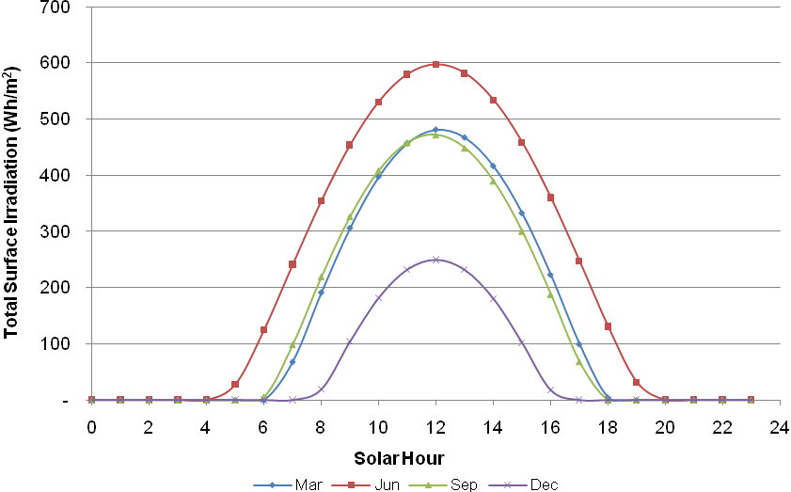
Figure 2.3: Example of Incoming Solar Irradiation in Žabljak
It is proposed to exploit the potential of solar energy for hot water production in the residential sector of Žabljak. Solar thermal systems convert sunlight into heat and represent an excellent and reliable alternative to electric water heating. At national level, an interesting funding scheme exists: the Montesol Program, an activity in the framework of the Kyoto Protocol’s initiatives regarding the solar water heating development in Montenegro, offering an attractive financial mechanism for obtaining a retail loan to install Solar Water Heating systems for the production of Domestic Hot Water in the households in Montenegro.
As for Photovoltaic, at the moment the installation of such power plants on a large scale is only at an early phase of implementation due to the recent introduction of a feed-in tariff (new Energy Law, dated April 22nd, 2010) that can make the investments appealing in a close future.
However, the installation of photovoltaic systems on voluntary basis (both large- and small-scale systems) is likely to become common practice and it is strongly encouraged by the Municipality, since the potential is not negligible.
Concerning the future benefits originated from the installation of solar photovoltaic systems within the Municipality, they are not considered in the quantitative calculations for the energy and emissions balances of the SEAP. Although a rough evaluation of the future diffusion of the photovoltaic systems along the Municipality can be made, the exclusion of photovoltaic from the SEAP is due to the fact that its effects can not be ascribed to any Municipal regulations: the installation of photovoltaic systems, especially the large scale one not tailored to the local demand, must comply with national regulations and therefore can not be accounted for in the Municipal balance.
Presently, there are no hydro power plants in the territory of Žabljak.

Low Energy Efficiency in the Residential and Public Sector
Large amounts of energy are presently wasted due to low efficiency of energy using appliances. The main areas of intervention are buildings, in particular space heating and domestic hot water production, and electricity end uses. The goal is to increase the energy efficiency in end uses. The recommendation is to develop a policy for increasing efficiency in heating, reducing energy demand of buildings thanks to high insulation levels and to the use of efficient windows, increasing of street lighting through lamps replacement.
Residential, tourist and public sectors are the most energy consuming segments in the Municipality and account for the most relevant GHG emissions and therefore several actions in these fields have been outlined.

ACTION PLAN OBJECTIVES AND GHG EMISSIONS REDUCTION TARGET
The strategic vision of the Municipality is based on the principles of sustainable development, focused on accelerating economic growth through strengthening the tourism sector in the Municipality, on respecting the sustainable energy principles, ensuring environmental protection and rational use of the natural resources, promoting at the same time an alliance between development and environment and taking into account the right of future generations to quality of life.
General objective is to combine the development of tourism industry and the sustainability principles in the Municipality of Žabljak. The crucial challenge related to sustainable energy is how to increase access to affordable and modern energy services.
The key pillars of a sustainable energy strategy are the development of renewable energy plants and the improvement of the energy efficiency in end uses. Enhancing energy efficiency levels can also slow down the growth of energy demand and alleviate, as a consequence, the reliance on fossil fuels.
The key actions to be pursued in order to reach a good level of sustainability can be therefore grouped under four main measures:
- improvement in electric infrastructures;
- energy production from renewable energy sources;
- increase of energy efficiency in end uses;
- promotion and management of sustainable energy.
The main actions planned by the SEAP are summarized in Table 2.1.
The goal is to improve the electricity production using the local available resources, to promote the use of solar and biomass for heat production and to increase the street lighting and the electric equipment efficiency.
The following Sections will show that the overall CO₂ emissions reduction calculated through the comparison between the reference 2020 “do-nothing” scenario and the “sustainable scenario” proposed by the SEAP amounts to 6,700 tCO₂/y; this is equal to a 37% decrease of the GHG emissions compared to 2009 level and 21.5 % compared to 2020 “do-nothing” level.
It must be noted that the estimation takes into account only the interventions of energy efficiency and renewable energy that can be assigned to Žabljak, excluding the large-size renewable projects such as wind and photovoltaic which are part of a National strategy.
The actions presented in Table 2.1 are described in the following sections.
The detailed assessments of the mitigation opportunities and of the related CO₂ emissions reductions are presented in Section 4.
Table 2.1 Actions Planned
Action | Type of action | Type of effect | Target Sectors | Contribution to SEAP
Electricity Transmission and Distribution Grid Rehabilitation | Energy Efficiency | Reduction of Energy Losses | National Grid | Qualitative evaluation (Relevancy of the National Strategy)
Solar Thermal Collectors | Renewable Energy | Domestic Hot Water Production | Residential, Public, Tourism, Commercial | Quantitative Evaluation
Photovoltaic Panels | Renewable Energy | Electricity Production | All Sectors (except Transport) on voluntary basis | Qualitative evaluation (Relevancy of the National Strategy)
Wind Farms | Renewable Energy | Electricity Production | Industrial Production dedicated to all sectors | Qualitative evaluation (Relevancy of the National Strategy)
Recovery of Wood Waste | Renewable Energy | Space Heating and Electricity Production | Industrial Production dedicated to all sectors | Qualitative evaluation (Relevancy of the National Strategy)
Improvement in Building Insulation | Energy Efficiency | Reduction of Thermal Energy Demand | Residential, Public, Tourism, Commercial | Quantitative Evaluation
Ban of Lignite | Energy Efficiency | Fuel Switch | Residential | Quantitative Evaluation
Efficient Heating Systems | Energy Efficiency | Reduction of Thermal Energy Consumption | Residential, Public, Tourism, Commercial | Quantitative Evaluation
Efficient Electric Appliances | Energy Efficiency | Reduction of Electricity Consumption | Residential, Public, Tourism, Commercial | Quantitative Evaluation
Lamps Replacement | Energy Efficiency | Reduction of Electricity Consumption | Public and Private Lighting | Quantitative Evaluation
Switch to LPG | Transportation | Fuel Switch | Transportation | Quantitative Evaluation

Improved Electric Infrastructures
Aged equipment and uncontrolled growth of unregistered settlements in the peri-urban area of Žabljak are the main causes of the current bad quality of the electric supply, often suffering of black-outs and of voltage drops.
The first action that can be undertaken is the Local electric grid rehabilitation, and specifically the rehabilitation of the substation feeding the town, the central hub of the local electric grid. The high voltage line feeding the city is a 110 kV power line operated at 35 kV. Although for the current and expected future electricity demand the operation could be kept at 35 kV, the elevation of the power line feeding the town to 110 kV would reduce losses and allow higher capacity.
Moreover, the revamping of the municipal medium and low voltage grid will be suitable. Revamping should include substitution of obsolete equipment and increase of capacity of lines in the center and in the suburban settlements, where lines once serving a couple of users feed now dozens of buildings.
A new high voltage 400 kV line directly connecting Pljevlja with Tivat is currently under study at a very preliminary stage, aimed at directly linking the future submarine cable between Montenegro and Italy directly with Pljevlja, which would become both a power generation point and an energy transit hub. The goal is to promote the minimization of the impact of the Pljevlja-Tivat 400 kV line. Since the most direct path would cross two National Parks (Durmitor and Lovcen, close to the coast) and cross mostly desert areas, with low population and no important energy infrastructures, this route would not be the most suitable alternative. An alternative option is the use of underground cables. Depending on the technical and economical feasibility, the most suitable route option should reduce the needs of forest clearing and the closeness to homes and areas with sensible fauna.

Production of Renewable Energy
The Municipality of Žabljak shall pursue the exploitation of its local resources to produce both electricity and thermal energy. The most interesting renewable source in the municipality is wind.
Wind plants, as big size energy production plants, are not directly competence of the Municipality but are included in a wider prospective of national energy planning.
However, the spread of renewable energy plants is an important point of the sustainability planning, so that an evaluation has been carried out even if the results will not be accounted in the SEAP.
Even though the Renewable Energy Resources Assessment (RERA) of Montenegro shows uppermost values along the highest ridges of the Durmitor, these areas are not considered since the necessary infrastructures (roads and power lines) would imply significant environmental damages and high costs.
Ongoing measurements indicate good wind speed values for the electricity production in Žabljak. The existing wind measuring mast is in the hilly area of Trnajevci, at the North West limit of the Jezerska Plateau. The RERA shows an average wind speed distribution with small variations along the whole Jezerska plateau and the Sinjajevina Range, with higher values along hill ridges. Therefore, the whole area of Jezerska Plateau and Sinjajevina Range could be the most suitable locations for wind farms development (Figure 2.2).
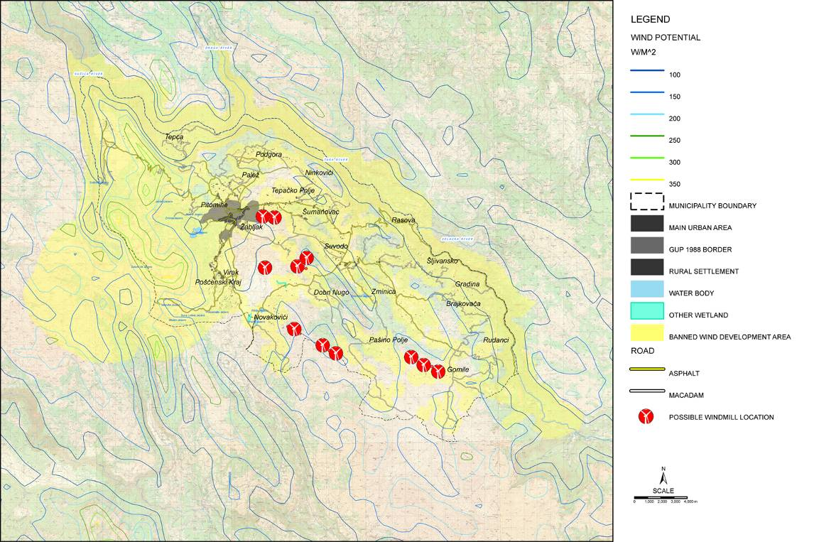
Figure 2.4: Potential Areas for Wind Energy
The terrain is generally complex, but the plateau has smooth shapes and reduced slopes, posing no serious problem in transporting the largest parts of wind turbines. Access roads are currently the most stringent technical problems for transporting wind turbine parts to Žabljak. These problems are now eased by the recent opening of the new road from Risan to Žabljak, which, besides the benefits to the global traffic conditions, allows transporting to the plateau large wind turbines, from the port of Bar through Podgorica, Niksic and Šavnik.
During the preparation of a comprehensive wind power development program, the recommendation is to take into account that:
- a minimum distance of 500 m between wind farms and inhabited areas should be preserved;
- plants should not be developed within the National Park and in other naturally sensitive areas;
- a careful survey on bird fauna should be carried out;
- the definition of a maximum number of turbines to be posed into the Municipality to prevent an excessive impact on the landscape;
- the definition of compensation measures.
The estimation is to install 2 MW wind turbines, realizing the wind farms on hills’ ridges with good wind conditions, close to the local grid and not too much in depth in the Sinjajevina Range.
In the optimal configuration, the proposed wind farms could reach 76 MW of power, with a related energy production of 167 GWh/year, a value largely exceeding the local electric consumption, as illustrated in the following Table 2.2.
Table 2.2: Optimal Configuration of the Proposed Wind Farms
Wind Farm | Number of Turbines | Installed Power (MW) | Yearly Production (MWh/y) | Emissions Reduction  (tCO2e/y)
Trnajevci | 7 | 14 | 31,000 | 36,000
Rudinovaca | 6 | 12 | 26,000 | 30,000
Borova Glava | 3 | 6 | 13,000 | 15,000
Mala Orujica | 5 | 10 | 22,000 | 25,000
Velika Orujica | 7 | 14 | 31,000 | 36,000
Korman | 10 | 20 | 44,000 | 50,000
Total | 38 | 76 | 167,000 | 191,000

As for biomass, the Municipality has a substantial unused potential, estimated at 14,000 m³. About 10,000 m³ of the total are wood waste produced at sawmills, whereas the remaining 4,000 m³ are branches and other wood residues abandoned in forests after cutting operations. Therefore, the use of wood residues for energy purposes and for producing wood pellets for exportation, and wood chips and briquettes for local use will be pursued.
Wood briquettes can be used both in traditional and modern stoves running with firewood pieces, wood chips are used in automatic stoves and boilers of medium-large dimensions and pellets are suitable for plants of small to medium dimensions. Large buildings (public buildings, hotels, etc.) shall be built or renovated installing centralized wood chips plants. Most of the residential sector will keep on using wood pieces stoves, although the use of pellets will start to diffuse, and become in the long term the most important heat source for homes with centralized heating systems. The use of wood based systems will allow shifting the energy demand from imported fuels (broadleaved tree wood, lignite, LPG, fuel oil) to local wood derived fuels.
Although the action will allow the energy use of yearly produced wood waste, it will not help in solving the problem of wood waste accumulated in the past years of operation of sawmills. The largest one in Njegovuđa operated for about 35 years abandoning residues in the surrounding area. The amount of material deposited there, is of the order of 350,000 m³. This material has been stored outdoor, exposed to rain, for a long time and is no more suitable for pellets or briquettes production. However it is likely that a still important fraction of the material keeps having a significant energy potential.
The energy recovery from the wood waste potential must be developed along with a deep clean up of the area, that could be achieved exploiting this potential as follows:
- producing energy by burning material with good energy content, resulting in financial revenues;
- using the earnings for cleaning up the area from the remaining degraded material.
The amount of wood scraps is too large to be used at local level, therefore the lignite power plant in Pljevlja could be a suitable option for the energy use of the wood waste.
Lignite is a type of coal with a poor heating value, even lower than wood. Lignite is a dirty type of fuel, causing significant GHG emissions. Wood material can not be directly fed into a lignite power plant, but after a proper wood waste preparation (chipping and drying) it can be added in a small percentage to the lignite plant. This technique is used in many plants, both in EU and in Eastern European Countries. Typically, a percentage of up to 3 - 5 % of wood residues can be added to the lignite feed with minor interventions on the plant or pre-treatments of wood (as wood waste, also raw lignite has a very high moisture content and is dried before entering the combustion chamber of the power plant). The main environmental benefit would be the reduction of GHG emissions and of sulphur emissions, since wood as a lower sulfur content than lignite (EIPPCB, 2006).
The needed investment of such operation could be financed by the sale of fuel to the power plant substitutive of lignite, and if these revenues were not sufficient to achieve financial feasibility further additional income could be obtained developing the action as a small scale voluntary project within the framework of the Climate Change initiatives for the reduction of the GHG emissions. The material not suitable to be used as fuel could be removed from the areas and spread as a fertilizer in agricultural or forest areas.
At the end of the Action the area of Njegovuđa could be fully remediated, with no need of financial intervention from the side of the Municipality. Of course, careful evaluations on the consistence and of the available wood waste stock should be carried out before starting such projects, but the figures indicate that this way could be very promising both as a business activity and as an environmental remediation action.
The introduction of solar thermal technologies would help decrease the electricity consumptions. Another recommendation is the use of solar energy for heat production, through a three-phase strategy: pilot, voluntary and mandatory.
The pilot phase, lasting one-two years, foresees the installation of the first solar systems in a set of new and/or renovated buildings, preferably public buildings or tourist facilities. Then, the existing subsidies introduced for citizens and enterprises interested in installing solar collectors by the Montesol Program will help boost confidence in the new technology and to broaden the market. Finally, the use of these technologies could become mandatory, requiring solar collectors in all civil structures facing construction or a heavy renovation. Most houses currently use traditional stoves for space heating, often burning imported broadleaved wood or lignite. At the same time, large amounts of wood waste are left abandoned in forests after cutting works or in dump sites around sawmills. The recommendation is the use of these residual materials in substitution of normal firewood, lignite and LPG. Similarly to the promotion of the use of SWH for heat production, also the use of modern biomass technologies, run with wood pieces, briquettes, chips or pellets will be promoted through a three-phase strategy: pilot, voluntary and mandatory.
Lignite is used for space heating in the residential sector and in a few other buildings of different use. The ban of lignite use would not pose serious problems to the community. Banning lignite use would provide immediate benefits in pollution reduction and improvement of the town image, with minimal economic efforts by public bodies and citizens.

Increase of Energy Efficiency in End Uses
The increase of efficiency in heating represents the most effective action for the reduction of energy consumption and improvement of internal comfort. The main focus is the reduction of energy demand, thanks to a better insulation of roofs, facades, basement and higher performances of glazed structures. The “sustainable and ideal building” should have high insulation, a hot air duct or hot water radiator based heat distribution system, a domestic hot water system based on solar collectors, a mechanic ventilation system for heat recovery. The main goal is to gradually transform the buildings of Žabljak into “green buildings”. This action will be promoted through a three-phase strategy: pilot, voluntary and mandatory. The first energy efficient pilot buildings should be built including high insulation, solar hot water system, automatic wood chip boiler with radiator system. The expectation is that the first demonstration building will attract public interest through information dissemination campaign, highlighting the high comfort, the cost savings and the environmental benefits. The financial sources for the first green building could be obtained from the Municipality, State’s grants or from international donations. The second phase foresees the introduction of financial and/or fiscal incentives for the construction of energy efficient buildings. Finally, high efficiency standards will become mandatory for all new buildings and for renovation of the existing facilities.
In the public sector, lamps replacement in street lighting is a priority action for achieving good results in the short term period. The use of energy efficient street lighting technologies provides energy and cost savings, GHG emission reductions, as well as economic benefits by an increase in municipal commercial activity. The proposal is to install high-pressure sodium lamps in all new public lighting systems by 2020. In order to reduce the high energy consumption in the residential sector it is suggested to gradually replace the current low efficient electrical devices with new and more efficient appliances.
The new facilities shall be realized according to energy efficiency principles, using good insulating layers, shading structures, high performance glazed materials, solar collectors.
Following a necessary awareness raising campaign, the use of high efficiency electric equipment will significantly reduce the consumption in the residential sector. The goal is to encourage consumers to switch from old energy inefficient domestic appliances to energy efficient products with energy label of Grade A/A+, in accordance with the EU energy labeling system. Based on the results of energy labeling and related awareness raising campaign in Europe, it is expected about 50 % of the population will switch to domestic appliances with energy label of Grade A+ by the end of 2020.
A significant increase of energy efficiency in end uses could be realized also in the transportation sector, which is responsible of significant energy consumption and GHG emissions. The recommendation is to increase energy efficiency in transportation by realizing modern infrastructures and encouraging the use of collective transport systems against the single-occupancy vehicle. Moreover, the creation of pedestrian zones and new parking areas should encourage cycling and walking. Having in mind that the current scenario is based on 80% contribution of single-occupancy vehicle and 20% of bicycling/walking, the overall goal of this strategy is to reach 30% cycling/walking, 30% car, 20% shuttle bus and 20% bus. A further important possibility for decreasing GHG emissions in the transportation sector is a gradual switch to cleaner fuels, such as LPG, biofuels and methane. LPG is not carbon neutral, but its CO₂ emissions are 10 % lower than gasoline. The suggestion is to gradually convert the fuel for private and public vehicles of Žabljak into LPG.

Promotion and Management of Sustainable Energy
The actions identified and analyzed in the previous Sections will allow a notable reduction of the energy consumption and GHG emissions within the Municipality. The actual implementation of the proposed actions will require the availability of financial mechanisms, such as grants and loans, for the start up phase, where the accessibility to incentives will be crucial. The necessary funds could be partially provided by the municipal budget; however, additional financial aids should be identified and obtained. The Government will surely support such a plan with dedicated funds within State budget, being the initiative a pilot case in Montenegro.
To facilitate the implementation of the program, a wide analysis will be undertaken to identify possible alternative or additional funding mechanisms such as facilities supported by International Financial Institutions and the European Union.
Promotion of sustainable development and energy management schemes in the public sector is a crucial action for Žabljak, as this can act as a model for other sectors across the Municipality. As a result, the quantification of energy consumption and carbon emissions values may be subject to differences in respect to the estimated values. For these reasons the set up of a municipal energy management system will guarantee an effective control of the implementation of the proposed actions and the individuation of the most effective interventions.

ORGANISATIONAL AND FINANCIAL ASPECTS

Coordination and Organisational Structures
The process of designing, implementing and monitoring the Sustainable Energy Action Plan of the Municipality of Žabljak is a complex task that would set up a number of challenges to all of its participants. The main prerequisite for the successful realization of the process is to build effective organizational structure where will be precisely defined tasks and responsibilities of every member.
Project Management Team was established in accordance with Article 65 and 68 Statute of the Municipality of Žabljak (Official Gazette of RM – municipal regulations, No. 9/05 and 23/07). This Team deals with preparation of project proposals and implementation of projects financed through EU and national funds, as well as with future activities related to Covenant of Mayors.
The first step in establishing the organizational structure for the process is designation of the coordinator. The coordinator of the Team is a key person who makes all important decisions on coordination and implementation of concrete projects and energy efficiency measures, renewable energy sources and environmental protection in accordance with priority measures and activities in the Sustainable Energy Action Plan.
This Plan foresees that the coordinator of the Team is Deputy Mayor of the Municipality of Žabljak, Mr. Vasilije Jakšić.

Staff Capacity Allocated
Project Management Team is composed of 6 members, namely:
1. Ostojić Milika,
2. Vuković Gorica,
3. Bojović Jelena,
4. Vojinović Tanja,
5. Dedeić Vesko,
headed by the Deputy Mayor of the Municipality of Žabljak as coordinator of the Team.
Team members have experience in gathering project ideas, providing advisory and consulting services to potential applicants, as well as in preparation, management and implementation of projects and their evaluation.
The main tasks of the Project Management Team in SEAP include:
- management and coordination of all phases of design, implementation and monitoring of the Sustainable Energy Action Plan;
- communication with stakeholders and citizens;
- review of the Sustainable Energy Action Plan and preparation of periodical reports on the results of implementation of the Sustainable Energy Action Plan to the European Commission.

Involvement of Stakeholders and Citizens
Direct involvement of stakeholders in the process of designing the Sustainable Energy Action Plan has been implemented since the very start of the process. The Action Plan for sustainable tourism development of the Municipality, which includes detailed monograph on energy sector in the Municipality, upon which the Sustainable Energy Action Plan is based, has been widely discussed with stakeholders.
In 2009-2010 a wide number of meetings was held in Žabljak regarding preparation of the Master Plan for sustainable tourism development, attended by representatives of public administration, businesses and citizens. On January 2011 the Master Plan was presented in Žabljak, in cooperation with Ministry of Tourism of Montenegro, Italian Ministry of Environment, Land and Sea and the Municipality of Žabljak.
Those events were very important for sharing with other institutions, stakeholders and citizens the future vision of the Municipality and the main objectives and foreseen activities in the Action Plan, including also main objectives, analysis, proposed measures and activities in energy sector of the Municipality.

Budget and Financing Sources for the Investments
An overall budget was not estimated. Detailed budget for each action described in the Sustainable Energy Action Plan template will be evaluated through accurate technical and economic feasibility studies.
The Municipal budget allocated for the implementation of the SEAP is the annual amount destined to the remuneration of the six members of the Project Management Team described in Section 2.4.2.
Realization of the projects within the planned activities of the Sustainable Energy Action Plan could be achieved through Public Private Partnership (PPP). PPP occurs in different areas of public administration, in various forms, with different duration and with different intensity, and usually in cases where public administration is not able to directly perform public affairs.
There are significant sources for funding of the proposed measures and activities in the form of grants through various programs of the European Union, and these sources will significantly increase when Montenegro becomes a full member of the European Union, through Structural Funds. It will be necessary to ensure strengthening of human capacity in terms of special teams or office to monitor open tenders and prepare project proposals in accordance with guidelines. Table 2.3 presents some of the funds and programmes of the EU, through which the planned activities of the Sustainable Energy Action Plan could be realized.

Planned Measures for Monitoring and Follow-Up
Continuous monitoring, control and reporting on the results are extremely important component of the implementation process of the SEAP of the Municipality of Žabljak.
Monitoring of the dynamics and the successful implementation will be carried out by Project Management Team of the Municipality and their main tasks will be:
- to periodically check the realization of the proposed actions;
- to monitor the level of CO₂ emissions sector by sector and consequently to issue updates of the greenhouse gases emission inventory on regular basis.
On two year basis the Municipality will submit an implementation report.
Table 2.3: Funds and Programmes of the EU
Instrument for Pre-Accession Assistance (IPA) | IPA is an instrument for pre-accession assistance for the period 2007- 2013, for candidate and potential candidate countries.  It is composed of five components: Assistance for transition and institution building; Cross-border cooperation (with EU Member States and other countries eligible for IPA); Regional development (transport, environment, regional and economic development); Human resources (strengthening human capital and combating exclusion); Rural development.
Cross-border cooperation Programmes (CBC) | Cross- border cooperation programmes are finances through second component of IPA fund. Montenegro is eligible to participate in the following programmes:  - bilateral programmed, Montenegro-Albania  - bilateral programme, Montenegro-Bosnia and Herzegovina  - bilateral programme, Montenegro-Croatia  - bilateral programme, Montenegro-Serbia  - IPA Adriatic CBC Programme  - South East Europe Programme  - MED Programme
Competitiveness and Innovation Program (CIP) | Competitiveness and Innovation Program (CIP) is operationally divided into three programs of which the Intelligent Energy Europe (IEE) covers an area of environmental protection and energy efficiency. The main objectives of the IEE are as follows: increase energy efficiency and rational use of energy sources; promote new and renewable energy sources and encouraging diversity of energy sources and promote energy efficiency and use of new and renewable energy sources in transport.
Seventh Framework Program - FP7 | Seventh Framework Program (FP7) is the main instrument of the European Union for funding scientific research and development, and activities include the organization of cooperation between universities, research centers and industry (including SMEs), and providing financial support for joint projects.
Concerto Program | Within FP7 is launched a special initiative called the Concerto, which has the main goal of encouraging local communities to implement activities to increase energy efficiency and renewable energy sources.
EU Structural Instruments | Structural instruments have the main goal to achieve economic and social cohesion and balanced development within the European Union through European Social Fund, European Fund for Regional Development and Cohesion Fund. Structural instruments have aim to reduce the differences between regions and create a better economic and social balance among member countries. Structural funds will be available to Montenegro and other candidate countries after their accession to the EU.
European Local Energy Assistance (ELENA) | Program ELENA was launched as cooperation between the European Commission and European Investment Bank in late 2009. The main source of funding ELENA comes from the Intelligent Energy Europe (IEE). Technical assistance will be provided to the cities and regions in developing energy efficiency projects and attracting additional investments, covering all types of technical assistance necessary for preparation, implementation and financing of the investment program.

BASELINE EMISSIONS INVENTORY
The BEI quantifies the energy flows and the amount of CO₂ emitted due to energy consumption in the territory of the Municipality of Žabljak in the baseline year, which serves as the reference for monitoring and comparison of the reduction targets and the actual achievements of individual actions and related emissions reduction in 2020.
As suggested by the Guidelines for the development of the SEAP, since there is no particular source of CH₄ and N₂O emissions in the area, those pollutants are not taken into account in the calculation and only CO₂ is considered in the BEI as relevant GHG.
In order to avoid a large uncertainty in the BEI due to unreliable data on energy consumption needed for CO₂ emissions estimation, the first step in drafting the SEAP was to choose a reference year. The main selection criterion was the availability of reliable data required for the calculation of CO₂ emissions, therefore year 2009 was selected as reference, and the observed time frame of the Plan covers the period from 2009 to 2020.
The BEI is prepared according to the Intergovernmental Panel on Climate Change (IPCC) protocol. IPCC protocol for the determination of emission pollutants in the atmosphere is the protocol of the executive body of the Program for the Environment United Nations (United Nations Environment Program - UNEP) and World Meteorological Organization (WMO) in implementing the United Nations Framework Convention on Climate Change (UNFCCC).
The BEI (see Appendix 2) contains data on energy production and consumption within the Municipality of Žabljak, and corresponding CO₂ emissions, related to the following sectors:
- municipal buildings, equipment/facilities;
- tertiary (non municipal) buildings, equipment/facilities;
- residential buildings;
- municipal public lighting;
- industries & Small and Medium Enterprises (SMEs);
- transport.

SOURCES OF DATA
The preparation of the BEI is very complex due to the difficulties in collecting homogeneous and complete data. In many cases, there are no complete data regarding various energy sources and sectors or they are not presented with the same level of territorial or sectoral aggregation. Therefore, it is necessary to perform calculations and assumptions based on indicators that use available information and allow a statistically based estimation.
During the preparation of the BEI, statistical data sources from organizations that have the institutional duty to perform surveys (Statistical Office of Montenegro- MONSTAT) were used, but the main data regarding energy consumptions were provided by Montenegrin Electric Enterprise-EPCG, through interviews and questionnaires filled in by representatives of this institution. Data were also assumed based on internal interviews with the municipal staff, the team’s experience and reliable forecasts.
Since there is a lack of data needed for the BEI preparation, many sectoral studies and analysis were used, as well as information provided by other institutions. Table 3.4 shows institutions and documents which were used for data collection on renewable energy resources.
Table 3.4: BEI Data Sources
INSTITUTION | DOCUMENT NAME
Ministry for Economic Development (MED) | Strategy for the Development of Small Hydro Power Plants, Podgorica (2006)
Ministry for Economic Development (MED) | Whitebook, Energy Development Strategy of Montenegro by 2025, Podgorica (2007)
Ministry for Economic Development (MED) | Investing in the Energy Sector of Montenegro, Podgorica (2007)
Ministry for Economic Development (MED) | Renewable Energy Resources in Montenegro, Podgorica (2007)
Foundations for the Development of Northern Montenegro (FORS) | Socio-Economic Analysis of the Northern Region of Montenegro, Podgorica (2008)
Food and Agriculture Organization of the United Nation (FAO) | Grain Storage Techniques – Evolution and Trend in Developing Countries (2005)
Food and Agriculture Organization of the United Nation (FAO) | Forest and Forest Products Country Profile: Serbia and Montenegro, Geneva, Switzerland (2005)
Hydrometeorlogical Institute of the Republic of Montenegro (HIM) | Data Sets of Sunshine Hours (2006)
Centro di progettazione, design & tecnologie dei materiali (CETMA) | Renewable Energy Resource Assessment: Wind, Solar, Biomass Energy Assessment (2007)
D’Appolonia / DFS Engineering | Masterplan for the Sustainable Tourism Development in the Municipality of Žabljak (2010)

The energy consumption for the transport sector was assessed considering data coming from different local sources:
- the traffic conditions of the Municipality were deducted from registered documents (European Agency for Reconstruction, 2003);
- the energy consumptions at national level were collected from the 2006 National Energy Strategy for Development;
- the emission factors for the vehicles and the heating values of the fuels were taken from the World Resources Institute (WRI) guide of the GHG Protocol (WRI, 2005);
- fuel sales at local fuel stations within the municipality were gathered through interviews;
- distances between locations were calculated during the surveys;
- other data were assumed based on interviews with the municipal staff, the team’s experience and reliable forecasts.

ENERGY DEMAND AND GHG EMISSIONS
The current Section constitutes an attempt to assess all possible sources of greenhouse gas emissions, which can be roughly attributed to:
- residential sector;
- tourism sector;
- public sector;
- industrial and commercial sector;
- transportation.
An overall analysis was carried out for each sector, though the accuracy of the collected data was different section by section, not allowing to assess all sectors with the same level of detail.
Most of the GHG emissions are originated by the combustion of fossil fuels.
The GHG emissions in the Municipality of Žabljak are calculated combining the amounts of the energy used (fuels and electricity) and the GHG emission factors of the energy sources as listed in Table 3.5. International standards (IPPC, 2006) were used as a reference for fossil fuel emissions evaluation.
In particular, the emission factor for electricity production was set at 1.146 tCO₂ equivalent per MWh of electricity. The reference source for this factor is the Montenegrin Designed National Authority (DNA), the national authority supervising Kyoto Protocol related activities in the Country, that has set this official value in a Project Design Document (PDD) recently approved.
As indicated in the SEAP guidelines, wood is considered GHG emissions free, since it is assumed that the carbon released during combustion equals the carbon uptake of the biomass during re-growth within a year.
This assumption is considered valid in the case of wood if the forests are managed in a sustainable manner, meaning that on average forest growth is equal to or higher than harvesting.
Table 3.5: GHG Emission Factors of Energy Sources
Type of Energy Source | GHG Emission Factor
Electricity | 1.146 tCO₂e /MWh
Wood | 0 tCO₂e /GJ
Lignite | 0.101 tCO₂e /GJ
LPG | 0.0631 tCO₂e /GJ
Fuel Oil (Mazut) | 0.0774 tCO₂e /GJ

Residential Sector
The residential sector includes both houses used all year long, whose number is reflected by the number of residents, and second houses, that are mainly used during weekend and holiday seasons. According to the official data, the population of the Municipality of Žabljak is 4,204 (MONSTAT, 2009).
According to the data records of the Municipality offices, the total number of households used by residents across the Municipality is 1,152 with an average of 3.65 inhabitants per household.
Beside official building stock, Žabljak is affected by the presence of many not registered second houses.
The number of legally registered second houses is 1,525.
The number of non-registered buildings has been evaluated by the Municipality within the “Decision Number 032/09-04-6” of the “Secretariat for Urban Planning, Construction, Housing and Public Affairs Žabljak” issued on November 10th, 2009. In total, there are 1,592 constructions without use permit, out of which 1,047 do not have the building permit.
The analysis of energy consumption by end uses in the residential sector is usually divided into four categories, namely space heating, domestic hot water (DHW) production, obliged electric uses (lighting and electrical appliances) and cooking.
Typically, in European Countries space heating covers from 60 to 80% of the total final energy consumption, DHW from 10 to 20%, obliged electric appliances from 10 to 15% and cooking around 4 - 5%.
These four sectors were individually analyzed, and strong efforts were done to separate consumption of first and second houses. This was done for two major reasons:
- the number of second houses is higher than first houses. An analysis aimed at identifying possible energy efficiency interventions and at quantifying their effects must evaluate the typical occupation rates of buildings;
- the number of presences within second houses is not available, due to the presence of owners or to unregistered tourist presences. It is a relatively common phenomenon in most of the tourist locations with a large share of second houses. In such situations, the actual presences are often assessed through the analysis of electricity consumption variations. This approach represents the most suitable method to evaluate tourist presences in the absence of registration.
Thus, the analysis of energy end uses was carried out in parallel to a comprehensive work for evaluating the shares of consumption in residential and second houses, to deliver a reliable energy analysis and to evaluate the size of the tourism grey market.
The main element evaluated to detach the contributions of the first and second houses was the electricity consumption (Figure 3.5), provided by EPCG. It was considered that, when occupied, the specific consumption of second houses is higher than the residential buildings, mostly due to:
- some consumptions are independent whether the house is occupied or not (e.g.: the fridge);
- large electricity uses, such as hot water boilers or electric heating systems, require significant amounts of energy for the start-up, lost when the house is no longer occupied;
- the life standards of tourists are higher than the resident population, therefore energy consumption levels are higher, too.

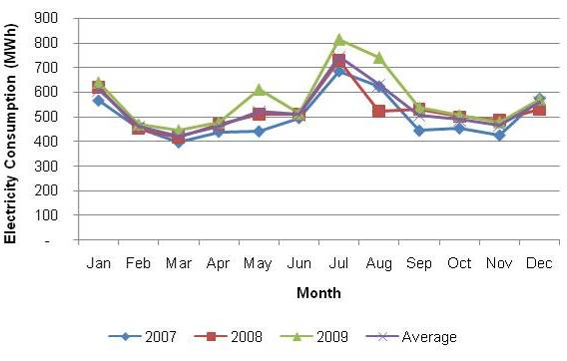
Figure 3.5: Monthly Electricity Consumption in the Residential Sector
As shown in Figure 3.5, electricity consumptions sharply vary along the year, mainly due to the changes in both the occupation rate of houses and the climate variation, which has an influence between summer and winter. Analyzed in the forthcoming paragraphs, the influence of climate on electricity consumption is not very strong, indicating that electricity is not much used for heating purposes (the contribution of air conditioners in Žabljak can be neglected). On the other hand, the influence of second houses is very strong. Such contribution is evident in the summer period, in particular July and August, and in December. The energy consumption by end uses in this sector was estimated through the following approach:
- energy consumption for first houses was assessed on the basis of data received, interviews, national and international benchmark values;
- the obtained values for electricity consumption was then compared with the registered electricity consumption data, and an indication of the second houses contribution was carried out;
- a further evaluation of second houses contribution was worked out comparing its monthly trends with registered monthly overnights in hotels;
- a more likely contribution of second houses was carried out comparing the results of the second and third item, with some adjustments. For instance, the assumption of the occupation rate in second houses following the trend of registered total overnights was modified by considering only national tourist overnights (since second houses owners are mostly Montenegrin and Serbian);
- consumption in second houses and first houses were finally adjusted to fit within the recorded electricity consumption data, and typical occupation rates and presences in second houses were estimated;
- from the obtained occupation rates, the non-electric energy consumptions in second houses were estimated.
In the following sub-sections, the outcomes of the analysis are presented.

Residential Sector (Residents)
It was assumed that the number of living units occupied all year long corresponds to the officially recorded number, which is 1,152 with an average occupation rate of 3.56 people per unit.
The average internal surface was estimated to be 70 m². Table 3.6 summarizes the main parameters of residents’ houses used for the analysis.
Table 3.6: Features of Residential Housing in Žabljak
Total Population | 4,204
No. of Households | 1,152
Average Floor Area of Residential Buildings | 70 m²
Average Number of Inhabitants per Household | 3.56

The analysis estimated the total annual energy consumption in the residential sector to be around 30 GWh/y. In accordance with the number of households in the Municipality (Table 3.6), the average annual energy consumption per household is about 26 MWh in Žabljak (equivalent to 7.1 MWh per capita). The energy sources used to satisfy the energy demand for households in Žabljak are electricity, wood, lignite and LPG. The energy consumption of residential sector by end-uses is generally divided into five categories: space heating, hot water production, cooking, domestic appliances and lighting. The breakdown of energy consumption based on the end uses in the residential sector in Žabljak is illustrated in Figure 3.6.
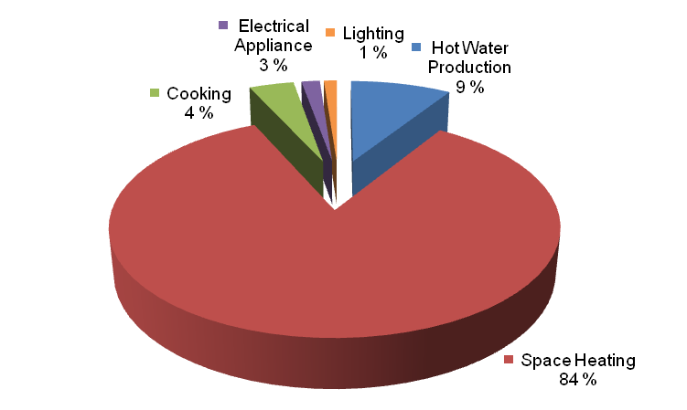
Figure 3.6: Energy End Uses Breakdown in Residents’ Houses
Space heating is the dominant energy end use in the residential sector of Žabljak, and accounts for nearly 84% of the total energy consumption in the residential sector in 2009. It is followed by hot water production, which contributes with about 9%. The contribution of the electrical appliances, cooking and lighting in the residential sector is 3%, ~4% and 1%, respectively.
Firewood is the main energy source in this sector, since it satisfies most of the space heating demand (also part of the demand for cooking and hot water production during the heating season).
The second key energy source is electricity, which is used for hot water production, space heating, cooking, domestic appliances and lighting. The total annual electricity consumption in the residential sector is found to be around 5.1 GWh in Žabljak, which is equivalent to 4.5 MWh per household. Figure 3.7 shows the breakdown of electricity consumption by end-uses in the residential sector. The high use of electricity for thermal uses (in particular hot water production, cooking and space heating, accounting all together nearly to 75% of electricity uses) represents the most important possibility of increasing energy efficiency, since the shift to other sources (biomass and solar for heating and hot water production, LPG for cooking) can strongly reduce primary energy use and therefore the GHG emissions.

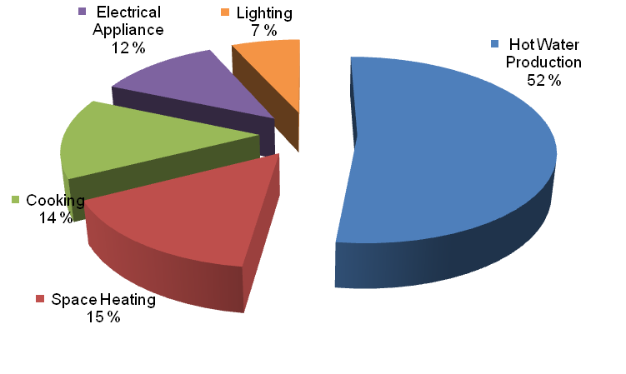
Figure 3.7: Breakdown of Electricity Consumption in Households – 2009
Hot water production is the dominant electricity end use in the residential sector and accounts for nearly 52% of the total electricity consumption. It is followed by space heating, which accounts for 15%. The third dominant consumer of electricity in the households is cooking, which contributes to 14%. It was estimated that 12% of the electricity consumption is used for domestic appliances, whereas the remaining 7% of electricity is consumed by lighting.
The following sub-sections provide the estimation for each of the end uses of energy consumption in the residential sector of Žabljak.
Energy Consumption for Space Heating
Space heating is the end use requiring the highest share of energy in the residential sector. The way in which houses are heated was discussed with the staff of the Urban Planning Sector of the Municipality, and the sector was further investigated through interviews with residents and the evaluations of the building stock. Heating in the residential sector is satisfied by wood, lignite, LPG and electricity. Single stoves are the most common space heating sources. The stove is generally installed in the kitchen or in the living room. The single stove system is mainly fuelled by firewood and in some cases by lignite. Many households also use electrical heaters for heating other rooms in the house. A small fraction of households has a centralized heating system, with a single heat generator (a special stove or a boiler) heating many rooms through radiators and heat distribution lines. These systems typically work with firewood or LPG. A small portion uses electricity for the year long.
It was assumed that only 5% of the households using wood as the main heating source has a centralized boiler or stove and radiator heat distribution system. The consumption of lignite is clearly detectable due to its typical smell in the air, but interviews with the Municipal staff and with local citizens indicated that its use is not widespread. Thus, its contribution is quantified as 10% of the total. LPG boilers are not much diffused, but they can be easily detected by the fuel cylinders around. It was assumed that LPG and liquid fuels satisfies about 10% of the demand.
In the absence of registered official data upon fuel at local level, the energy consumption was estimated starting from the wood use in houses with individual stove, as summarized in Table 3.7.
Table 3.7: Evaluation of Household Energy Demand for Heating
 | Value | Source
Yearly Firewood Consumption | 12 m³ | Municipality
Wood Density | 440 kg/m² | The bulk density of wood is between 350 and 500 kg/m², the average was assumed
Wood Heating Value | 15 MJ/kg | Source: http://bioenergy.ornl.gov/papers/misc/energy_conv.html
Energy Consumption per Household | 23,000 KWh/y | Calculated from the above data, adding 5 % from electrical energy source
Energy Consumption per Square Meter | 327 kWh/ m²y | Assumption: Surface Area : 70 m²
Overall System Efficiency | 65 % | Typical value for traditional equipment
Energy Demand per Square Meter | 216 kWh/m²y | Assumption:  Surface Area : 70 m²  Overall Efficiency: 65 %

A yearly average consumption of 12 m³ firewood per year per household was estimated. An average density of wood 440 kg/m² and a heating value of 15 MJ/kg (4.2 kWh/kg) were considered and an average stove efficiency of 65% was assumed.
Beside the households that use traditional single stoves for space heating, it is estimated that the main heating fuels (wood and lignite) supply around 95% of the heating needs and the remaining is satisfied by electric heaters. Back up electrical heaters are generally not used in households with radiator systems, due to the poor heat distribution allowed by single stoves.
Starting from the calculated energy demand value and assuming it as a benchmark of the demand of all buildings independently from their heating plants, the consumption of the other heating fuels was estimated, as reported in Table 3.8. The assumed efficiency of heating plants was 65% for lignite (stoves is similar with different use). For LPG boilers an efficiency of 85% was assumed, whereas for wood boiler systems an efficiency of 80% was considered.
The total energy consumption for space heating in the residential sector is estimated to be around 25.1 GWh/y.

Table 3.8: Space Heating Energy Use in the Residential Sector
 | Solid Fuel Stove, Using Wood | Solid Fuel Stove, Using Lignite | LPG Boiler and Radiators | Wood Boiler and Radiators
Diffusion among Households | 76 % | 10 % | 10 % | 4 %
Energy Sources  - Fuel as Indicated  - Electricity | 95 %  5 % | 95 %  5 % | 100 % | 100 %
Efficiency of Heating System | 65 % | 65 % | 85 % | 80 %
Average Fuel Consumption | 5.3 t/y | 6.7 t/y | 1.3 t/y | 4.5 t/y
Energy Consumption per Household | 23 MWh/y | 23 MWh/y | 18 MWh/y | 19 MWh/y

Figure 3.8 illustrates the distribution of energy sources for space heating in the residential sector in Žabljak in 2009. Wood is the dominant energy source used for space heating in the residential sector in Žabljak and accounts for 79% of the total energy consumption for space heating. The total annual firewood consumption for both space heating and cooking in the residential sector is about 11,000 m³.
The second mostly used fuel is lignite, satisfying 10% of the total energy consumption. LPG and electricity contribute to 8% and 3% of the total energy consumption for space heating in the residential sector, respectively.
It must be noted that the average annual registered firewood production within the Municipality was in the range of 2,518 m³/y to 6,429 m³/y between 2003 and 2008 (MONSTAT, 2009), whereas the annual wood consumption for space heating in the residential sector of the Municipality is about 11,000 m³/y. This indicates that a large part of the wood used is either imported or not registered.
Figure 3.8: Breakdown of Energy Consumption for Space Heating
in the Residential Sector
Energy Consumption for Hot Water Production
Almost all the households in Žabljak use electric boilers for domestic hot water production. Although some houses are equipped with centralized heating systems that could also produce hot water from wood or LPG, there is no building with a long hot water distribution system. Electric boilers close to taps, in bathrooms and kitchens, are much diffused also in buildings equipped with radiators and large centralized boilers (e.g.: hotels MB and Javor). Therefore, it was assumed that 100% of the households in Žabljak produces hot water from electricity. The overall energy consumption for hot water production in the residential sector of Žabljak is estimated based on the parameters listed in Table 3.9: .
Table 3.9: Assumed Parameters for Hot Water Production in the Residential Sector
Cold Water Temperature | 5 ºC
Hot Water Temperature | 50 ºC
Daily Hot Water Consumption per Capita | 30 L
Efficiency of Electric Boiler (Including Thermal Losses in Distribution) | 90 %
Based on these parameters, the annual energy consumption for hot water production in the residential sector of Žabljak is estimated to be around 2.7 GWh.
Energy Consumption for Cooking
The overall energy consumption for cooking was assumed to be around 4% of the total energy consumption in the residential sector of Žabljak. The total energy consumption for cooking in the residential sector of Žabljak was therefore estimated to be around 1.2 GWh/y. In the absence of benchmark values for Montenegro, this assumption was benchmarked with values of Italy in year 1999. It was decided not to compare it with more recent data, since the past Italian situation was considered better matching with that of Žabljak nowadays. At that time, energy consumption in the residential sector for cooking in Italy was estimated at 1,901 kTOE at national level (ENEA, 2001), thus at 385 kWh/y per capita. Using this value for Žabljak, the result would be around 1.4 MWh/y per household, thus about 1.6 GWh/y. Considering the typical different lifestyles between Italy and Montenegro, the estimated value was considered to be reliable. The energy consumption for cooking in the residential sector of Žabljak is mostly satisfied by electricity, but a relevant fraction of families uses the wood stove for cooking during the winter. Considering the long period when stoves are used, the fraction of energy from wood in the sector (included into the amount used for heating) was estimated to be around 40%. Figure 3.9 illustrates the breakdown of energy consumption by energy sources for cooking in the residential sector.
Figure 3.9: Breakdown of Energy Consumption for Cooking
This implies that in winter almost half of the demand is satisfied by wood stoves and in summer only electric ones are used.
Thus, different values of specific consumption, both for electricity and wood, have been calculated for the two periods of the year, assuming a conversion efficiency of 65% for wood stoves and 90% for electric ones.
Energy Consumption in Lighting
The distribution of lamps in the residential sector of Žabljak was assumed to be 90% conventional incandescence lamps and 10% energy efficient lamps, i.e. compact fluorescent lamps (CFL) and/or linear fluorescent tubes. CFL produce the same amounts of lights using five to seven times less energy. Traditional fluorescent tubes are however not much suitable for illumination in houses, and CFLs suffer voltage drops and grid instability. These are the reasons why such lamps are not that diffused, beside a lack of knowledge on their benefits in terms of energy savings. The total annual energy consumption for lighting in the residential sector in Žabljak is estimated to be around 345.6 MWh, which is equivalent to 300 kWh per household.
Split of Electricity Consumption between First and Second Houses and Energy Consumption for Domestic Appliances
Domestic appliances energy needs are completely satisfied by electricity. The typical domestic appliances used in the residential sector include fridge/freezer, Personal Computer, router, modem, washing machine, dishwashing machine, television, DVD/video player, Hi-Fi, iron and electric oven. As each appliance has different rated power and different operating hours throughout the year, the annual energy consumption of each device is different. Furthermore, the type and number of domestic appliances owned by each household is variable.
Assuming the electricity consumption values estimated in the previously listed end uses, domestic appliances are the only parameter that can be varied in the analysis for separating first and second houses contribution. The split was done by assuming that the second houses occupation rate roughly follows the trend of overnights of national tourists into hotels. Table 3.10 and Figure 3.10: show the data used. Data of overnights were provided by the Ministry of Tourism of Montenegro on June 2010.

Table 3.10: Electricity Consumption and Tourist Overnights (2008-2009)
Month | Monthly Electricity Consumption (MWh) | Monthly No. of Tourists Staying Overnights
January | 629 | 9,224
February | 461 | 1,592
March | 432 | 1,094
April | 474 | 462
May | 561 | 3,217
June | 513 | 1,845
July | 772 | 5,327
August | 631 | 5,919
September | 535 | 2,615
October | 504 | 1,574
November | 483 | 49
December | 551 | 779

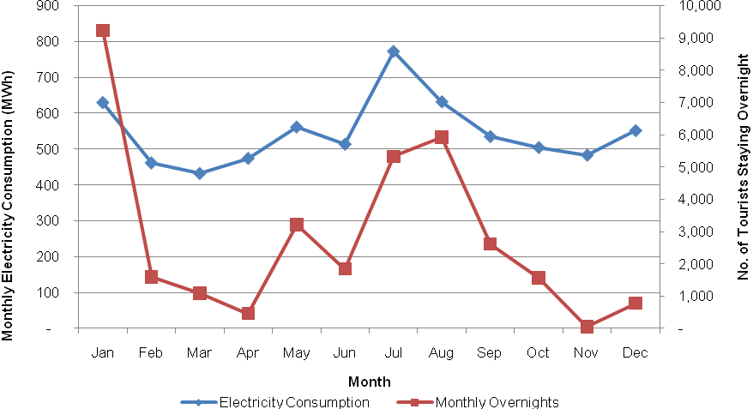
Figure 3.10: Electricity Consumption and Tourist Overnights – 2008-2009
Figure 3.10 shows the good correlation between the two trends, with very limited exceptions. This corroborates the approach used for the estimation.
The split between the contributions of first houses was done by dividing the period with heating off, assumed to be between the 1st of June and the 30th of September (a total of 122 days) and the period with heating switched on, between the 1st of October and the 31st of May (a total of 243 days).
In summer, consumption of residents should remain constant over the whole period. Thus, attributing the variations of summer monthly consumption in the sector only to second houses, it is possible to identify the contributions of first and second houses. The separation was done considering the months of June and July, assuming that second houses consumption is proportional to registered national tourists overnights in these two months. With this assumption, the average monthly consumption of first houses was determined.
The summary of the calculation is reported in the following Table 3.11.
Table 3.11: Calculation of First Houses Summer Consumption
Total Electricity Consumption in June | kWh/month | 513,291
Total Electricity Consumption in July | kWh/month | 772,152
Difference of Electricity Consumption between June and July | kWh/month | 258,861
Consumption Second Houses in July (Assumed as Proportional to National overnights) | kWh/month | 396,043
Consumption Second House in June (Assumed as Proportional to National overnights) | kWh/month | 137,182
Consumption First Houses (Assumed as Constant in Both Months) | kWh/month | 376,109
Daily Consumption per First House (Summer) | kWh/day | 10.88

The obtained value per household, 10.88 kWh/day, comprehends all electric uses.
The same approach was used for the winter period, considering January and February as reference months, and obtaining a value of 12.33 (the difference is due to electric heating consumptions). The following Table 3.12 summarizes the figures of the winter scenario.
Table 3.12: Calculation of First Houses Winter Consumption
Total Electricity Consumption in February | kWh/month | 461,143
Total Electricity Consumption in January | kWh/month | 629,318
Difference of Electricity Consumption between January and February | kWh/month | 168,175
Consumption Second Houses in January (Assumed as Proportional to National overnights) | kWh/month | 203,258
Consumption Second House in February (Assumed as Proportional to National overnights) | kWh/month | 35,083
Consumption First Houses (Assumed as Constant in Both Months) | kWh/month | 426,060
Daily Consumption per First House (Winter) | kWh/day | 12.33

Among electric households, a tentative evaluation of diffusion percentage among households of the most important appliances was done in order to assess the likely changes of consumption trend up to year 2020 in the baseline scenario, without energy efficiency interventions and introducing energy efficient equipment within Section 4. The average energy consumption of domestic appliances was defined by taking into consideration the domestic appliances used in Italy in the late 1990s (ENEA, 2001), prior to the drastic increase of efficiency on the new domestic appliances following the introduction of energy labeling of the most common domestic appliances.
Table 3.13 illustrates the diffusion rate of domestic appliances. Consumption for domestic appliances does not vary significantly along the year, therefore it was assumed constant along winter months.
Table 3.13: Diffusion and Consumption of Domestic Appliances
Type of Household Appliance | Energy Consumption per Single Appliance (kWh/year) | Diffusion in Žabljak (2009)  (%) | Electricity Consumption per Household in Italy (1999) (kWh/year) | Electricity Consumption per Household in Žabljak (2009) (kWh/year)
Fridge/freezer | 508 | 75 % | 498 | 381
Washing machine | 313 | 62 % | 275 | 194
Dish washing machine | 500 | 1 % | 175 | 3
TV | 219 | 90 % | 219 | 197
DVD/video player | 183 | 15 % | 95 | 27
Hi-Fi | 173 | 15 % | 95 | 26
PC and Devices | 455 | 5 % | 91 | 23
Iron machine | 167 | 85 % | 150 | 142
Electric Oven | 200 | 55% | 100 | 110
Other | 550 | 8 % | 110 | 44
Total |  |  | 1,808 | 1,146

The values of summer and winter daily consumption previously evaluated have been compared with the sum of all the single contributions: the domestic appliances, the heating system (in winter), the hot water system and the lighting appliances. The two values were comparable (12.33 – 14.08 for winter and 10.88 – 12.55 for summer), so that the final consumptions assumed are a middle way value estimated introducing a correction factor of 90%.
Therefore, the previous calculations were corrected taking into account thus factor, giving a final value of 12.68 kWh and 11.30 kWh, respectively for daily winter and summer energy consumption.
GHG Emissions in First Houses
The total annual energy consumption in the first houses is estimated to be around 30 GWh.
Table 3.14 and Figure 3.7 show the summary of energy consumption for end uses in the residential sector. Wood is by far the most important energy source (accounting for 67%), whereas electricity is the second (accounting for 18%). Lignite and LPG contribute to the total consumption for 8% and 7%, respectively.

Table 3.14: Summary of Energy Use of First Houses (MWh/y)
 | Electricity | Wood | Lignite | LPG | Total
Hot Water Production | 2,676 | - | - | - | 2,676
Space Heating | 789 | 19,763 | 2,549 | 2,052 | 25,153
Cooking | 720 | 480 | - | - | 1,199
Electrical Appliances | 605 | - | - | - | 605
Lighting | 346 | - | - | - | 346
Total | 5,136 | 20,243 | 2,549 | 2,052 | 29,979

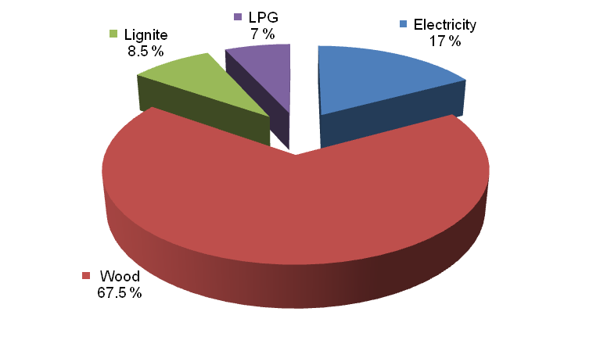
Figure 3.11: Energy Breakdown by Source, First Houses
The overall annual GHG emissions in the residential sector of Žabljak, were estimated to be around 7.3 ktCO₂e, as illustrated in the following Table 3.15.
Table 3.15: Summary of GHG Emissions for First Houses (tCO₂/y)
 | Electricity | Wood | Lignite | LPG | Total
Hot Water Production | 3,067 | - | - | - | 3,067
Space Heating | 905 | - | 927 | 466 | 2,297
Cooking | 825 | - | - | - | 825
Electrical Appliances | 693 | - | - | - | 693
Lighting | 396 | - | - | - | 396
Total | 5,886 | - | 927 | 466 | 7,279

By far, space heating and hot water production are the largest sources of GHG emissions, accounting for 32 % and 42 %, respectively. Due to the large use of firewood, the emissions caused by space heating are significantly lower than its incidence on the overall energy consumption.
The breakdowns of GHG emissions in terms of sources and end uses in the residential sector are illustrated in Figure 3.12 and Figure 3.13: .
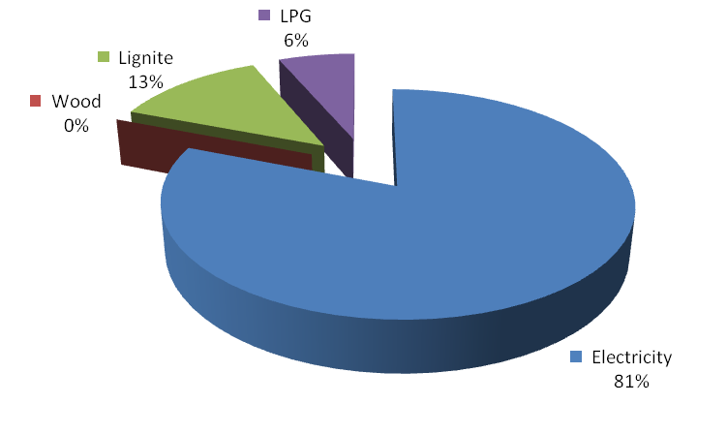
Figure 3.12: Breakdown of GHG Emissions by Source, First Houses

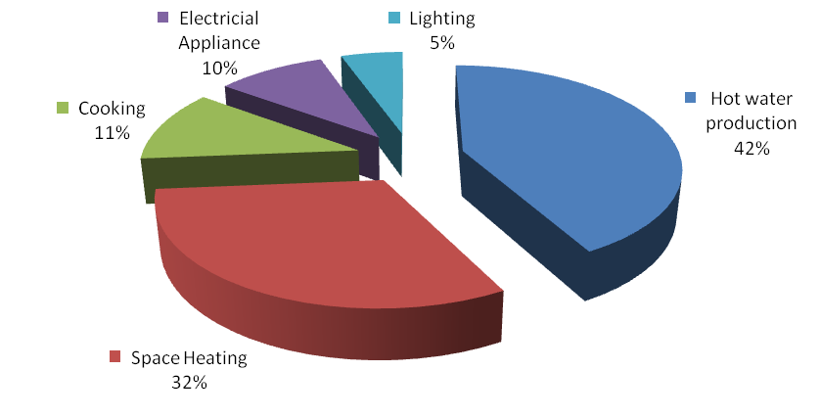
Figure 3.13: Breakdown of GHG Emissions by End Uses in First Houses – 2009

Estimation of Energy Consumptions and GHG Emissions in Second Houses
The estimation of the energy consumption in second houses was carried out by considering some different parameters with respect to first houses:
- heating systems of the second houses were considered to run 30% on wood, 30% on LPG and 40% on electricity. It was noticed that many of the new houses do not have chimneys. Therefore, it was considered that if they are used in winter, they must use electricity;
- a correction factor with respect to first houses was introduced in order to justify the second houses higher consumptions. In particular, the heating plant must heat the whole structure before the internal environment reaches a comfortable temperature. Once the house is empty, this energy is slowly wasted towards the environment. The same thing occurs to the electric hot water boiler. Also electric appliances use more energy, partly due to the higher level of life standard of the owners and partly to the fact that some appliances consume electricity, even when nobody occupies the house (e.g.: the fridge). Thus, a correction factor of 1.2 was adopted for space heating, hot water production, electric appliances and lighting;
- hot water consumption per tourist was assumed to be around 50 liters per day;
- three people is assumed as the average number of people staying in a second house.
Table 3.16 compares the daily electricity consumption of first and second houses, considering, for the latter, the above listed assumptions and correction factors.
Table 3.16: Daily Electricity Consumption of First and Second Houses
Season | Electricity Consumption per Household  Residents  (kWh/year) | Electricity Consumption per Household  2nd House  (kWh/year)
Winter | 12.68 | 45.2
Summer | 11.30 | 11.9
On this basis, the total number of overnights was estimated to be around 217,000 during summer and 36,000 in the remaining months. The total of these numbers is nearly 253,000 overnights per year, extremely high with respect to the overnights registered in commercial structures, indicating a huge tourist grey market.
It must be highlighted that the assumptions upon electric consumption in second houses is considered very high, so that the evaluated overnights are probably underestimated.
Considering the number of overnights and the total number of second houses of about 3,000 units, the average occupation rate per house remains, anyway, pretty low, around 28 days per year per household.
Considering these numbers of overnights and the assumptions, it is possible to estimate consumption of all other uses and energy sources in the second houses sector.
Under the assumptions outlined above, energy consumption in second houses was estimated to be around 1.4 GWh/y. The breakdown of annual energy consumption in second houses is illustrated in Figure 3.14: .

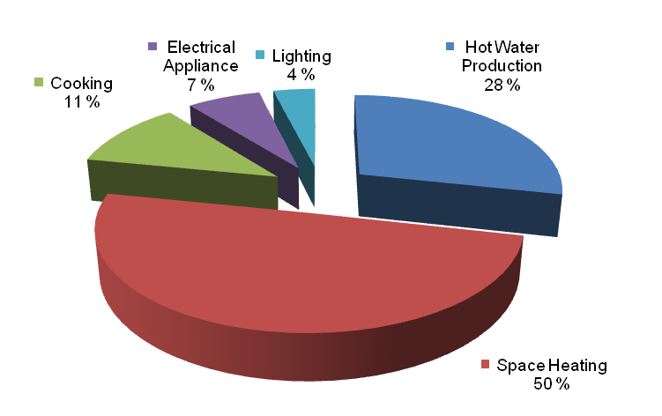
Figure 3.14: Breakdown of Energy Consumption in Second Houses – 2009
The dominant energy consumption end use in second houses is space heating, which accounts for 50% of the overall annual energy consumption. Domestic hot water production is responsible for 28% of the total annual energy consumption in the second houses. Domestic appliances and cooking contribute respectively for 7% and 11% to the total energy consumption. The energy used for lighting is only 4%. By comparing the breakdowns of energy consumption in end uses between the first houses and the second houses, it is noted that the contribution of annual energy consumption for space heating in the second houses is much lower than in the first houses, which is mainly because the second houses are mostly occupied during summer, when heating is not needed.
The annual GHG emissions of the second houses is determined based on the annual energy consumption and the corresponding GHG emission factor of the energy sources used within the sector (Table 3.5). The total annual GHG emissions in the second houses are estimated to be around 1.7 ktCO₂e. The breakdown of GHG emissions in end uses is illustrated in Figure 3.15: .
It is noted that domestic hot water production is the dominant source of GHG emissions in second houses, accounting for 41% of the total emissions. Space heating is the second key GHG emissions source in the second houses, accounting for 31% of the total emissions. Lower contributions are given by cooking (12%), electrical appliances (10%) and lighting (6%).

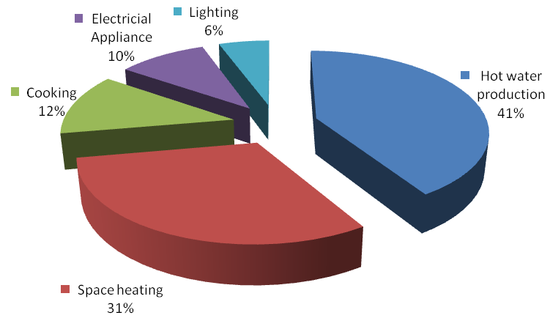
Figure 3.15: Breakdown of GHG Emissions in Second Houses

Tourism Sector
Consumption data for hotels and restaurants are provided only for the electricity consumption. Differently from the residential sector, the consumption in tourism is relatively independent of the number of overnights but heavily dependent on climate. Figure 3.16: shows the consumption in this sector between 2007 and 2009. Due to the broad variability of the features and dimensions of the facilities in this field, the analysis was done starting with a fitting procedure, considering that the monthly consumption is constituted by three parts namely, a) constant, b) linearly dependent on temperature and c) linearly dependent on presences. In this way, it is possible to separate the consumption in one part approximately proportional to the number of beds, and the other proportional to the overnights, and to evaluate also electricity contribution to heating.
Figure 3.17: shows the fit done using the following formula to estimate consumption along the year in the sector:
C(m) = b + a₁T(m)+ a₂ o(m)
where:
- C(m) is the consumption in month;
- m, b is the constant value;
- a₁ is the climatic coefficient;
- T(m) is the monthly average temperature in the month;
- m, a₂ is the coefficient of occupation;
- o(m) are the registered overnights in the month m.
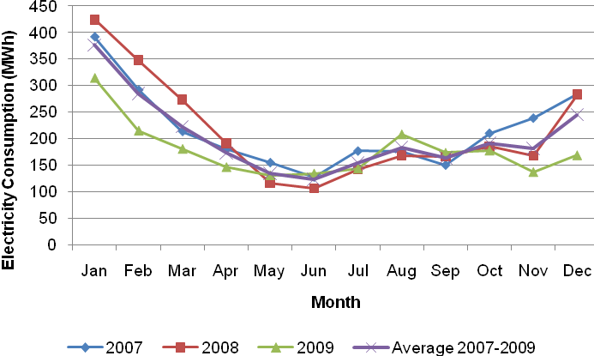
Figure 3.16: Electricity Consumption in the Tourist Sector
The monthly number of overnights and the number of hotel beds in the Municipality (825 at present) was provided by the Ministry of Tourism of Montenegro, and is reported in Table 3.17.
The coefficients were evaluated as:
- Constant Value, b: 208,138 kWh/y;
- Temperature Coefficient, a₁: -11,151 kWh/y °C;
- Overnights Coefficient, a₂: 10.0 kWh/overnight.
The constant fraction of monthly consumption and the part related to temperature depend on the size of facilities, which can be assumed as proportional to the number of beds. In the following, it is called “structural contribution”. It takes into account the amount of energy that must be spent to run the structures independently of the number of guests.
The part depending on the tourists presence, given by the overnights coefficient multiplied the number of overnights, leads to a small contribution to the total electric consumption.
Table 3.18 shows the split at monthly level. It is worth noticing that the contribution due to the actual use of beds is low, slightly below 23% of the total. This is partly due to the low occupation (the ratio between actual overnights and maximum possible overnights, at yearly level is the total number of beds multiplied by 365 days), which is around 18.4% in the considered period.
From this evaluation, it can be easily understood that increasing the structures’ occupation rates is the best way to reduce the specific energy consumption of the sector.
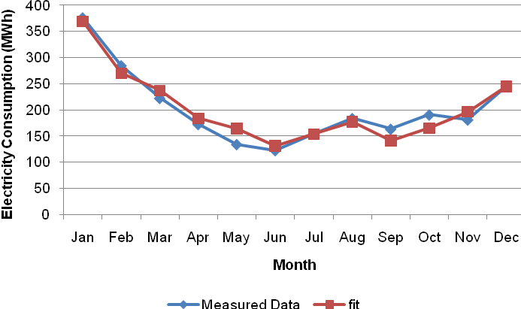
Figure 3.17: Average Measured and Fitted Data on Electricity Consumption
Table 3.17: Total Overnights in Žabljak, 2007-2009
Month | 2007 | 2008 | 2009 | Average 2007-2009
January | 10,967 | 15,730 | 6,482 | 11,060
February | 2,006 | 2,741 | 1,312 | 2,019
March | 1,392 | 2,601 | 1,049 | 1,680
April | 971 | 637 | 1,218 | 942
May | 5,865 | 4,781 | 4,104 | 4,916
June | 8,215 | 3,332 | 5,068 | 5,538
July | 14,130 | 7,470 | 8,453 | 10,017
August | 16,171 | 8,942 | 10,665 | 11,926
September | 4,408 | 3,096 | 6,140 | 4,548
October | 1,714 | 772 | 3,378 | 1,954
November | 234 | 172 | 67 | 157
December | 144 | 1,281 | 823 | 749
Total | 66,217 | 51,555 | 48,759 | 55,510

A good indicator for assessing the consumption of the sector is the total consumption per bed. This value is, on a yearly basis, around 3,000 kWh per bed.
The fraction of total sector consumption related to heating can be estimated considering the yearly variation of the structural consumption. The lowest structural electricity consumption is in July (see Table 3.18). This part, about 53,000 kWh/month, can be considered as the monthly structure electricity use, independent of the season. The remaining part of structural consumption is due to the seasonal variations.
The electricity use for heating purposes can be estimated on an annual basis by subtracting the structural consumption of July (supposing that no energy is used for heating in July) to the other months. It results that about 50% of consumption is related to the temperature variations.
Table 3.18: Split of Energy Use between Structural and Overnights Contribution
Month | Average  Overnights  (2007-2009) | Average Temperature  (°C) | Average Energy Contribution, Fit (kWh/y) | Structural  Contribution  (kWh/y) | Contribution Due to Overnights  (kWh/y)
January | 11,060 | -4.51 | 369,061 | 258,394 | 110,667
February | 2,020 | -3.74 | 270,092 | 249,882 | 20,209
March | 1,681 | -1.07 | 236,851 | 220,033 | 16,817
April | 942 | 3.03 | 183,738 | 174,312 | 9,426
May | 4,917 | 8.37 | 163,999 | 114,801 | 49,198
June | 5,538 | 11.86 | 131,264 | 75,845 | 55,418
July | 10,018 | 13.87 | 153,745 | 53,505 | 100,240
August | 11,926 | 13.48 | 177,115 | 57,780 | 119,336
September | 4,548 | 10.09 | 141,129 | 95,620 | 45,509
October | 1,955 | 5.62 | 165,064 | 145,504 | 19,559
November | 158 | 1.18 | 196,557 | 194,980 | 1,578
December | 749 | -2.61 | 244,779 | 237,281 | 7,498
Total | 55,510 | 4.63 | 2,433,393 | 1,877,938 | 555,455

This value is very high, even considering that all the visited hotels have a centralized heating plant running on LPG or liquid fossil fuels (heating oil or mazut). Electricity use for heating must therefore be originated by the many small structures, like bars, restaurants and offices/kiosks in Žabljak.
Accurate measurements of energy consumption in some hotels showed that about 50% of the primary energy came from electricity and 50% came from the heating fuels. Assuming the same hypothesis applied to the whole sector in Žabljak, it is obtained, on average, a value of 2,400 MWh/y from electricity and 2,400 MWh/y from fossil fuels. In this way, about 3,600 MWh/y (75% of the total) would be used for heating purposes and 1,200 (consisting only of electricity) for other end uses.
It was observed that the most recent hotels have heating plants running on LPG, whereas the older facilities mostly use mazut. It was assumed that the share of fuels is 50% among the total fuel consumption.
Assuming that all the climate-related energy consumption is dependent on the structure and not on the overnights, the following specific consumptions were evaluated at yearly level:
- Structural specific electric consumption per bed: 2,276.29 kWh/(y);
- Overnight dependent electric consumption: 10.0 kWh/overnight;
- Structural fuel consumption per bed (mazut): 1,474.8 kWh/(y);
- Structural fuel consumption per bed (LPG): 1,474.8 kWh/(y).

GHG Emissions for the Tourism Sector
As stated above, the energy consumption in the tourist sector is related to 50% electricity and 50% fossil fuels (50% mazut and 50% LPG). Under these assumptions and using the GHG emission factors listed in Table 3.5, the emissions caused by the tourism sector are around 3,400 tCO₂e. Table 3.19 shows the split of sources. Electricity is the main source of GHG emissions.
Table 3.19: Electricity Consumption Split in Tourist Structures
Energy Sources | Energy Consumption (MWh/y) | GHG Emissions (tCO₂e/y) | Breakdown of Total GHG Emissions (%)
Electricity | 2,400 | 2,800 | 82 %
Mazut | 1,200 | 340 | 10 %
LPG | 1,200 | 280 | 8 %
Total | 4,800 | 3,420 | 100 %

Public Sector
The energy consumption of the public sector includes public lighting and public facilities (health care center, schools, municipal buildings and administrative building). The evaluation of the energy consumption pattern in the public sector is mainly based on the received data of the electricity consumption in the public sector from EPCG and the energy consumption of particular institutional settlements, including Žabljak health center, Dusan Obradovic Primary School, Training center with public institution/mixed school “17 September”, 21 Municipal buildings, and the administrative offices of the National Park Durmitor obtained through questionnaires. According to the collected data, the common energy sources used to satisfy the energy demand in this sector include electricity, fuel oil and LPG.

Energy Consumption for Public Lighting
During the meetings with the Public Utility (PU), it was reported that two types of lamp are mainly used for street lighting, namely Philips HPL-N-125/542-E27 and Osram HW (MBFT) 125-E27, both mercury vapor lamps with an average wattage of 125 W. The total number of lamps installed for public lighting was 415 in 2009, which are under the management of the PU. The public lighting systems are connected to three-phase 0.4 kV to the power grid at four points.
The operating hours of public lighting in Žabljak are different in summer and winter. The daily operation in summer (between May and October) is 8 hours per day, whereas the daily operation in winter (between November and April) is 14 hours per day. Some of the lamps are equipped with photocell switches, where lamps would switch on/off depending on the light condition, whereas the remaining lamps are equipped with timer. None of the lamps for street lighting is equipped with flow reducers, in order to reduce the light intensity during late night hours.
The total average annual energy consumption of public lighting is 109 MWh in the Municipality of Žabljak in year 2009, in accordance with the questionnaire filled by EPCG. However, if the annual operating factor of public lighting is 100%, the annual energy consumption for public lighting can be estimated of the order of 207 MWh, by taking into account 415 lamps with an average wattage of 125 W are operating 14 hours per day during winter and 8 hours per day during summer. The annual operating factor of public lighting is found to be around 59% within the Municipality. This is mainly due to the relatively short life span of the lamps for public lighting, i.e. around 45 days. According to the PU of Žabljak, 30% of lamps for public lighting has to be replaced every 15 days. The cause of this high replacement rate of lamps for public lighting could be mainly related to the voltage instability of the grid and the frequent damage of lamps by the citizens.

Energy Consumption of the Institutional Facilities
In Žabljak, the institutional facilities consist of health care centers, schools, municipal buildings, administration offices, utilities, recreation centers, police stations, etc. The common energy sources used in this sector are electricity, fuel oil and LPG.
Electricity is the dominant energy used to satisfy the energy demand of the institutional facilities in Žabljak ( Figure 3.18). The total electricity consumption for institutional facilities is about 1.5 GWh in 2009, according to the questionnaire provided by EPCG.

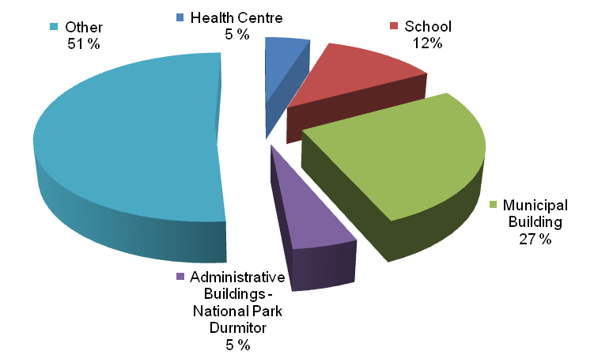
Figure 3.18: Breakdown of Electricity Demand in Institutional Facilities – 2009
During the preparation of this document, an energy consumption survey was conducted for several institutional facilities, including the Dusan Obradovic primary school, the Žabljak health center, the training center with public institution/mixed school “17 September”, several municipal buildings and the administrative offices of National Park Durmitor, in order to determine the current energy consumption pattern among the institutional facilities of the Municipality.
The data collected through the survey are used as a model for the evaluation of the current energy consumption pattern of the institutional facilities of Žabljak, thus assuming that all institutional facilities in Žabljak follow the same energy consumption pattern as the facilities covered in the survey.
The electricity consumption of the public facilities covered in the survey represents around 49% of the total electricity consumption provided by EPCG, and the remaining 51% of electricity is used in other municipal facilities including utilities such as water supply system, police stations, recreational centers, municipal offices, other schools, etc.

Žabljak Health Care Center
According to the energy consumption data provided by the Center’s Management, the total annual energy consumption of the Žabljak Health Care Center is about 284 MWh. The dominant energy source used in Žabljak Health Care Center is fuel oil, which accounts for nearly 75% of the total annual energy consumption and it is assumed to cover the entire space heating demand of the facility. The total annual fuel oil consumption is 21,000 l, which is equivalent to 212 MWh. The remaining 25% of energy demand is met by electricity; the electricity consumption is 72 MWh, which accounts for 5% of the total annual electricity consumption of public facilities in the Municipality. The Žabljak Health Care Center uses electricity and fuel oil to satisfy its energy demand, whereas electricity is mainly used for lighting and electrical appliances including computers, refrigerators, television, medical devices and hot water production during summer. The health care center is equipped with fuel oil boiler and a radiator based system, which is used for space heating and hot water during the heating seasons.
The breakdown of energy consumption of the Health Center is illustrated in Figure 3.19.
Figure 3.19: Breakdown of Annual Energy Consumption in the Žabljak Health Care Center – 2009
The assumption of a 75-25% energy split in end uses is considered reasonable, if compared with the data regarding the residential sector, where the values are 84-16%.
For this reason, such energy breakdown is assumed as starting hypothesis also in the calculation of the other municipal buildings.
Schools
The evaluation of energy consumption of schools is based on the data collected from the Dusan Obradovic primary school and the training center with public institution/mixed secondary school “17 September”.
The energy sources used in both schools are electricity and LPG. In general, electricity is used for lighting, electrical equipment, domestic hot water production and small portions of space heating; whereas LPG is mainly used for space heating, cooking, and hot water production during heating seasons.
The total annual electricity consumption of both schools was 181 MWh in 2009, which accounts for 12% of the total electricity consumption among the institutional facilities in the Municipality. The energy demand of space heating in both schools was met by electricity until 2007. LPG heating system for space heating and cooking was introduced in the training center with public institution/ mixed secondary school “17 September” in 2008, and the Dusan Obradovic primary school also started using LPG heating system since 2009, according to the questionnaire.
The total energy consumption in both schools is about 375 MWh. LPG was the dominant energy source in 2009, which accounts for 52% of the total energy consumption. The remaining 48% energy demand was met by electricity.
It is noted that the total electricity consumption in schools was decreasing after the introduction of the LPG heating system in 2008. The total energy consumption was further decreased to 375 MWh in 2009 (from 417 MWh in 2007) when more LPG heating systems were used in schools. Figure 3.20 illustrates the trend of annual energy consumption of both schools between 2007 and 2009.

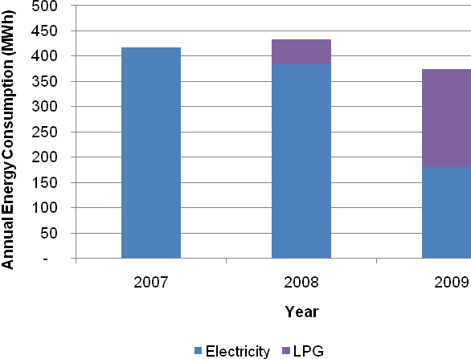
Figure 3.20: Annual Energy Consumption in the Schools – 2009-2020
Municipal Buildings
The evaluation of energy consumption pattern in the municipal buildings is carried out in accordance with the energy consumption data collected from 19 municipal buildings in Žabljak (12 old and 7 new buildings).
The average annual operating hours of the municipal buildings is around 2,080 hours. All the energy demand, including space heating, hot water production, electrical equipment and lighting in the municipal buildings is satisfied by electricity. Most of the municipal buildings are equipped with electric hot water boiler with radiator systems. The total annual electricity consumption in municipal buildings is 392 MWh, as shown in Figure 3.21.

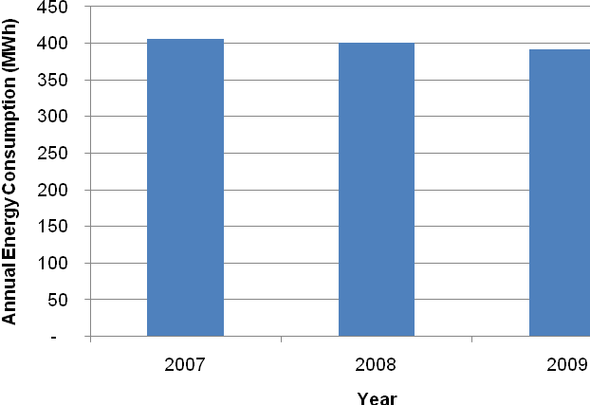
Figure 3.21: Annual Energy Consumption in the Municipal Buildings
2007-2009
It is noted that the total annual electricity consumption was decreasing slightly from 406 MWh in year 2007 to 392 MWh in year 2009.

Administrative Office in the National Park Durmitor
The administrative office in National Park Durmitor consists of six offices, a souvenir shop, a library, and an exhibition room, with 2,120 yearly operating hours on average. Electricity is the only source of energy used in the administrative offices, which meets the needs of space heating, electrical equipment and lighting. It is noted that the administrative office is equipped with centralized space heating system. The annual energy consumption of the administrative offices is 73 MWh, corresponding to 83 tCO₂e/y of GHG emissions.

Other Public Facilities
The only information available about the public facilities not covered by the survey is the global electricity consumption.
For these buildings the energy breakdown has been built starting from the data collected and presented for the previous buildings. From these hypothesis the energy consumptions of fuel oil and LPG have been deduced, and they account respectively for 225 and 204 MWh/y.

GHG Emissions in the Public Sector
The GHG emissions of the public sector are estimated on the basis of the data collected through the evaluated energy consumptions and on the available emission factors (Table 3.5).
The GHG emissions in the public sector include both public lighting and institutional buildings and are mainly due to the consumptions of electricity, fuel oil and LPG. According to the calculations, it is estimated that the total annual GHG emissions in the public sector are about 2.6 ktCO₂e.
The breakdown of GHG emission in public sector by energy sources is shown in Figure 3.22.
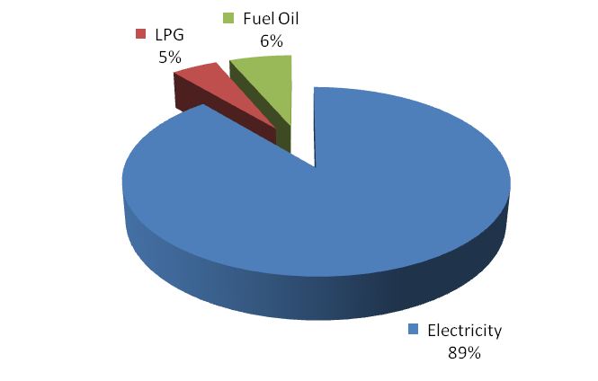
Figure 3.22: Breakdown of GHG Emissions in the Public Sector – 2009
Electricity is the dominant source of GHG emissions in the public sector, accounting for 89% of the total. The share of fuel oil and LPG of total GHG emissions in the public sector is relatively low (6% and 5% respectively).

Commercial Sector
The commercial sector consists of offices, wholesale businesses, retail stores, and other service enterprises. A number of 28 wholesale, retail trade and motor vehicles companies, and eight real estate companies were registered in the Municipality in Žabljak in 2008 (MONSTAT, 2009). In general, energy in the commercial sector is mainly used for heating, ventilation and air conditioning (HVAC), water heating, lighting and electrical appliances, such as refrigeration and computers.
The average temperature in summer in Žabljak is below 20°C, therefore it is assumed that HVAC systems are not used in the Municipality.
In general, electricity is used for the electrical components including lighting, computers, refrigerators, etc. Furthermore, electric hot water boilers are largely predominant in the Municipality. Although some large buildings are equipped with centralized heating systems that could also produce hot water from fuel oil, it was noticed that no building is equipped with a well structured hot water distribution system. Electric boilers close to tap are diffused also in buildings equipped with radiators and large centralized boilers (i.e.: hotels MB and Javor). It was therefore assumed that 100% of the hot water is generated through electric boilers in the commercial sector.
As for the space heating in the commercial sector, the breakdown of energy consumption by energy sources was not available. During the interviews with the personnel from the Urban Planning Sector of the Municipality, it was found that electricity, fuel oil and wood are used for space heating within the Municipality. According to the consultations, it was assumed that the breakdown of energy consumption in the commercial sector is: 70% electricity, 20% wood and 10% fuel oil.
According to the available data, the average annual electricity consumption in the commercial sector between 2007 and 2009 was found to be 0.73 GWh.
The seasonal fluctuation of electricity consumption in the commercial sector is illustrated in Figure 3.23.
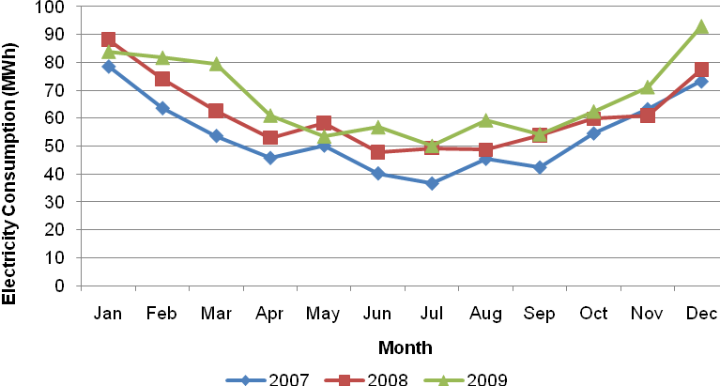
Figure 3.23: Monthly Electricity Consumption in the Commercial Sector – 2007-2009
As shown in Figure 3.23, the electricity consumption in the commercial sector varies throughout the year, with the lowest values between June and September. In general, the electricity consumption for hot water production and the uses of other electrical components such as lighting, refrigeration, computers, etc. (about 50 MWh in our case) is constant throughout the year. Therefore, the additional electricity consumption between October and May is assumed to be used for space heating, which is in compliance with the assumption of the period with heating on between the 1st of October and the 31st of May.
The overall annual energy consumption in the commercial sector of Žabljak was estimated to be around 1.2 GWh in 2009.
The total average annual electricity consumption for all other applications (except space heating) is estimated to be around 584 MWh, whereas the total average annual consumption of electricity, wood, and fuel oils for space heating are 145 MWh, 208 MWh and 104 MWh, respectively. Therefore, the total annual consumptions of wood and fuel oil for space heating are 251 MWh and 145 MWh, respectively.
Figure 3.24 illustrates the breakdown of energy consumption by energy sources in the commercial sector of Žabljak in 2009.

GHG Emissions of the Commercial Sector
The GHG emissions of the commercial sector in the Municipality of Žabljak is mainly due to the use of electricity and fuel oil. The total annual GHG emissions of the commercial sector is about 956 tCO₂e. The breakdown of GHG emissions in the commercial sector of Žabljak is illustrated in Figure 3.25: . Electricity is the dominant source of GHG emissions (97% of the total). The remaining 3% of GHG emissions is due to the consumption of fuel oil.
Figure 3.24: Breakdown of Energy Consumption in the Commercial Sector – 2009
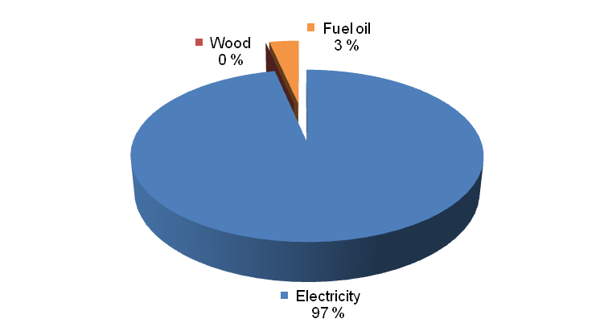
Figure 3.25: Breakdown of GHG Emissions of the Commercial Sector
by Energy Sources – 2009

Industrial Sector
The industrial sector consists of small sized facilities and a large sawmill in Njegovuđa. The total number of registered manufacturing establishments in Žabljak was 22 by the end of 2008 (MONSTAT, 2009). Data upon monthly electricity consumption in the industry sector of 2007, 2008 and 2009 were received by EPCG on June 2010. These data reveal a very low consumption during winter months, around 2,000 kWh/month, increasing to about 11,000 kWh/month in summer, when sawmills are operating. To these values, an estimation of the unregistered connections (around 100 MWh/y) was added, and the total was reduced by 17%, to take into account that energy consumption refers to both Šavnik and Žabljak.
Apart from sawmills, there are not many other relevant activities. As most of thermal energy used in sawmills is recovered by burning wood waste, it was decided to exclude these (unknown) amounts of energy from the calculations and to consider that 90% of the energy used comes from electricity, whereas the remaining 10% is from fuel oil. Under these assumptions, energy consumption and emissions from this sector were calculated as reported in Table 3.20.
Table 3.20: Electricity Consumption Split in the Industrial Sector
Energy Source | Contribution to the Total Consumption | Energy Used (MWh/y) | GHG Emissions (tCO₂e/y)
Electricity | 90 % | 173 | 198
Mazut | 10 % | 19 | 5
Total | 100 % | 192 | 203

Transportation
The analysis of the energy consumption from transportation, and of the related GHG emissions, is one of the most delicate issues within this document. Accurate data are needed for fuels, distances, means of transport, uses, etc.
Up to date, the only way to reach Žabljak is by car using the road through Šavnik or Kolašin – Mojkovac, with a travel time from Podgorica of about three hours in summer.
No bus connection from the airports of Podgorica or Tivat is operating, while the railway is too far (in Mojkovac) to serve Žabljak.
Road transport is the only field to assess: it is almost impossible to assign a share of contribution to the Municipality starting from the air traffic recorded in the national airports of Podgorica and Tivat.
The specific mountain position of the Municipality makes the assessment of the transport related emissions easier than for municipalities rising along transit roads. Žabljak is not located along a specific road crossing Montenegro and going abroad, so it can be reasonably assumed that the transit traffic is quite low and every car/truck traveling inside the boundaries is actually related to some local business.
The inter-municipal connections are, up to date, guaranteed by the Regional Road R5, going from Đurđeviča Tara through Žabljak and Šavnik to Niksic.
The inter-municipal link has recently been strengthened by the realization of the 140 km road Risan-Žabljak, wanted by the Government to enhance the connection between the coastal and the mountainous areas.
At present, the privately owned car is the main mean of transport which is used to move from one place to another within the Municipality, and this is also the case for the access to the area from the outside. Cars and, to a much lesser extent, taxis and buses, are the mainstay of Žabljak mobility, both for residents and for tourists.
International connections from/to Belgrade are used by about 15 passengers per day in tourist seasons, while during the rest of the year are from one to three tickets per day.
Žabljak is characterized by low urban traffic conditions, i.e. reduced number of daily transfers, in accordance with the very low population density. The main actors in traffic are cars, buses and a few heavy trucks, mainly destined to the local supply operations. Besides the typical daily traffic, a further contribution is due to the tourists reaching the Municipality.
Data come from the following sources:
- the energy consumptions at national level collected from the 2006 National Energy Strategy for Development;
- fuel sales records at the municipal fuel station;
- distances between locations calculated during the surveys;
- the traffic conditions of the Municipality were deduced from registered documents, (L. Berger, 2001);
- the emission factors for the vehicles and the heating values of the fuels were taken from the WRI’s guide of the GHG Protocol and from the DEFRA inventory (DEFRA, 2008; WRI, 2005);
- other data assumptions based on interviews with the municipal staff, the team’s experience and reliable forecasts.
The conversion of traffic data (km or fuel consumption) into CO₂ emissions was based on emission factors’ database enclosed in DEFRA report, which covers an European dataset on vehicles comparable to the Montenegrin situation.
A baseline scenario was identified considering the current traffic situation of the Municipality in year 2010. Following the approach suggested by the GHG Protocol and DEFRA, the emission factors for the means of transport and heating values for the fuels were combined in order to calculate the resulting CO₂e emissions.
Relevant data on fuel consumption were collected by interviewing the municipal staff. The yearly amount of fuel sold at the gas station amounted to approximately 965,000 l. When the fuel consumption is available, the emissions are usually calculated following the “Fuel-based method”, which consists in multiplying the EF of each fuel (kgCO₂e/l) for the amount of fuel used. When fuel consumption is not available, the “Distance-based method” can be applied, consisting in multiplying the EF of the fuels (kgCO₂e/km) for the distance traveled by each vehicle.
However, some important uncertainties need to be carefully evaluated:
- the split between diesel and unleaded fuel is unknown; only the total value is available; it was assigned 42% to gasoline and 58% to diesel;
- the composition of the fleet (either cars or vans or buses or motorcycles or trucks) is unknown;
- the share of consumption of each category of vehicles is not available;
- the available studies on traffic data including records of vehicles’ passages along the main national road do not cover all the routes;
- the contribution of transit traffic, although low, can only be estimated.
On the basis of a similar scenario, some assumptions are needed for a reliable evaluation. The values used for the calculation suggested by the above mentioned methodology are illustrated in Table 3.21.

Table 3.21: Data Assumptions for Transport GHG Emissions
Parameter | Unit | Value
Emission Factor - Car | kgCO₂/km | 0.204
Emission Factor - Var | kgCO₂/km | 0.266
Emission Factor – Rigid Truck | kgCO₂/ton-km | 0.276
Emission Factor - Bus | kgCO₂/passenger-km | 0.069
Emission Factor Petrol/Gasoline | kgCO₂/GJ | 69.25
Emission Factor Diesel | kgCO₂/GJ | 74.01
Heating Value Gasoline | GJ/L | 0.0344
Heating Value Diesel | GJ/L | 0.0371
Share of Gasoline | % | 42
Share of Diesel | % | 58
Distance Žabljak - Đurđeviča Tara | km | 18
Distance Žabljak - Virak | km | 5
Conversion Factor GJ/GWh | GWh/GJ | 0.000278

Road Transport
The estimation on the traffic conditions in Žabljak was carried out considering data collections from surveys provided by Luis Berger Study from 2002. An analysis on car passages was realized measuring the annual average daily vehicular traffic along the main national roads.
These accurate data were used to estimate a projection on the current traffic conditions, combining them with data from the national inventory. The study contained data on the annual fuel consumption for road transport for the overall Montenegro and forecast for the annual average vehicular traffic for year 2010; the national inventory contained data on the annual energy consumption for road transport and it was possible to convert them into fuel consumption, according to the share of diesel and gasoline presented in Table 3.21. In this way, a comparison between the forecasts and the real situation has been produced, thus getting a coefficient which allowed projecting the specific data sample for the two roads to the current year. This coefficient is the ratio between the real data and Luis Berger’s forecasts and its value is 1.49. Applying this coefficient to the sample, the annual average daily vehicular traffic for the current situation was estimated for the two roads.
According to the available data and to the assumptions, the estimation of energy consumption and CO₂e emissions was possible considering the several contributions given to road traffic by internal traffic, buses, heavy trucks and tourist transportation.
For the vehicular traffic related to cars, vans, trucks and buses, it was possible to estimate the annual average daily traffic conditions along the main extra-urban roads connecting Žabljak with the rest of the country, properly combining data sampling with the energy consumption of the national strategy. The routes considered for the sampling were Đurđeviča Tara – Žabljak and Žabljak – Virak. This estimation allowed to calculate the total GHG emissions due to buses, trucks, urban transport and tourists.
These data confirm that cars are the most common vehicles, around 60%; the contribution of trucks is low, since the Municipality is not set along a busy transit road and therefore the only trucks are directly related to the local business.

Buses
The estimation made for the buses is based on the national statistics for road transportation: getting from the statistics the national amount of “passenger-kilometer” and the national “kilometer traveled”, the data were projected at local scale considering the ratio between the population of Žabljak and the population of Montenegro. Once obtained the “passenger-kilometer” data on Žabljak, the yearly CO₂e emissions were calculated applying the DEFRA emission factor for buses, which is expressed in kgCO₂/passenger-kilometer. This approach allowed calculating overall emissions equal to 68 tCO₂e/y. The assumptions and the figures of the calculation are enclosed in Table 3.22.
Table 3.22: Annual GHG Emissions for Buses
National Population | 620,145
Žabljak Population | 4,204
National Passengers-km | 146,000,000
Žabljak Passengers-km | 989,700
Emissions | 67,900 kgCO₂e/y

Trucks
The same approach used for buses was adopted for the estimation of the emissions related to trucks. The relevant data in this case were “ton-kilometer”. This approach allowed calculating overall emissions equal to 256 tCO₂e/y. The assumptions and the figures of the calculation are enclosed in Table 3.23.
Table 3.23: Annual GHG Emissions for Trucks
National ton-km | 137,058,000
Žabljak ton-km | 2,198,825
Emissions | 256,500 kgCO₂e/y

Urban Transport
Everyday local inhabitants have to move inside the Municipality for private obligations: work, shopping, etc. A high number of trips take place for small routes all the year long; considering an average number of 1,000 trips per day, of which 90% by car and 10% by motorcycle, and an average route of 15 km per round trip, every year the urban transport is responsible for 1,060 tCO₂e.

Tourists Transport
Currently, the impact of tourism on traffic is still low since the annual number of presences in Žabljak is approximately 225,500 overnight stays. This value includes the recorded stays at hotels (55,500 on three-year average) and an estimation of presences in second houses and room rentals based on electricity consumption (about 200,000).
They are mainly weekend tourists, but the estimated future scenarios say that an increase in the number of presences is expected by 10 years. This will impact, besides the urban development and the infrastructure system of the town, also on the environment with an increase of the GHG emissions.
The current situation was assessed considering urban and extra-urban contribution: this aims at distinguishing the round trip to get to Žabljak and the local transport inside the Municipality, from the hotels/houses to the tourist attractions.
The evaluation of the GHG emissions related to the tourism flow was carried out on yearly basis. The average stay of tourists within Žabljak is around 2.69 days and the yearly overnight stays are 225,510 (average of the last three years). These values were considered for the evaluation of the number of tourists per day getting to the Municipality: an average daily number of 230 tourists resulted from the calculation.
The assumptions for the calculation of the tourist impact on CO₂ emissions are summarized in Table 3.24. It was assumed that the average round trip distance traveled to reach Žabljak is 150 km. The modal mix for extra-urban transportation was assumed to be 15% by bus and 85% by car.
The consumptions and the related emissions for the extra-urban transport can be accounted, therefore, only for the going and the return trip, but not for the days of stay in Žabljak. Whereas the emissions for the movements inside the Municipality are calculated based on the number of overnights. According to the “Distance-based” approach, the trend shows that for the whole season the extra-urban transport will be responsible for 730 tCO₂e/y and the local transport for 245 tCO₂e/y.
Table 3.24: Data Assumption for Tourists’ Traffic Emission
Parameter | Unit | Value
Yearly Overnight Stays |  | 225,510
Average Overnight Staying | nights/capita | 2.69
Average No. of People | people/day | 230
Average Route from Outside | km | 150
Average Local Route | km | 20
Share of People by Car from Outside | % | 85
Share of People by Bus from Outside | % | 15
Share of People by Car Locally | % | 80
Share of People by Foot/Bicycle Locally | % | 20
Car Occupation | people/car | 3
Bus Occupation | people/bus | 50
Once they are in Žabljak, tourists have to get to the points of interest, moving either by car or by foot/bicycle. 80% of them will use private car (3 people/car) to get to their destinations (National Park, Ski Center, etc.) with an average round trip of 20 km. Using the “Distance-Based” approach, it was calculated that they are responsible for 245 tCO₂e emissions every year.

Outcomes
The assessment revealed that the local road transport can be considered responsible for more than 65% of the total transport emissions. The contribution given by trucks and buses is low, since transit traffic should not be considered. The calculated emissions are the net contribution the Municipality is responsible for. Only contributions destined to the local business, either everyday obligations or tourism, plus buses, trucks, urban transport and the tourist transportation concur in the analysis. Deducting buses, trucks, urban transport and tourists emissions from the total road transport account, it was possible to isolate the transit contribution, which resulted to be approximately 480 tCO₂e/y. Table 3.25 resumes the vehicular traffic emissions calculated according to the above mentioned assumptions.
Table 3.25: GHG Emissions for Vehicular Traffic – 2009
Vehicular Traffic | Unit | Emissions
Transit | tCO₂e/y | 480
Buses | tCO₂e/y | 68
Trucks | tCO₂e/y | 255
Urban Transport | tCO₂e/y | 1,065
Tourists | tCO₂e/y | 975
The results of the calculation show that vehicular transport can be considered responsible of 2,360 tCO₂e/y. This is the net amount of CO₂ emissions excluding the transit traffic.
The reliability of the estimation on GHG emission is confirmed by a test-calculation based on the fuel sales. According to the interviews with the local operators of the fuel station, the fuel sales can be roughly estimated equal to 80,000 l/month, on the average, corresponding to 960,000 l/year. The related CO₂e emissions can be calculated according to the share of diesel and gasoline (58% and 42%, respectively) and to their emission factors. This calculation led to yearly emissions equal to 2,490 tCO₂e/y.
The contribution given by the tourist traffic on the municipal GHG emissions is around 40 % on yearly average, but this contribution is expected to grow in the next ten year according to the figures on tourism development of the area. Figure 3.26: illustrates the incidence of transport sectors on GHG emissions, including transit traffic. Figure 3.27: illustrates the net contributions of transport sectors, excluding the transit traffic share.
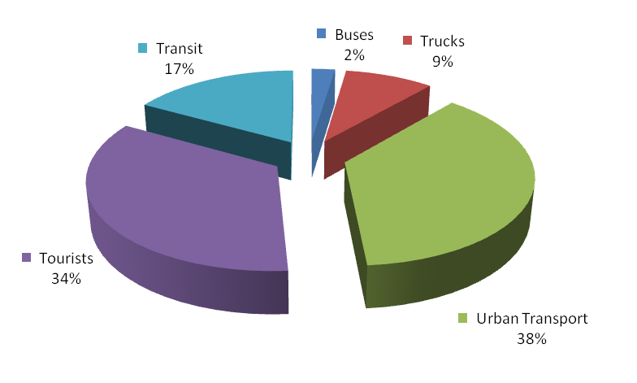
Figure 3.26: Influence of Transport Sectors on GHG Emissions, with Transit – 2009

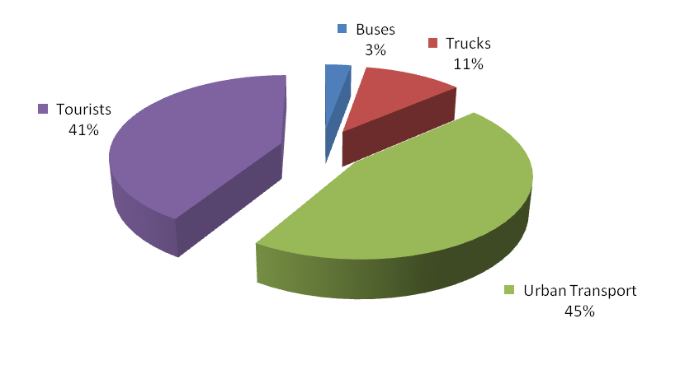
Figure 3.27: Influence of Transport Sectors on GHG Emissions – 2009

BASELINE EMISSIONS INVENTORY RESULTS
In the following Table 3.26, the annual energy consumption and the related GHG emissions for each sector above described are summarized; the Baseline Emissions Inventory developed according to the SEAP template is presented in Appendix 2.
As shown in the Table 3.26, the Municipality of Žabljak used around 50 GWh in 2009 with an equivalent GHG emissions volume of 18 ktCO₂; a majority consistent share of the energy (42%) was supplied by biomass mainly used for domestic heating and by the electric power which is largely used (23%) in all the sectors as shown in Figure 3.28: . It must also be noted that all the demand of the transport sector is met by fossil fuels (diesel and gasoline) as well as little part of the heating energy demand that is fulfilled by heating oil.
Table 3.26: Baseline Energy Consumption and GHG Emissions – 2009
Category | Energy Consumption
Category | [MWh/y]
Category | Electricity | Liquid Gas | Heating Oil | Diesel | Gasoline | Lignite | Biomass | Sector Total
First Houses | 5,136 | 2,052 | 0 | 0 | 0 | 2,549 | 20,243 | 29,979
Second Houses | 1,411 | 374 | 0 | 0 | 0 | 0 | 362 | 2,148
Residential | 6,547 | 2,426 | 0 | 0 | 0 | 2,549 | 20,605 | 32,127
Tourism | 2,433 | 1,217 | 1,217 | 0 | 0 | 0 | 0 | 4,867
Public | 1,585 | 397 | 437 | 0 | 0 | 0 | 0 | 2,419
Industry | 173 | 0 | 19 | 0 | 0 | 0 | 0 | 192
Commercial | 806 | 0 | 115 | 0 | 0 | 0 | 230 | 1,152
Transport | 0 | 0 | 0 | 5,147 | 3,983 | 0 | 0 | 9,130
Total | 11,545 | 3,835 | 1,563 | 5,147 | 3,983 | 2,549 | 20,836 | 49,458

Category | GHG Emissions
Category | [tCO₂e/y]
Category | Electricity | Liquid Gas | Heating Oil | Diesel | Gasoline | Lignite | Biomass | Sector Total
First Houses | 5,890 | 466 | 0 | 0 | 0 | 927 | 0 | 7,283
Second Houses | 1,617 | 85 | 0 | 0 | 0 | 0 | 0 | 1,702
Residential | 7,507 | 551 | 0 | 0 | 0 | 927 | 0 | 8,985
Tourism | 2,790 | 275 | 340 | 0 | 0 | 0 | 0 | 3,405
Public | 1,815 | 45 | 60 | 0 | 0 | 0 | 0 | 1,920
Industry | 198 | 0 | 5 | 0 | 0 | 0 | 0 | 203
Commercial | 925 | 0 | 32 | 0 | 0 | 0 | 0 | 957
Transport | 0 | 0 | 0 | 1,370 | 993 | 0 | 0 | 2,363
Total | 13,235 | 871 | 437 | 1,37 | 993 | 927 | 0 | 17,833

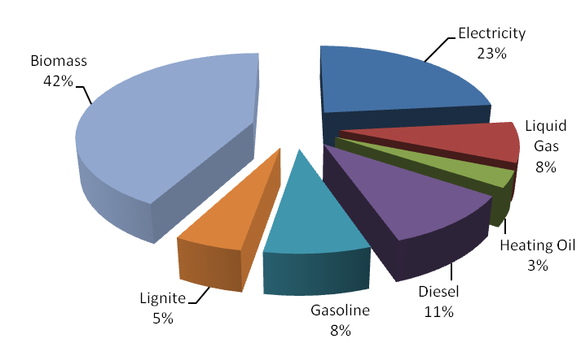
Figure 3.28: Energy Sources Contribution to the Baseline Scenario Energy Consumption – 2009

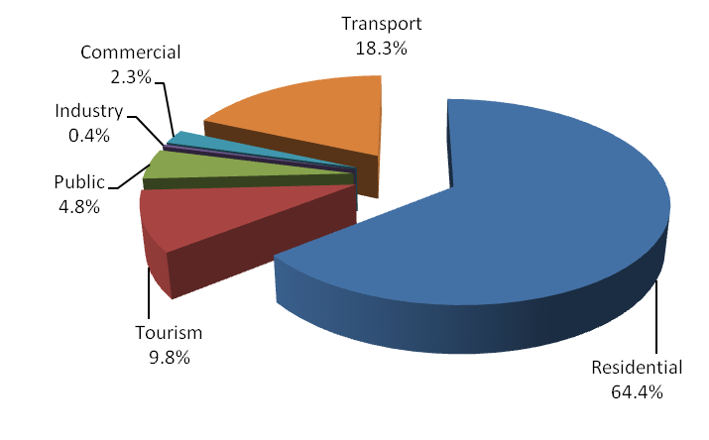
Figure 3.29: Final Uses Contribution to the Baseline Scenario Energy Consumption –2009
As shown in Figure 3.29: , the residential sector is the main energy consumer accounting for approximately the 65% of the total energy consumption; another relevant sector is transportation, accounting for almost the 20% of the share, while smaller contributions are given by tourism (10%), public (4%) and commercial sector (2%). A negligible amount of energy, if compared with the other final uses, is requested by the industrial field.
Figure 3.31 presents the sectoral contributions to the overall GHG emissions of the Municipality; it must be noted that even if the residential sector remains the main contributor, its percentage drastically reduces of more than 15% since a relevant share is satisfied by biomass, considered carbon neutral in this plan; the residential sector percentage decrease is absorbed by the other sectors contributions, in particular by the commercial, tourism and public ones, due to the utilization of electric power and fossil fuels for energy purposes.
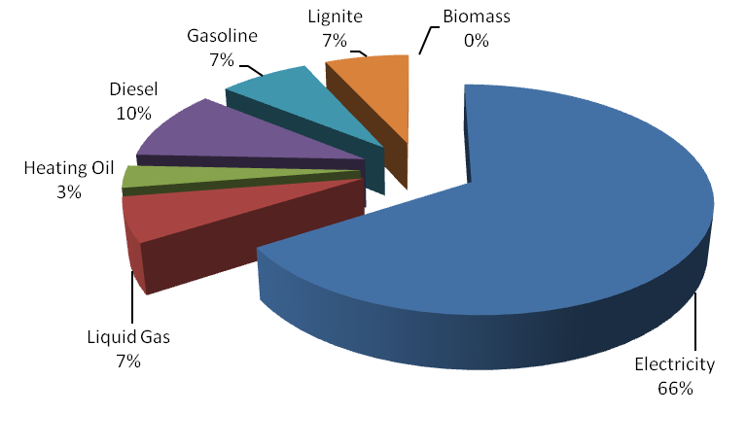
Figure 3.30: Energy Sources Contribution to the Baseline Scenario GHG Emissions – 2009
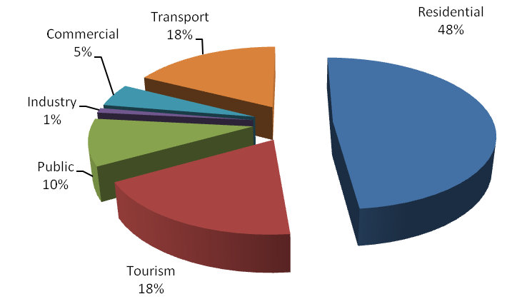
Figure 3.31: Sectoral Contribution to the Baseline Scenario GHG Emissions – 2009

PLANNED ACTIONS AND MEASURES
In this section the actions planned in order to meet the objectives and emissions reduction target set for each sector outlined in Section 2.3 are described; the description of the actions provides an estimation of the resulting CO₂ emissions reduction at municipal level in the timeframe for implementation until the 2020, where the body responsible for their implementation is the Municipality of Žabljak.
Since Žabljak is expected to evolve from the current situation in the next few years, a scenario-based approach has been chosen. This means that the actions results by 2020 are compared with a reference scenario that estimates the town situation at 2020 in case of a non-sustainable development. The Action Plan summarized according to the SEAP template is presented in Appendix 3.

RESIDENTIAL SECTOR
The actions presented are focused on the residential sector with the purpose of further enhancement of the overall energy efficiency level and promoting rational energy consumption in households. The proposed actions will significantly reduce the consumption in the residential buildings, allowing the citizens to reach energy and financial savings.
For the implementation of the proposed actions, an initial information and awareness raising campaign at municipal level is fundamental, aimed at highlighting financial benefits guaranteed by energy efficient domestic products including domestic appliances and lighting.
To evaluate the possible results of such actions, the assessment of the projections of the energy consumption along the period under investigation (2009-2020) is necessary.
On one hand, it is foreseen that the overall population in the Municipality of Žabljak will remain constant over the period between 2009 and 2020, thus the total number of households in the Municipality is likely to remain the same over that period of time. On the other hand, an increase is expected in the second houses occupation rates.
An increase in living standards has been considered, with the exception of the heating demand that has been assumed constant along the years.

Use of Solar Energy for Heat Production in Residential Buildings
The key scope of this action is to promote and disseminate the use of the solar thermal technology in the Municipality of Žabljak. It is necessary to:
- create the market for solar thermal technologies in Žabljak, including capacity building for professionals design, installation and operation of solar thermal heating systems;
- encourage the integration of solar thermal systems in the building design;
- provide easy access to information on features and advantages of individual solar thermal systems;
- introduce new financial mechanisms providing support for consumers to face the relatively high installation costs and promote the existing ones (i.e.: Montesol program).
The proposed strategy is divided into three main phases: pilot, voluntary and mandatory.
Due to the impacting interventions on the building needed for the installation of solar collectors (interventions on the roof, the hot water storage tank and long pipelines to connect the solar system with taps), such intervention makes sense only in case of construction of new buildings or large renovation works. Since such works are usually done every 20-40 years, it is expected that approximately 3% of the households stock annually faces this situation (this corresponds to the average interval of 33.3 years between renovations of the same building). Žabljak has already a very huge residential building heritage, exceeding the needs of residents and tourists, so that construction of new buildings should stop in the forthcoming years and their contribution to energy consumption should be minimal. The Action development phases are reported in Table 4.27.
Table 4.27: Phases of Solar Thermal Systems Installation in the Residential Sector
Year | Duration | Description
2011 - 2012 | 2 years | No solar thermal system will be installed in the residential sector of the Municipality
2013 - 2015 | 3 years | Promotion of investment subsidy schemes  20 % of the renovated buildings will install solar hot water heating system each year
2016 - 2020 | 5 years | Continuation of investment subsidy schemes  Further promotion of solar energy from the Government  75 % of the renovated buildings will install solar hot water heating system each year

The following assumptions are considered in order to evaluate the effectiveness of the proposed measure:
- hot water demand in the residential sector of the Municipality is currently satisfied by electric boilers;
- the population in the Municipality was around 4,200 inhabitants in 2009, and it will remain stable;
- the average daily hot water consumption is currently 30 liters per capita per day in Žabljak and will reach 40 liters per capita per day because of changes in lifestyle and improved living standards;
- for each installed solar thermal system, 75% of the overall hot water energy demand will be achieved by solar energy, the remaining (due to cloudy days, snowing days, extra hot water consumption, etc.) will be provided by the back-up (mostly electric) system;
- an investment subsidy scheme will be introduced at national level for the promotion of solar thermal systems.
The input parameters for the evaluation of this action are summarized in Table 4.28.
Table 4.28: Hot Water Consumption in the Residential Sector
Parameter | Value
No. of Inhabitants | 4,204
Water Inlet Temperature | 5°C
Water Outlet Temperature | 50°C
Hot water Consumption per Person in 2008 | 30 Liters per day
Hot water Consumption per Person in 2020 | 40 Liters per day
Collectors Daily Operating Hours | 10 hours per day
The overall annual thermal energy demand for hot water production in the residential sector of Žabljak will reach 3.6 GWh.
If this action is implemented, the penetration of solar hot water system in Žabljak will start after the introduction of investment subsidy support scheme in 2013, with an annual installation rate of 0.6% of households (that is, 20% of the annual renovation rate estimated at 3% of the number of buildings). During Phase 3 (mandatory installation), the rate will become much higher, since 75% of renovations will imply installation of solar systems. About 13% households across the Municipality will install solar hot water heating system by the end of 2020. In this way, about 10% of the hot water demand in the residential sector will be met by solar energy by the end of 2020, which is equivalent to 314 MWh/y. The remaining 90% of energy demand for hot water production would be achieved by electricity by the end of 2020, which is equivalent to 3.2 GWh/y considering that the average efficiency of the electric boiler is 90%.
The production of hot water with solar systems will reduce electric consumption and the total electricity saving from this action during the whole period will be around 1.2 GWh against the baseline projection by the end of 2020. Figure 4.32Error: Reference source not found illustrates the projected breakdown of energy consumption for hot water production in accordance with the proposed measure during 2009 – 2020.
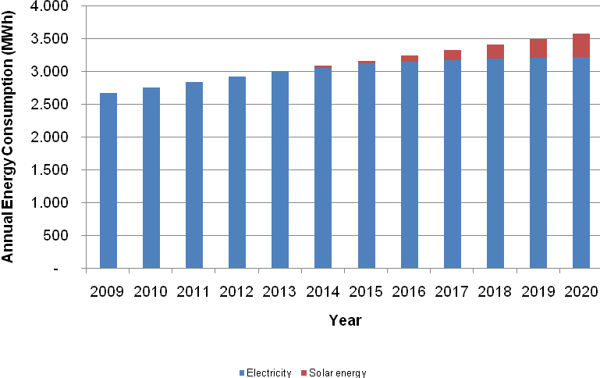
Figure 4.32: Breakdown of Consumption by Energy Sources for DHW Production
Solar energy is a renewable energy and does not cause GHG emissions. It is hence expected that the GHG emissions for hot water production in the residential sector would decrease proportionally to electricity savings. Figure 4.33Error: Reference source not found shows the comparison of annual GHG emissions for hot water production in the residential sector between the baseline projection and the proposed action.
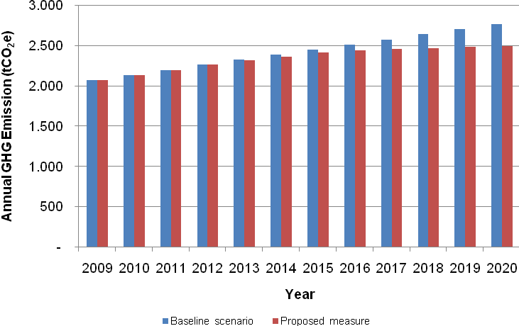
Figure 4.33: GHG Emissions for Hot Water Production
in the Residential Sector - Baseline Scenario vs. Proposed Action
The annual GHG emissions for hot water production in the residential sector are expected to be around 2.5 ktCO₂e by the end of 2020 with the presented measured, against the 2.76 ktons of the baseline projections. The total installed area of solar thermal collectors should reach about 660 m² by the end of 2020, 90 m² of which will be installed in Phase 2 (voluntary installations, between 2014 and 2016) and the rest during Phase 3 (mandatory phase). Figure 4.34: illustrates the expected total installed area of solar collectors between 2009 and 2020 in accordance with the proposed action.
The total amount of subsidies for sustaining this policy would be around 64,000 EUR over the period between 2013 and 2020.
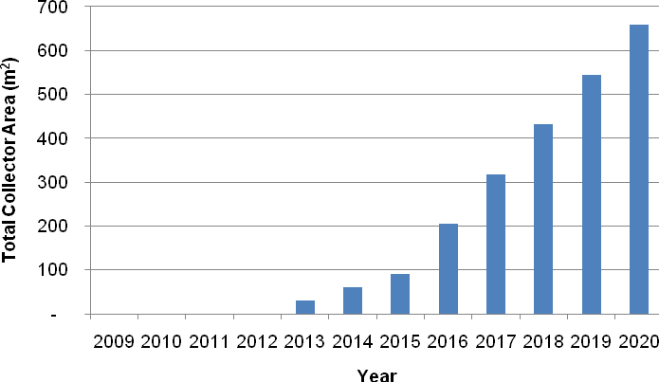
Figure 4.34: Total Installed Surface of Solar Collectors
in the Residential Sector – 2009-2020

Increase of Energy Efficiency in Heating
Space heating final energy consumptions, and the related GHG emissions, can be reduced acting both on the demand and on the supply side.
For this reason, three actions have been considered:
- improvement of buildings insulation;
- ban of lignite;
- increase of heating systems efficiency.
Due to the correlation between energy efficiency (reduction of losses) and efficient wood fuelled heating plants, the results are assessed according to the phasing shown in Table 4.29.
Table 4.29: Phasing of “Increase of Energy Efficiency in Heating” – 2012-2020
Year | Duration | Description
2012 - 2013 | 2 years | Pilot projects will be carried out in the Municipality, with the objective of promoting energy efficient wood heating system, as well as capacity building for technical personnel to develop the market. At the same time, lignite will be prohibited for space heating in the Municipality by end of 2012
2014 - 2016 | 3 years | Possible financial mechanisms introduced into for energy wood stoves system and energy efficient buildings. 20% of renovated buildings will install energy efficient wood stoves by the end of 2015, and will accomplish high standards of insulation.
2017 - 2020 | 4 years | Further promotion of energy efficient wood heating system and the financial mechanisms is pursued. 100% of renovated buildings in the Municipality will install energy efficient heating system by the end of 2020.

The following assumptions are considered in order to evaluate the effectiveness of the proposed actions:
- improved thermal insulation will reduce the specific energy demand for the renovated buildings to 50 kWh/m² year;
- automatic wood and wood chips stoves and boilers will become the major energy sources for household heating systems in the future;
- the surface of a house will remain 70 m² with constant number of residents.
The input parameters for the assessment of the proposed actions are summarized in Table 4.30.
Table 4.30: Data on Energy Demand in Renovated Residential Buildings
Parameter | Value
Specific energy demand | 50 kWh/m²
Efficiency of new heating systems | 85%
Average surface | 70 m²

One of the most effective measures for reducing energy consumption (and improving at the same time internal comfort), is to decrease the energy demand, through a better insulation of roofs, facades, basement and higher performances of glazed structures.
The ideal building design includes the following features:
- high insulation, reducing energy demand for heating of several times and allowing a much more uniform temperature distribution within the premises;
- a hot air duct or hot water radiator based heat distribution system;
- a domestic hot water system based on solar collectors, with backup supplied by the space heating system in winter and by an electric resistance in the summer;
- a mechanic ventilation system for controlled air changes with heat recovery.
The main goal is to gradually transform the buildings of Žabljak into green buildings.
The period between two large renovations of a building (of roof, facades, windows etc.) is normally in the range of 25 to 50 years. It was estimated that on a yearly basis about 3% of the building stock is renovated (thus meaning that the same building achieves full renovation every 33 years).
It was assumed that during Phase 1 no significant changes will take place. By 2013, during Phase 2, it was estimated that about 20% of renovations (3% year) will adopt energy efficient solutions, thus having an influence of about 0.6% of energy consumption, and during Phase 3 (from 2016 onwards) the effect will be on 3% on total energy consumption, i.e. on all renovations.
The gradual decrease of thermal energy demand for heating purposes (global heating demand should pass from 17.5 GWh/y to 15.2 GWh/y) brings to a corresponding reduction of the related energy consumptions and GHG emissions: this action will lead to an energy saving of almost 2.3 GWh/y and an avoided GHG emission of 300 tCO₂/y in 2020.
Even if the GHG emissions savings of this action do not seem to be relevant, it has to be considered that this kind of action gives great benefits mostly in the long term and it affects positively other actions on the supply side.
On the supply side, the first action considered is the ban of lignite.
Currently, lignite is used for space heating in the residential sector and in a few other buildings of different use. Since it is used in plants that can also run on firewood, and since most of the lignite users normally use both firewood and lignite, banning its use would not pose serious problems to the community. Banning lignite use would provide immediate benefits in pollution reduction and improve the town image with minimal economic efforts by public bodies and citizens; it is hence suggested to enact this action in the short term period. Assuming that lignite is used in the residential sector only, its substitution with carbon neutral firewood should allow the reduction of GHG emissions by about 800 tCO₂e by 2020, against the reference scenario.
Currently the majority of homes uses traditional stoves for space heating, often burning imported broadleaved wood or lignite. At the same time, large amounts of wood waste are left abandoned in forests after cutting works or in dump sites around sawmills.
The goal is to develop the use of these residual materials in substitution of normal firewood, lignite and LPG. The realization of large power plants fed by biomass does not seem to be economically feasible.
Thus, the use of building-scale technologies, run with wood pieces, briquettes, chips or pellets will be promoted. The local market already offers some good technologies suitable for residential dwellings, such as:
- kitchen stoves (also suitable for cooking), also producing hot water for space heating, running with wood pieces or briquettes;
- boilers producing hot water for space heating, running with wood pieces, with tunable power and autonomy of several hours;
- wood chips boilers, suitable for medium to large sizes, from about 30 kW thermal power up, so that their best application is in large buildings;
- pellet stoves, suitable also for small sized plants. Depending on the stove type they can work only by radiation and convection (like traditional stoves) or produce hot water or hot air for a heat distribution network, and have a typical efficiency around 90%.
Automatic wood stoves and boilers are not yet commercialized in Žabljak. Pellets and wood chips, moreover, do not have any local supply chain. The installation of these technologies requires lower technical skills in design than that of solar systems, although capabilities are required for maintenance and proper operation, as well as a well developed supply chain for spare parts and assistance. For a successful implementation of this Action, it is necessary to build the supply chain and to create a demand. Moreover, the start up of the pellet production plant in Njegovuđa (or some other pellet plant in Northern Montenegro) would significantly help a local pellet distribution chain.
The final implementation of this action will lead to GHG emissions reduction of 154 tCO₂e/y.
This action is phased as the previous one: pilot phase, voluntary phase and mandatory phase.
It was assumed that households already having a radiator heating system, using a wood or LPG boiler, were renewed in recent years, since these technologies recently came on the local market.
The following general benefits could be accomplished:
- the efficiency of a traditional wood stove is in the range of 55-70%, whereas a modern automatic equipment has efficiency values around 85%;
- in case of use of chips, the fuel can be obtained from wood waste currently abandoned in the cutting yard or produced at sawmills, with a net gain of 100% in terms of fresh firewood cutting.
The results of the actions regarding space heating are shown in Figure 4.35.

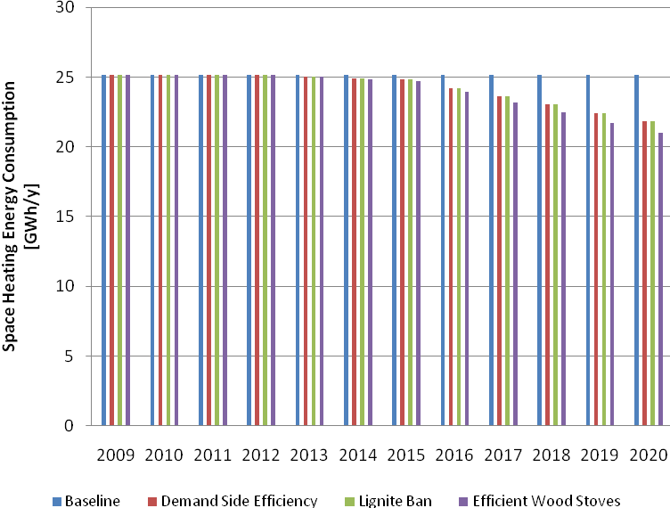
Figure 4.35: Energy Consumption for Space Heating in the Residential Sector
It can be noticed that demand side and heating systems efficiency actions will reduce GHG emissions thanks to a decrease of energy consumption, while the lignite ban will not give any energy savings, but it will be the most effective action in terms of GHG reductions (Figure 4.36).

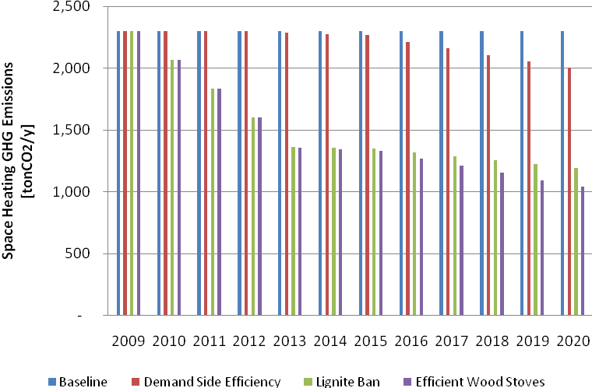
Figure 4.36: GHG Emissions for Space Heating in the Residential Sector

Use of High Efficiency Electric Equipment
It is foreseen to gradually replace the current low efficient electrical devices with new, more efficient appliances. This action will significantly reduce the consumption in the residential sector. The implementation of this action will be actually feasible only if an initial information and awareness raising campaign at municipal level is implemented. The following specific activities should be included in the campaign:
- start-up of a municipal-wide information campaign regarding the cost-effectiveness of energy efficient domestic appliances as well as on the importance of thermal insulation and proper heating and cooling systems, and integrating renewable energy sources in the residential buildings. The campaigns should be repeated on a regular basis, addressing specific target audiences including engineers, installers, students, owners and tenants;
- publication and dissemination of leaflets on energy saving topics by providing the orientation on how to choose new appliances by their energy class and further parameters, which can be distributed through specific events, electricity bills and municipal offices;
- introduction of detailed information in bills on energy expenses split, in order to allow consumers to understand how to reduce their energy consumption;
- encouraging consumers to switch from old energy inefficient domestic appliances to energy efficient products with energy label of Grade A/A+ in accordance with the EU energy labeling system through a special scheme of “Consulting citizens on energy efficiency”;
- encouraging re-sellers and consumers to pay more attention to energy efficiency labeling and to the information provided in the technical specification of products brought and sold.
Citizens would accept to replace old domestic appliances with energy efficient appliances once they understand the benefits in terms of energy and cost savings.
summarizes the target annual electricity consumption at Grade A+ level and/or the most energy efficient level for various types of domestic appliances.
Beside energy efficiency, usually Grade A+ domestic appliances have also better operational performance in respect to lower grade appliances.
Based on the results of energy labeling and related awareness raising campaign in Europe, it is expected that about 50% of the population will switch to domestic appliances with energy label of Grade A+ in accordance with the EU standards by the end of 2020.
Nevertheless, according to the EU directives including Commission Directive 2003/66/EC, Commission Directive 1999/9/EC, and Commission Directive 96/89/EC, only fridge/freezer, washing machine, and dish washing have energy label of Grade A+.

Table 4.31: Electricity Consumption of Energy Efficient Domestic Appliances
Households Appliance | Grade A – consumption (kWh/y)
Fridge/freezer | 240*
Washing machine | 220*
Dish washing machine | 230*
Television | 250
DVD/video player | 180
Hi-Fi | 170
Computer | 250
Iron | 170
Electric Oven | 300
Microwave Oven | 100
* Remark: expected Grade A+ annual electricity consumption

Based on the above factors, the installation of high efficiency domestic appliances in the residential sector is expected to develop according to Table 4.32.
Figure 4.37: illustrates the overall electricity consumption for domestic appliances for one household in accordance with the baseline scenario and the proposed action between 2009 and 2020.
According to Figure 4.37: , it can be noted that the growth of annual energy consumption for domestic appliances will slow down the projected baseline annual energy consumption upon the same time horizon. The annual energy consumption for domestic appliances will reach 0.7 GWh/y in the residential sector by the end of 2020, compared to 0.9 GWh/y in the baseline scenario. The total annual GHG emissions for domestic appliances in 2020 are envisaged to be 1,020 tCO₂e/y, with a net reduction of 65 tCO₂e/y, while compared to the baseline scenario, as shown in Figure 4.38: .
Table 4.32: Phases of Installation of Energy Efficient Domestic Appliances
Year | Duration | Description
2012 | 1 year | No Grade A+/B domestic appliances will be installed in households.  Energy Efficiency information and awareness campaign starts.
2013 - 2020 | 8 years | Introduction of Energy Labeling in Montenegro  50% of the households will have Grade B appliances by the end of 2020  50% of the households will have Grade A+ appliances by the end of 2020 due to the energy efficiency information and awareness campaign.

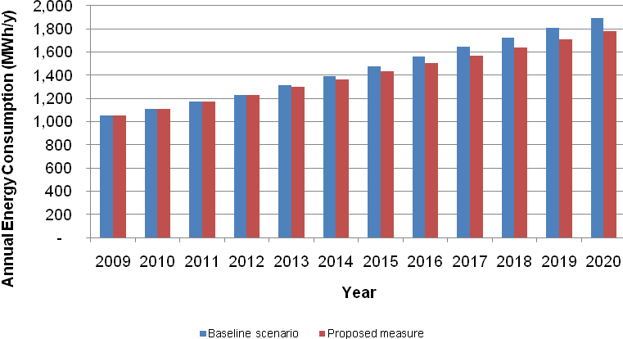
Figure 4.37: Electricity Consumption for Domestic Appliances
in the Residential Sector – 2009-2020
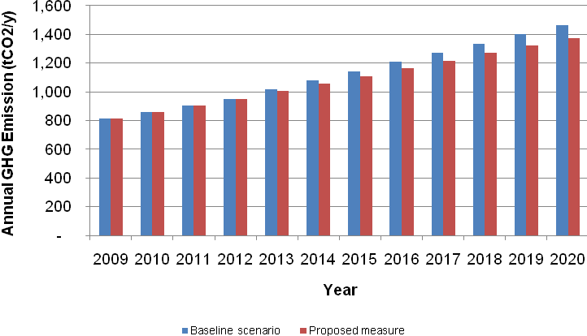
Figure 4.38: GHG Emissions for Domestic Appliances
in the Residential Sector – 2009-2020
Indoor lighting, even though representing a small share of total energy consumption, could be easily reduced with low financial impact. The diffusion of energy efficient lamps, such as CFLs, into lighting market increased due to lower prices and increase of consumers’ awareness. The rate in OECD countries in 1999 is approximately 1.5 CFL per household (Lefevre, 2006). Advancement of technology allows CFLs to replace conventional incandescence lamps with no changes in existing lighting fixtures.
It is expected that many residents in the Municipality will decide to switch from the traditional incandescence lamps to CFLs after they become aware of their economic and environmental benefits. As listed in Table 4.33, it was estimated that about 90% of lamps will be CFL by 2015.
Table 4.33: Phases of CFLs Installation in the Residential Sector – 2012-2020
Year | Duration | Description
2012 | 1 year | Approximately 4.5 % of the population will switch from incandescence lamp to CFL annually, in accordance with the baseline scenario. Energy Efficiency awareness campaign starts.
2013 – 2015 | 3 years | Installation of CFLs in the residential will accelerate due to the energy efficiency awareness campaign, with the annual replacement rate of 13.3 %. 90 % of lamps for residential lighting is contributed by CFLs by the end of 2015.
2016 – 2020 | 5 years | The breakdown of electricity consumption for residential lighting remains the same at 90 % from CFLs, and the remaining 10 % is contributed by incandescence lamps.
As shown in Figure 4.39: , the annual electricity consumption for residential lighting is expected to decrease to 190 MWh/y by the end of 2020 (baseline scenario). Implementing this Action, it will drop down to 100 MWh/y by the end of 2020. The GHG emissions in 2020, as shown in Figure 4.40: , will be 114 tCO₂/y versus 220 tCO₂/y in the baseline scenario and 396 tCO₂/y in 2009.
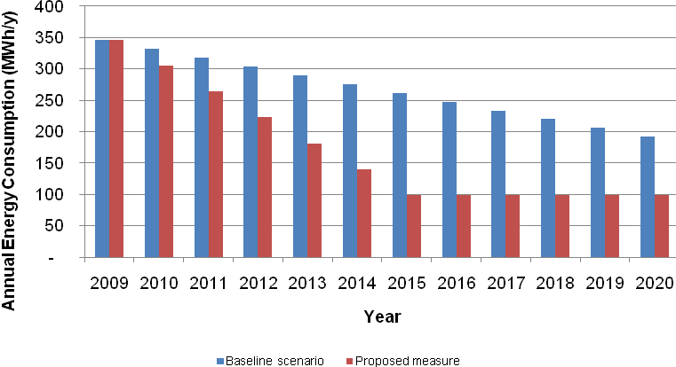
Figure 4.39: Projected Consumption for Residential Lighting – 2009-2020
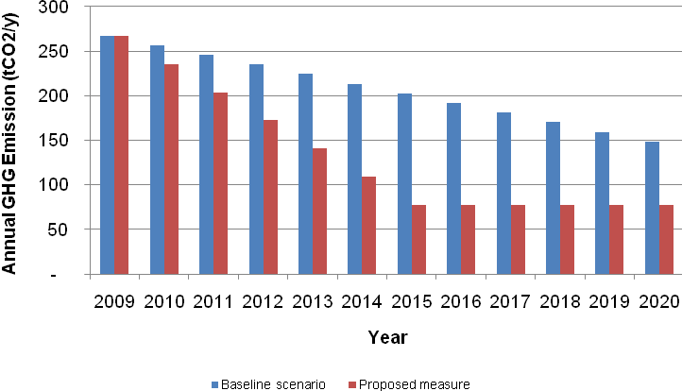
Figure 4.40: Projected GHG Emissions for Residential Lighting – 2009-2020

Second Houses
An increase is expected in the second houses occupation rates. A number of overnights of about 400,000 was estimated (i.e.: double of the current values) by the end of 2020, 75% in summer and the remaining 25% in winter (Figure 4.41).
Figure 4.41: Second Houses Occupation Rate
It was assumed that the annual energy consumption for each single house will be constant, even though the energy demand will increase due to the increase diffusion of domestic appliances.
Second houses constitute the large majority of the about 1,500 unregistered buildings that were constructed in the peri-urban areas. If the tax relief for solar systems and efficient electric appliances will be consistent, it is likely that many owners would take into consideration their installation, with the result of boosting demand .
The following aspects will support the realization of energy efficiency interventions in illegal buildings:
- tax reliefs on legalization fees;
- some external features (i.e.: finishing of external walls with metal plates, external finishing materials different from façade to façade) will be penalized, implying an additional annual fee to owners;
- many illegal buildings are still incomplete, so that some interventions might be done – in particular windows, external insulation of walls and roofs, basement insulation – during their finishing works.
The potential outcomes of this Action were estimated based on the following assumptions:
- number and surface of second houses will remain constant between 2010 and 2020;
- the yearly overnights in second houses will increase from about 200,000 to 400,000, out of which 300,000 in summer and 100,000 in winter;
- improved thermal insulation will reduce the specific energy demand for renovated buildings to 50 kWh/m² year under standard conditions (100 % occupation), resulting in about 0.4 kWh/m² day for second houses;
- automatic wood systems will be installed on 20% of second houses;
- solar systems will be installed on 20% of second houses;
- the occupation rate will remain constant throughout the year.
The annual energy consumption for second houses will reach 4.2 GWh/y by the end of 2020, out of which 65% in winter and 35% in summer. The energy consumption during winter is higher due to space heating. In respect to the baseline, the overall annual energy consumption will decrease about 0.4 GWh/y by the end of 2020. Meanwhile, the total annual GHG emissions for second houses will be around 2,950 tCO₂e/y by the end of 2020, about 350 tCO₂e/y less than the baseline scenario.

TOURISM SECTOR
In order to achieve the target of sustainable development in Žabljak, satisfying the increasing energy demand for hot water consumption and alleviating at the same time the environmental impacts due to the combustion of fossil fuels, a measure regarding solar thermal systems for hot water production in the tourism sector in the Municipality is hence proposed.

Use of Solar Energy for Heat Production in Tourism Sector
Water heating covers an important fraction of the energy demand in the tourist structures. As a benchmark value, water consumption per tourist can be estimated at 80 L/day (CETMA, 2007). The current offer in commercial structures is 825 beds. It is expected that the number of beds will increase up to 2,500 by 2020, and that overnights will rise up to 228,000 yearly.
It is likely that the existing structures will follow the path of resident’s homes, with about 13% of the structures (and of bed capacity) having solar systems installed. This evaluation is obviously just a working assumption: hotels operating in Žabljak in 2010 are only 10, with such a reduced number the renovation of a single hotel in 10 years can drastically change the situation, so that this 13% has to be considered as a reference value.
It is more interesting to take into consideration the new hotel capacity. About 1,200 new beds to be realized in the forthcoming ten years are forecast by the recent trends, and probably also existing structures like hotels Planinka and Žabljak will be heavily renovated. Additional beds will be realized through renovation of existing structures (for instance, Hotel Jezera and Hotel Durmitor) and in new structures, like for instance in the ski area.
It is likely that many of these new structures will be taken over by investment groups with a sound experience in tourism management, with a good investment capacity and international skills in design. Such large projects, that in the will of the Government will increase bed offer especially in the high classes (four and five stars), will imply large investments where an economic effort in energy efficiency and renewable sources will require a small additional endeavor. The latter could be quickly repaid not only in energy terms but also in terms of image to the potential customers.
Considering that also to get agreements in these terms with investors requires technical skills to set the requirements, this policy will be possible substantially starting from action’s phase two, after 2013. This would greatly enlarge the number of beds served by solar systems.
If such policy will be carried out, around 1,000 beds could be served by solar thermal systems by 2020.
Table 4.34 shows the effects, in terms of energy consumption and CO₂ emissions, of this policy. The use of solar energy at the estimated rate would save about 270 MWh electricity and 306 tons of CO₂ emissions yearly.
Table 4.34: Effects of Solar Systems in the Tourist Sector
Number of Overnights by 2020 | 228,000
Liters Used per Day Overnight | 80 l
Difference of Water Temperature | 45 °C
Total Energy Required for Hot Water | 950 MWh/y
Solar Contribution in Solarized Hotels | 70 %
Fraction of beds Served by Solar System | 40 %
Total Electricity Saving from Solar System | 267 MWh/y
GHG Emissions Reductions | 306 tCO₂e

PUBLIC SECTOR
Increasing energy efficiency is the most cost-effective way to minimize the gaps between energy supply and demand, to lower energy-related expenses and to lower the contributions to GHG emissions and other air pollutants in the Municipality.
The public sector has a crucial role in this, since it has to play an exemplary and awareness raising role for the population.
Efficiency measures and renewable energy systems installations in the public buildings should act as pilot and demonstrating projects, showing to the other sectors the advantages and feasibility of such actions.
Moreover, the installation of these measures in schools can be a powerful way to raise awareness in new generations on the topic of sustainability.

Actions on Municipal Buildings
For these reasons, municipal buildings shall apply actions analogous to the ones of the residential sector: improvement of building insulation, installation of solar collectors, substitution of obsolete heating systems with biomass efficient stoves. The reduction of electricity consumption and bills would be further pursued through a gradual replacement of the currently used electric appliances and lighting systems with more efficient devices, that account for relevant shares in this sector (the breakdown assumed is shown in Figure 4.42: ).
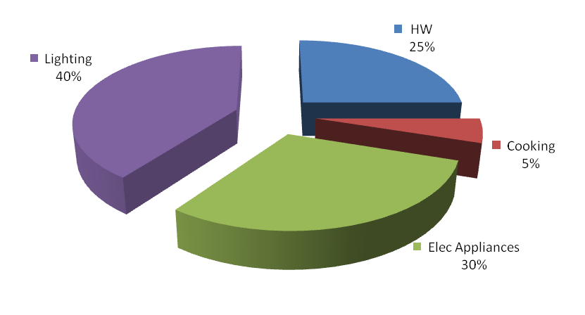
Figure 4.42: Electricity Breakdown in Municipal Buildings
In the reference scenario, the total energy consumption for municipal facilities is foreseen to increase at an average annual growth rate of 3% between 2011 and 2020, due to the development of the social and economic activities within the Municipality.
The energy consumption for municipal facilities is expected to reach 3.14 GWh by the end of 2020, and the GHG emissions are envisaged to increase, up to around 2.60 ktCO₂e/y.
The evaluation of the actions effects in the municipal buildings are not of easy evaluation. For this reason, assumptions and deduction from the residential sectors results have been made.
Reductions of 10% in electricity consumption related to hot water production, 20% for improvement of the electrical appliances, 30% for efficiency in lighting and 15% in electrical appliances have been estimated. Moreover, a decrease of 15% on the demand side of space heating should be achieved thanks to better buildings insulation. This will lead to a reduction in GHG terms of 637 ktCO₂e in 2020 compared with the reference scenario.

Lamps Replacement in Street Lighting
The use of energy efficient street lighting technologies provides energy and cost savings, GHG emission reductions, as well as economic benefits by an increase in the municipal commercial activity. In Section 2 it was assessed that high-pressure sodium lamps will be used for 60% of new public lighting installations in the Municipality by the end of 2020. It is hence proposed to install high-pressure sodium lamps in all new public lighting systems and for replacing all the existing public lighting street lamps by high-pressure by 2020. The total substitution by 2020 would be achieved with an average annual replacement around 10%. The annual electricity consumption for street lighting is expected to increase from 109 MWh/y in 2009 to 320 MWh/y by the end of 2020, due to the higher number of public lights (from 415 in 2009 to 2,000 in 2020). As shown in Figure 4.43: , the electricity consumption in the action scenario will be 55% lower than in the baseline scenario. Figure 4.44: highlights that the GHG emissions in the action scenarios will reach 300 tCO₂e/y by the end of 2020, 45% lower than in the baseline scenario.
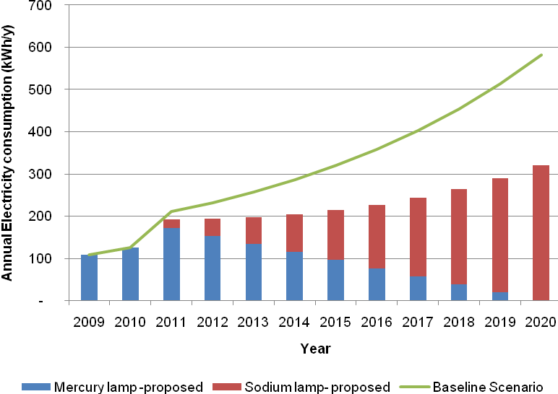
Figure 4.43: Projected Energy Consumption for Street Lighting – 2009-2020
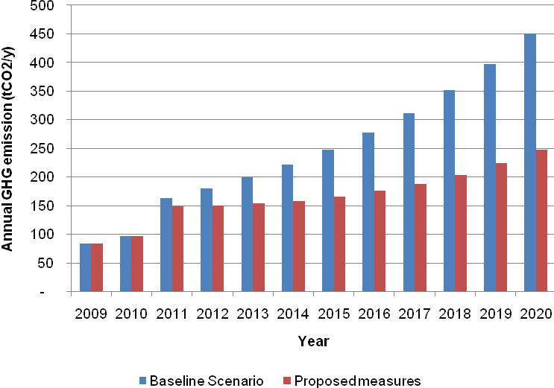
Figure 4.44: Projected GHG Emissions for Street Lighting – 2009-2020

INDUSTRIAL AND COMMERCIAL SECTOR
In the reference scenario, an annual increase of the energy consumption equal to 3% in the commercial sector is foreseen, due to new openings and to the working time extension.
The annual energy consumption is expected to increase from 1.2 GWh in 2009 to 1.6 GWh by the end of 2020, and the GHG emissions will reach 1.3 ktCO₂e by the end of 2020.
No significant development of the industrial sector in the next decade is foreseen, therefore the consumption in this sector will remain approximately in line with the current figures.
Due to the development of the Municipality, an energy efficiency action is also proposed for the commercial and industrial sectors, aimed at maintaining the annual energy consumption at 2009 level. The following activities are planned:
- information and awareness raising campaign. The objective of the campaign is to replace the energy inefficient products with energy saving appliances including office equipment, lighting, and small electronic equipment, as well as to promote an efficient utilization of all devices;
- establishment of minimum energy efficiency requirements for new energy-consuming products on the market;
- development of energy management and energy audit systems for the commercial sector, by improving the qualifications and skills of workers managing energy, starting training programs in energy management for technical and management staff, promoting tools for energy audit and benchmarking, etc.;
- promotion of Energy Services Companies (ESCO), whose payment is based on the energy savings achieved;
- introduction of financial mechanisms to support a market change towards energy efficient equipment.
It is expected that the activities will start in 2012. It is hence foreseen that the commercial sector will start implementing energy efficiency measures and the result of energy reduction in these sectors become significant from year 2013. Figure 4.45: illustrates the annual energy consumption in the commercial sector in accordance with the baseline scenario and the proposed action between 2009 and 2020.
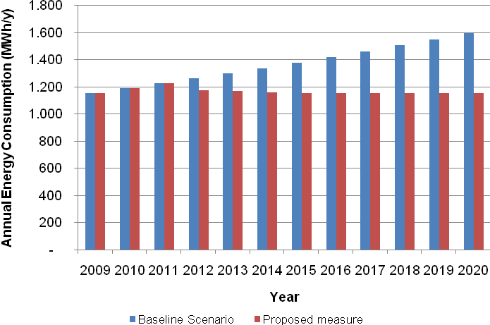
Figure 4.45: Projected Electricity Consumption in the Commercial Sector – 2009-2020
This action will result in maintaining an average consumption of 1.2 GWh/y over the period 2012 - 2020. The annual energy reduction in the commercial sector will reach about 440 MWh/y by the end of 2020. The annual GHG emissions will be 370 tCO₂/y by the end of 2020, as highlighted in Figure 4.46: , resulting in a 28% decrease.

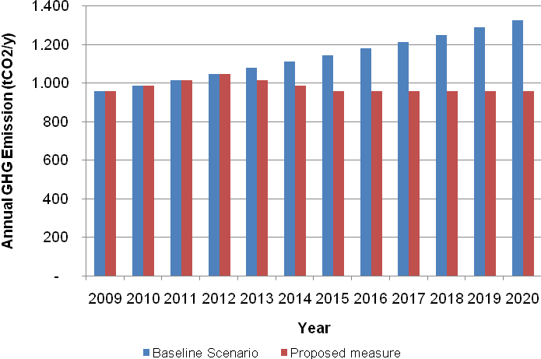
Figure 4.46: Projected GHG Emissions in the Commercial Sector – 2009-2020

TRANSPORTATION
Transportation is nowadays responsible of a significant amount of energy consumption and, consequently, of GHG emissions. It is hence proposed the reduction of energy consumption in transport.

Reduction of Energy Consumption in Transport
The action gives a quantitative evaluation of the emission savings related to the implementation of transport policies as car-pooling by tourists, promotion of LPG use, etc.
The identified policies for the implementation of an efficient transport framework are:
- enhancement of the bus service for the extra-urban accessibility;
- introduction of local shuttles and buses to get to the tourist attractions at urban level.
The realization of an inviting tourist offer based on bus connection is aimed at increasing the share of tourists getting to the Municipality by bus. In the current scenario, 15% of tourists use bus and 85 % car. The final goal of this action is to double the bus share, thus reaching 30 %. The estimated benefit of such strategy in 2020 will be a reduction of GHG emissions equal to 350 tCO₂e/y, i.e. 1,680 tCO₂e/y in the sustainable scenario versus 2,030 tCO₂e/y in the baseline scenario.
The introduction of a local bus service for the internal connections (from/to the National Park, the Ski Center, etc.) based on vans or large buses, is aimed at encouraging the use of collective transport system against the single-occupancy vehicle. Moreover, the creation of pedestrian zones and new parking areas should encourage bicycling and walking. Having in mind that the current scenario is based on 80% contribution of single-occupancy vehicle and 20% of bicycling/walking, the overall goal of this strategy is to reach the following shares of utilization: 30 % bicycling/walking, 30% car, 20% shuttle bus and 20% bus.
As shown in Figure 4.47: , the GHG emissions trends indicates that the strong tourism development of the Municipality will imply a significant increase in GHG emissions, to be partially mitigated by the introduction of sustainable interventions.
A further important possibility for decreasing GHG emissions in the transportation sector is a gradual switch to cleaner fuels, i.e. LPG, biofuels and methane. LPG, a petrol derived fuel made by the lightest fraction coming from oil refining, is the most suitable fuel for a future switch. It is not carbon neutral, but CO₂ emissions from its combustion are about 10% lower than those of gasoline. Moreover, carbon monoxide and nitrogen oxides emissions from a LPG fuelled car are significantly lower than those coming from a gasoline fuelled car, whereas dust and sulphur oxides emissions are practically absent. Thus, a city where all cars use LPG would virtually eliminate car pollution problems.
In Žabljak there is only one fuel station, not selling LPG. Therefore, two barriers should be overcome: the introduction of LPG in the local market (i.e.: the fuel station must be provided with LPG pump) and the retrofit interventions on cars.
All existing gasoline vehicles can be converted to LPG with a payback time equal to 10,000-20,000 km of car use, and nearly all car producers have widely began selling LPG cars at the same price of the gasoline since the end of year 2008. In both cases, an LPG car can also run with gasoline, it has two tanks and dual alimentation.
The suggestion is, therefore, to gradually convert and renovate the private and public vehicles of Žabljak into LPG. This Action could start for municipal vehicles, and then be enlarged to private cars with the help of awareness campaigns.
Figure 4.47: Total Transport GHG Emissions

ACTION PLAN

Summary of the Expected Results
The identified actions provide the key elements to implement a SEAP for the Municipality, preparing the ‘road map’ for the reduction of GHG emissions. The selected priority actions allow a gradual reduction of the GHG emissions in each relevant sector (buildings, district heating/cooling, industry, transport, electricity production, land use, etc.). This section summarizes the achievable GHG emissions reduction through such actions.
As stated before, the chosen approach is “scenario-based”, where the results are compared with the projection at 2020 of the 2009 situation. The following Table 4.35 presents the summary of the overall action plan, indicating actions and related expected results.
Table 4.35: Action Plan Summary
SECTORS  & fields of action | Key actions/measures  per field of action | Expected energy saving per measure  [MWh/a] | Expected CO₂ reduction per measure [t/a] | Energy saving target  per sector [MWh]  in 2020 | CO₂ reduction target  per sector [t]  in 2020
Municipal buildings, equipment/facilities | Use of solar energy for heat production  Increase of buildings insulation  Use of high efficiency electric equipment  Lamps replacement | 51  103  154  77 | 64  127  191  95 | 10,257 | 6,217
Tertiary (non municipal) buildings, equipment/facilities | Use of solar energy for heat production | 443 | 367 | 10,257 | 6,217
Residential buildings | Use of solar energy for heat production  Increase of buildings insulation  Ban of lignite use  Increase of efficiency in heating systems  Use of high efficiency electric equipment  Lamps replacement  Smart Second Houses | 350  3,311  N/A  862  57  92  450 | 400  297  807  154  65  106  342 | 10,257 | 6,217
Municipal public lighting | Lamps replacement in street lighting | 261 | 300 | 10,257 | 6,217
Transport / mobility planning | Increase of energy efficiency in transportation | 1,822 | 472 | 1,822 | 472
TOTAL |  |  |  | 12,079 | 6,689

The scenarios of energy consumption and GHG emissions are presented in Figure 4.48 and Figure 4.49: a comparison is carried out between year 2009, year 2020 in the do-nothing scenario and year 2020 in the SEAP scenario.
The growth of the local economy and in particular of the tourism sector will lead to an increase of energy consumptions and GHG emissions if compared with 2009 despite the planned actions: annual energy consumption will grow from 50.0 GWh to 58.2 (+17%) and annual CO₂e emissions from 18.0 to 24.4 kton (+36%).
Without the sustainable development principles, such increase would have been much stronger: +41% in energy consumptions and +74% in GHG emissions.

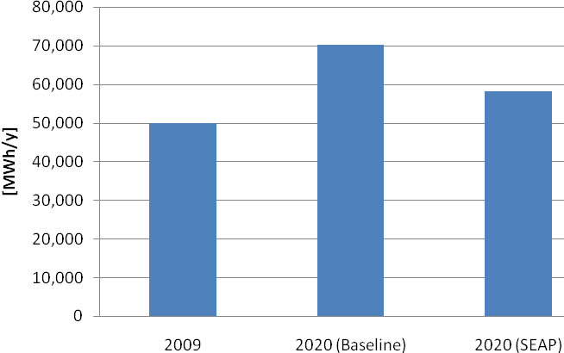
Figure 4.48: Energy Consumptions Scenarios
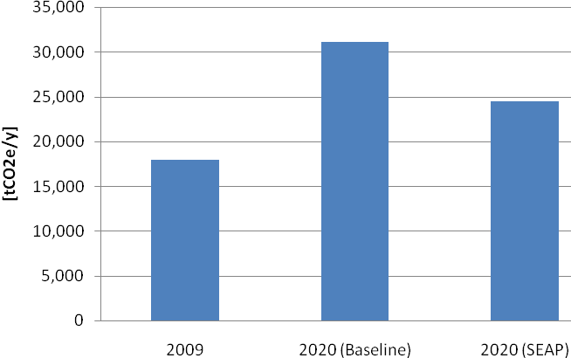
Figure 4.49: GHG Emissions Scenarios
Therefore, following the scenario-based approach, the real comparison has to be done between the two 2020 scenarios: in this case, a decrease from 70.3 to 58.2 GWh/y in annual consumptions (-17%) and from 31.1 to 24.4 tCO₂e/y in annual emissions (-21.5%) will be achieved.
It must be noted that the estimation takes into account only the interventions of energy efficiency in Žabljak, excluding the renewable projects which are part of a National strategy.
A large contribution in GHG emission will be given by the residential sector (-7%). The introduction of biomass boilers, the ban of lignite use and the introduction of energy efficient design in buildings, related to the building sector, will imply sharp reductions in electricity, liquid fossil fuels and imported wood consumption and the elimination of lignite use. Their effect in residents’ homes will be a reduction of emissions of 1,800 tCO₂e/y, and in second houses of 342 tCO₂e/y. The largest results will be, however, obtained by the tourist sector, where emissions reductions will reach 2,750 tCO₂e/y (-8.8%) if the Municipality will be able to force the new investors to take a strong commitment in green building technologies.
Increase of efficiency in public lighting will sensibly decrease electric energy consumptions for public lighting, with net economic savings for the Municipality and emission reductions around 300 tCO₂e/y. The action of the all municipal sector will result in GHG emissions reduction equal to 940 tCO₂e/y (-3%). Finally, the effects of sustainable mobility policies will involve a GHG emission reduction of 470 tCO₂e/y (-1.5%). The industrial sector is not included in the action plan, therefore its contribution is null. The weight of each sector in the overall reduction objective is shown in Figure 4.50.

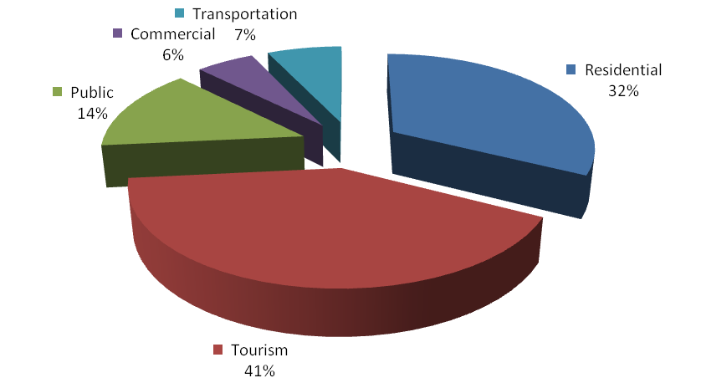
Figure 4.50: GHG Emissions Reduction – Sectoral Contribution
The energy planning strategy, based on the increase of efficiency and on the production of energy through low impact renewable energy plants, has been articulated in measures and actions complementary to the achievement of the objective of sustainable energy development for sustainable tourism development.
The growth of the tourism sector is shown by the breakdown of the GHG emissions of 2009 (Figure 4.51) and 2020 (Figure 4.52), where the decrease of the residential sector is also visible.

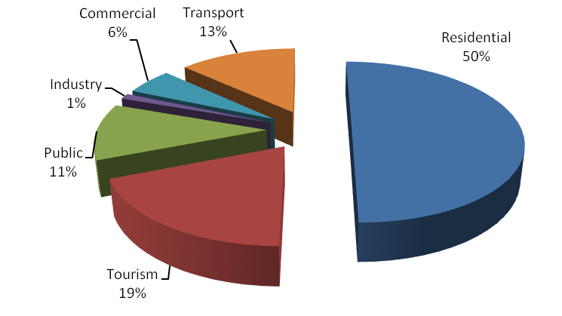
Figure 4.51: Breakdown of the Generated GHG Emissions in 2009
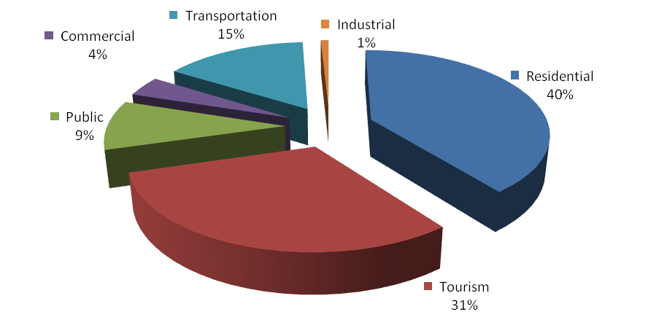
Figure 4.52: Breakdown of the Generated GHG Emissions in 2020

Timeframe for Implementation
The proposed actions could have different time frame for their implementation, due to the specific characteristics of the required interventions and to the involvement of private and public sector. Therefore, the timeframe for implementation has been organized in three phases:
- Phase I: short term actions and initiatives;
- Phase II: voluntary subsidized actions, start up of facilities;
- Phase III: mandatory policies.
The duration of Phase I is expected to be around 2 years (2012 and 2013). The main objective of this period will be capacity building among the relevant public institutions, set up of rules and development of energy plans.
Within the first two years, the municipal wind power development plan should be prepared. Once this plan will be prepared, the pre-conditions for interesting investors will be ready.
Strong efforts should be done by Municipality and EPCG to improve the local electric grid at least in the central area of Žabljak, to increase grid stability.
An agreement should be pursued between the Municipality and the sawmills owners to solve the problem of wood waste, through the realization of a pellet production plant and, with the involvement of EPCG, of a cleaning scheme for remediating wood landfills. In the meanwhile, first programs of capacity building of the municipal staff in the fields of efficient energy use in buildings will have to start, together with theoretical preparation of technicians and designers. In addition, the first pilot projects related to solar energy use, efficient building design, efficient electric appliances modern biomass boilers should start too. Together with the first biomass boilers, the wood chips supply chain should be organized through agreements between the Municipality and firewood traders. Once the first public pilot cases are developed and the municipal staff is trained, it will be necessary to sign agreements with private investors in the tourist sector to build new sustainable accommodation capacity. In the meanwhile, substitution of mercury lamps with sodium lamps in street lighting should begin.
After municipal staff is trained, the set up of targets and energy accounting system will be done. This phase will see the start-up of all actions. Only the ban of lignite use, shall be fully accomplished within Phase I.
Phase II is envisaged to last three years, from 2014 to 2016. The main step to be accomplished will be the shift from pilot project to large scale voluntary interventions, supported by public policies.
During Phase II, it is likely that the first wind power plants will start being installed, providing the Municipality with financial resources to undertake surveys, made by the Institute for Nature Protection of Montenegro, to monitor the impact of windmills on birdlife, and to finance energy efficiency policies.
After the DUPs of the peri-urban areas will be implemented, efforts shall be done by the Municipality and EPCG to improve the local electric grid in the peri-urban areas, to increase grid stability. If properly managed, these renovation works on the local grid will be helped by the needs of wind farms, which will imply strengthening of the substation and of the local power lines between the wind plants and Žabljak.
During this period, the chips production from coarse sawmill wood waste will develop, and the pellet plant should start operation, bringing also on the local market the possibility of installing small sized, household scale pellet fired systems.
Shipping of old wood waste to the lignite power plant of Pljevlja should start, together with the remediation of Njegovuđa wood waste dumps and of the smaller sites.
The installation of solar systems, of modern wood biomass boilers and of stoves and the energy efficient building design will be boosted by the tourist sector, with the development of new accommodations. This will expand local market and technical capabilities needed for green, green building design, and privates (residents, commercial and industrial subjects) will start using these new techniques and technologies aided by subsidies and loans. Some illegal houses owners will decide to adopt sustainable technologies to have a discount in legalization fees. Besides, the Municipality will keep on revamping in a sustainable way its building stock, and replacing street lights with efficient sodium bulbs.
The dissemination campaign upon energy efficient electric equipment and lights will continue and start giving tangible results in this period, also thanks to a broader market of efficient products driven by increased demand.
The monitoring system will provide information upon how to better tune incentives and on which further interventions will be possible in the public sector, whereas the Covenant of Mayors will keep providing credit loans for public interventions for energy efficiency improvement, giving visibility to Žabljak and addressing municipal efforts in the energy field.
In Phase III, expected to last four years (from 2017 to 2020), most of the actions will be completed. By 2020, it is expected that the cap for wind power plants will be reached, providing a continuous income to the Municipality, to be used for further public works and environmental protection actions or for lowering local taxes. The local grid will be fully renovated, even in the remote areas, thanks to joint investments of EPCG and Municipality and to the needed improvements for wind power plants connection.
Industrial wood waste will be fully recycled for pellet and chips production, and additional wood waste needed to satisfy chips increased demand will be recovered by forest works wood waste. The last phase of wood landfills remediation will allow to have clean areas suitable for agricultural uses and, close to the sawmill, to new industrial activities. The awareness on high efficiency windows, thick building envelopes and renewable energy plants will be spread, and the Municipality could launch mandatory rules for new constructions and renovations.
It is expected that energy efficient households and lamps will keep diffusing without the need of further promotion programs. By 2020 also substitution with efficient lamps in public illumination will be completed.
By 2020, Žabljak will have:
- an electric production from wind largely exceeding its internal consumption;
- heat mostly provided by local biomass, facilities exporting wood pellets;
- electric uses at the highest efficiency grade;
- an important share of the building heritage following the highest energy conservation standards.
Thanks to these results, Žabljak will become a Sustainable destination, an excellence in the Western Balkans. This will give a broad visibility to the Municipality, and will also create a brand for Žabljak in the international tourist market.
references
European Agency for Reconstruction (EAR), 2003, Strategic Plan for Road Infrastructure Maintenance and Development - Final Report Volume 4 - Traffic Forecasts and Inputs into HDM.
Hydrometeorlogical Institute of Republic of Montenegro (HIM), 2006, Data Sets of Sunshine Hours.
Intergovernmental Panel on Climate Change (IPCC), 2006, Guidelines for National Greenhouse Gas Inventories.
Italian Ministry for the Environment Land and Sea, 2006, “Renewable Energy Resources Assessment, Republic of Montenegro (Wind, Solar and Biomass)”, December 2006, Rome.
Italian Ministry for the Environment, Land and Sea, Department for Environmental Research and Development, 2007, Assessment of the Projects’ Potential in the Fields of Renewable Energy Sources, Energy Efficiency and Forestry Management, in the Framework of Clean Development Mechanism.
Montenegrin Ministry of Economic Development (MED), 2006, Strategy for the Development of Small Hydro Power Plants, Podgorica.
Montenegrin Ministry of Economic Development (MED), 2007a, Whitebook, Energy Development Strategy of Montenegro by 2025, Podgorica.
Montenegrin Ministry of Economic Development (MED), 2007b, Investing in the Energy Sector of Montenegro, Podgorica.
Montenegrin Ministry of Economic Development (MED), 2007c, Renewable Energy Resources in Montenegro, Podgorica.
Montenegrin Ministry of Economic Development (MED), 2008a, Energy Development Strategy of Montenegro by 2015 – Action Plan, Podgorica.
Montenegrin Ministry of Economic Development (MED), 2008b, Energy Development strategy of Montenegro by 2025. Action Plan 2008-2012, Podgorica.
Montenegrin Ministry of Economic Development (MED), 2008c, Hydro Power Plant on the River Moraca, Podgorica.
Montenegrin Ministry of Economic Development (MED), 2008d, Detailed Spatial Plan of Accumulation for Several Purposes on River Moraca, Podgorica.
Montenegrin Ministry of Economic Development (MED), 2009, Energy Law – Final Draft, Podgorica.
Montenegrin Ministry of Tourism of the Republic of Montenegro, 2002, Master Plan. Strategy of Tourism Development by 2020, Podgorica.
Montenegrin Ministry of Tourism and Environmental Protection, 2007, “National Strategy of Sustainable Development of Montenegro”, January 2007, Podgorica.
Montenegro Statistical Office (MONSTAT), 2008, Statistical Yearbook.
World Resources Institute (WRI), 2005, GHG Protocol - Mobile Guide (03/21/05) v1.3.
APPENDIX A
OVERALL STRATEGY
APPENDIX B
BASELINE EMISSIONS INVENTORY
appendiX C
SUSTAINABLE ENERGY ACTION PLAN

This fit has been obtained using the method of least squares through a computer calculation.

